# **Udemy**

**Día 45 – 27/11/2023**  
**Udemy:** <https://www.udemy.com/>**email:** *miopersonal*  
**pw:** *???*

# **Course: Machine Learning A-Z™: AI, Python & R + ChatGPT Bonus [2024]**

## **Section 1: Welcome to the course!**

Relevant videos: -   
Interesting videos: -

#### **Welcome Challenge!**

**Welcome** to our Machine Learning A-Z course!

**Congratulations**, you took a great first action starting it, but now we want to motivate you to really learn Machine Learning and finish the course.

**That's why we are giving you a challenge, which starts right now:**

If you manage to complete this course in less than **2 months**, we will give you **an incredible Bonus** right after. Here is what we will send you (we saved the best for the end):

* **10 Data Science use cases we do with ChatGPT, including Time Series Analysis, ChatBots, Computer Vision, Recommender Systems, Fraud Detection, Self-Driving Cars and more**.We recorded one very clear hands-on tutorial for each use case so you will get 10 video lectures plus the codes of each tutorial. What ChatGPT can do has blown my mind, it's really incredible you'll see.
* **Our 10 Best Machine Learning & Data Science PDF Cheatsheets**.
* **One video tutorial where we help you write a great cover letter for your resume**.
* **A resume template for Data Science**.
* **AND NOW THE BEST FOR THE END:** You will get a **free 2-hour mini-course on Generative AI**, in which we will leverage the power of **Cloud Computing** for **Prompt Engineering**, **Conversational Chatbot**, **Text Generation**, **Text Classification**, **Text Summarization**, **Question Answering**, **Information Extraction**, and **Image Generation**, by using the following **state of the art LLMs / foundation models**:  
  [Claude by Anthropic](https://www.anthropic.com/index/introducing-claude),  
  [Jurassic-2 by AI21 Labs](https://docs.ai21.com/docs/jurassic-2-models),  
  [Command by Cohere](https://cohere.com/models/command),  
  [Titan by Amazon](https://aws.amazon.com/bedrock/titan/).  
  This last Bonus will give you incredible tools for Generative AI, which will without a doubt help you tremendously in your day-to-day work.

To take the challenge, here are the three simple steps you need to follow:

1. Starting from now, you complete the course within two months.
2. Once done, you can **send me a direct message** ([link here](https://www.udemy.com/user/hadelin-de-ponteves/) and then you click "Send message") **with a screenshot of your certificate of completion** which you will get after completing all the lectures. Or, if you are happy to share your certificate on LinkedIn, feel free to do so **and mention me (@Hadelin de Ponteves, Hon. PhD)** in the post so that I can see it. And then because I have a LinkedIn Premium account, I will be able to send you a message (InMail) with the Bonus (which I will do quickly because I am very active on LinkedIn).
3. Then I will just check that you subscribed to this course less than two months before the moment you sent me the certificate of completion, and if so, I will immediately send you the Bonus.

**PS:** By succeeding the challenge you will also be selected to participate in a **$3600 Prize Pool Giveaway**. We are drawing **8 Amazon gift cards** this month for students who complete any of the challenges we have in our courses: The prizes for this month are **one gift card of 100 USD** (Bronze Medal), **another one of 200 USD** (Silver Medal), **another one of 300 USD** (Gold Medal), **another one of 400 USD** (Diamond Medal), **another one of 500 USD** (Platinum Medal), **another one of 600 USD** (Palladium Medal), **another one of 700 USD** (Iridium Medal), and **a last one of 800 USD** (Rhodium Medal). If you win, we will contact you directly and send you immediately your Amazon gift card.

The winners of October are...: John (Bronze), George (Silver), Navodit (Gold), Mitali (Diamond), Sohail (Platinum), Boris (Palladium), and the big winner Salma (Iridium). Huge Congrats to them!!! Video of the draw [here](https://www.linkedin.com/feed/update/urn:li:ugcPost:7125894935748198400/).

**PPS:** We now attribute different weights to our courses having the challenge, so that students who complete the longer courses get more entries in the draw. Since Machine Learning A-Z is our longest course with a 2-month challenge, **you will get 5 entries in the draw by completing this course**.

#### **Links**

Tips and extra resources: <https://sdsclub.com/machine-learning-a-z-tips-and-resources/>ML skill track: <https://sdsclub.com/learning-paths/machine-learning-track/>Mango faq bot: <https://www.superdatascience.com/pages/welcome-to-faqbot>

## **Section 2: Part 1: Data Preprocessing**

Relevant videos: 10  
Interesting videos: -

**8. The Machine Learning process** --> ver slides

In this course we won’t focus on cleaning the data: it is precleaned ("cleaning data is 80% of the job" - Diego)

Data Pre-Processing:

* Import the data
* Clean the data
* Split into training & test sets
* Feature Scaling

Modelling:

* Build the model
* Train the model
* Make predictions

Evaluation:

* Calculate performance metrics
* Make a verdict

**10. Feature Scaling**

Feature Scaling can only be applied to columns, it’s never applied accross columns, so it can never be applied to a row.

There are 2 main techniques: Normalization and Standarization.

Normalization: $$X^{′}=\frac{X−X_{min}}{X_{max}−X_{min}}$$--> values [0,1]

Standarization: $$X^{′}=\frac{X−μ}{σ}$$--> values [-3, 3]

$$μ$$: average $$σ$$ 
: standard deviation

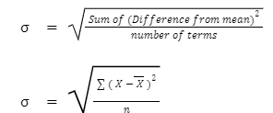

It’s important to scale your features in order to compare features so you don’t compare pears to oranges, or 10 pears to 2 pears.

**Blue vs Purple vs Red person feature scaling --> antiintuitive for myself**

### **Section 3: Data Preprocessing in Python**

Relevant videos: 20, 21, 27  
Interesting videos: -

The course can be completed in R or Python, choose 1 --> Python  
IDE: Visual Studio Code (VSC)

**13. Importing the Libraries**

We are going to work with NumPy (necessary to work with arrays), matplotlib (plot charts) and pandas (matrix of features and the dependent variable vector).

**14. Importing the Dataset - Step 1**

Code: Machine Learning A-Z (Codes and Datasets)\Part 01 - Data Preprocessing\classroom \data_preprocessing_tools.ipynb

**20. Encoding Categorical Data - Step 1**

One-hot encoding: we don’t want to encode Spain, France and Germany as 1, 2 and 3; because then the model could get easily confused. We will do one hot encoding, we will turn each value into a column, 3 values, so there would be 3 columns represented by vectors: Spain (1,0,0), France (0,1,0), Germany (0,0,1).

One hot encoding consists in creating binary vectors for each of the countries.

We replace yes by 1 and no by 0. This is absolutely understandable.

**21. Encoding Categorical Data - Step 2**

It is absolutely compulsory to have X as a numpy array, this will be expected by the future ML models

**23. Splitting the dataset into the Training set and Test set**

We have to apply feature scaling after splitting the data set into the train set and the test set.

Feature scaling: scaling all the variables so that they take place in the same scale: normalization?

Feature scaling is a technique that would get the mean and the standard deviation of the feature in order to perform the scaling. If we apply feature scaling before the split, this would include scaling the values on the test set; and since the test set is sthing you are not supposed to have, applying feature scaling before the split will cause info leakage on the test set.

The essential reason why you should not apply feature scaling before the split is to prevent information leakage on the test set; which you are not supposed to have until the training is done.

**26. Feature Scaling - Step 1**

Normalization is recommended for normal distributions. **Standardization works all the time**.

**27. Feature Scaling - Step 2**

**Q:** Do we have to apply feature scaling (standardization) to the dummy variables in the matrix of features?   
**A**: NO. The goal of standardization is to have all the values of features in the same range. Standardization will only make it worse.

### **Section 4: Data Preprocessing in R**

We will not focus on R, it’s deprecated for ML/DL.

## **Section 5: Part 2: Regression**

### **Section 6: Simple Linear Regression**

Relevant videos: -  
Interesting videos: -

**41. Simple Linear Regression Intuition**

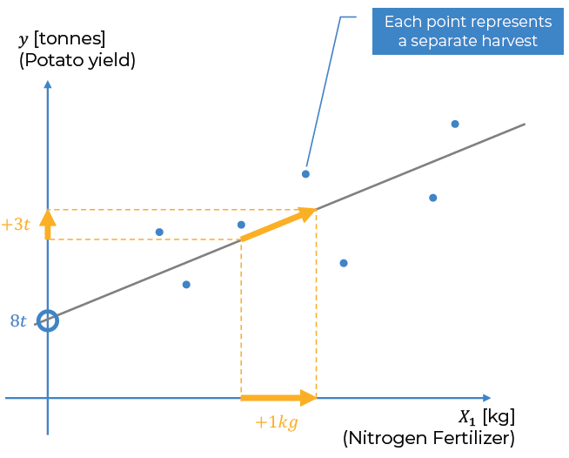

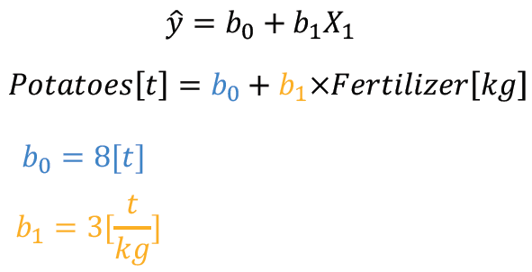

**42. Ordinary Least Squares**

**Q:** How do we know which slope line is the best one?

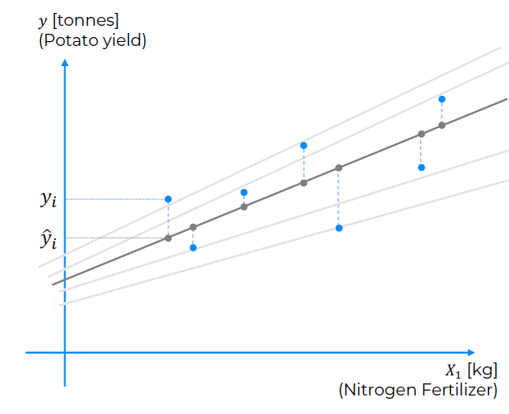

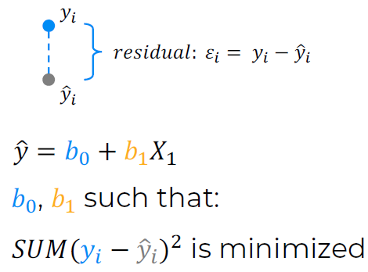

### **Section 7: Multiple Linear Regression**

Relevant videos: -  
Interesting videos: 58, 59, 60, 61, 62, 63, 67, 68

**58. Multiple Linear Regression Intuition**

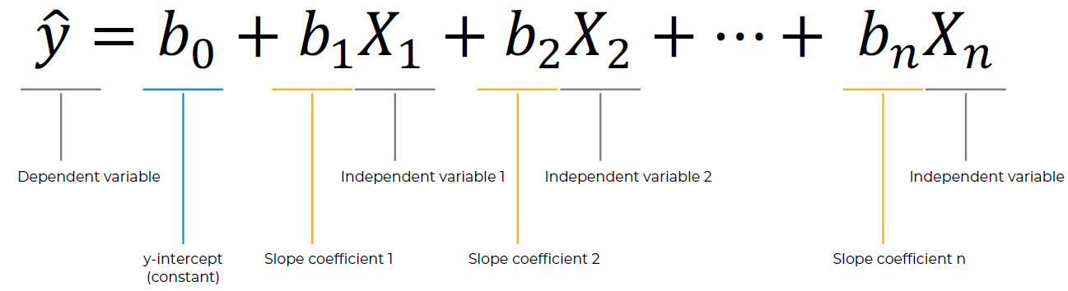

Additional reading: The Application of Multiple Linear Regression and Artificial Neural Network Models for Yield Prediction of Very Early Potato Cultivars before Harvest

Link: <https://www.mdpi.com/2073-4395/11/5/885>

**59. Assumptions of Linear Regression**

You have to make sure the set is fit for linear regression. In this course, all the data is fitted for regression, but this will not always be the case in the real world.

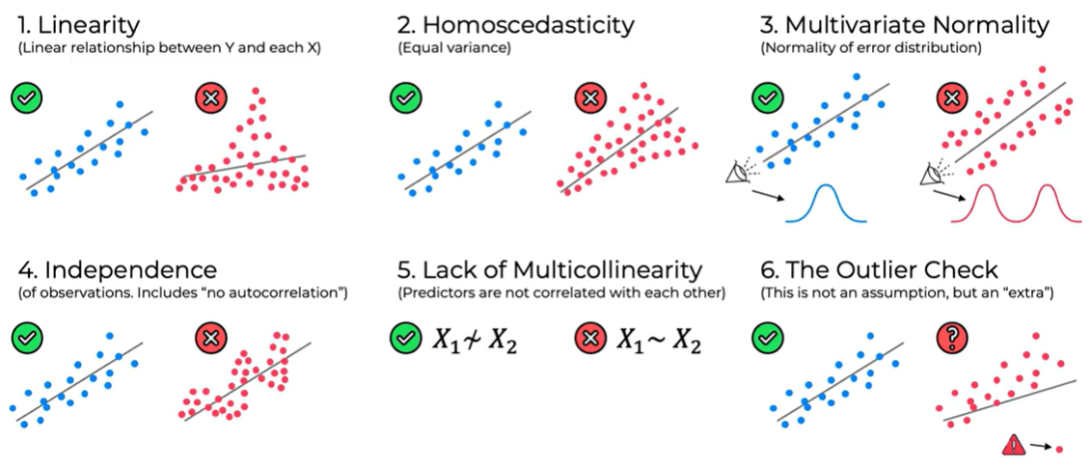

**60. Multiple Linear Regression Intuition - Step 3**

You don’t have to include all your dummy variables in the dataset. In the following example, with only including New York, (binary election), is enough.

**61. Multiple Linear Regression Intuition - Step 4**

The dummy variable trap: multicollinearity

**62. Understanding the P-Value**

H0: This is a fair coin  
H1: This is not a fair coin

$$∝$$ = 0.05 (5% --> 1/20 or less likely to happen: makes you reject the fair coin universe (H0))  
You can increase or decrease the confidence level ($$∝$$)  
Medical trials (99%)  
It’s a gaussian distribution

|  |  |
| --- | --- |
| Result Tails (P-value) |  |
| 0.5 |  |
| 0.25 |  |
| 0.12 |  |
| 0.06 |  |
| ------------------ | $$∝=0.05$$ |
| 0.03 |  |
| 0.01 |  |

$$∝$$: this is where we draw the line to reject the H0 universe (fair coin), if we get 4 tails in a row, then it is quite suspicious.

**63. Multiple Linear Regression Intuition - Step 5**

Sometimes you have to discard variables and keep only the variables that predict stuff. There are 5 methods of building models:

1. **All-in**: we throw in all the variables because of: prior knowledge or you have to or you are preparing for backward elimination.
2. **Backward Elimination**:
   1. **Step 1**: Select a significance level to stay in the model (e.g. SL = 0.05)
   2. **Step 2**: Fit the model with all possible predictors.
   3. **Step 3**: Consider the predictor with the highest P-value. If P > SL, go to step 4, otherwise go to FIN.
   4. **Step 4**: Remove the predictor (variable with the highest P-value)
   5. **Step 5**: Fit the model without this variable. If you remove the variable you have to refit the model, recreate and rebuild the model.
   6. **Step 6**: Go to step 3 until the predictor: P < SL
3. **Forward Selection**:
   1. **Step 1**: Select a significance level to enter the model (e.g. SL = 0.05)
   2. **Step 2**: Fit all simple regression models y ~ Xn and select the one with the lowest P-value.
   3. **Step 3**: Keep this variable and fit all possible models with one extra predictor added to the one(s) you already have.
   4. **Step 4**: Consider the predictor with the lowest P-value.
   5. **Step 5**: Go to step 3 until the predictor: P > SL
4. **Bidirectional Elimination aka stepwise regression**:
   1. **Step 1**: Select a significance level to enter and to stay in the model (e.g. SLENTER = SLSTAY = 0.05)
   2. **Step 2**: Perform the next step of Forward Selection: (new variables must have P < SLENTER to enter)
   3. **Step 3**: Perform ALL steps of Backward Elimination (old variables must have P < SLSTAY to stay)
   4. **Step 4**: Go to step 2 until no new variables can enter and no old variables can exit.
5. **Score Comparison**:
   1. **Step 1**: Select a criterion of goodness of fit (e.g. Akaike criterion)
   2. **Step 2**: Construct All Possible Regression Models: (2^n) -1 total combinations
   3. **Step 3**: Select the one with the best criterion
   4. **E.g.**: 10 columns means 1023 models (2^10)

Stepwise regression: they mean (2,3,4) or maybe just number (4).

We will use Backward Elimination process because it is the fastest in implementation.

**67. Multiple Linear Regression in Python - Step 2b**

In multiple linear regression you don’t have to apply feature scaling, because in the equation of multiple linear regression you have a coefficient that is multiplied to each independent variable, each feature, so it doesn’t matter that some features have higher values than others. The coefficients will compensate to put everything on the same scale.

y = b0 + b1x1 + b2x2 + … + bnxn

**68. Multiple Linear Regression in Python - Step 3a**

**Question 1**: Do we have to do something to avoid the dummy variable trap? No, the multiple linear regression class that we are about to import and which will build the Multiple Linear Regression model itself and also train it, this class, will automatically avoid this trap.

**Question 2:** Do we have to work on the features to select the best ones, highest p-values with techniques like backward elimination? No, the class will automatically identify the best features, the most statistically significant.

### **Section 8: Polynomial Regression**

Relevant videos: -  
Interesting videos: -

**82. Polynomial Regression Intuition**

Polynomial linear regression: y = b0 + b1*x1 + b2*x1^2 + … + bn*x1^n  
It is a special case of the multiple linear regression.

### **Section 9: Support Vector Regression (SVR)**

Relevant videos: -  
Interesting videos: 104, 106

**102. SVR Intuition (Updated!)**

Book: The Nature of Statistical Learning Theory by Vladimir N. Vapnik (1992)

Yellow tube: Epsilon insensitive tube, we disregard the error of the points inside the tube, we allow that margin of error for our tube. It gives a kind of buffer to our model.

We want ot minimize the epsilon distances (if they have a * they are below the tube, if they do not, they are above the tube):

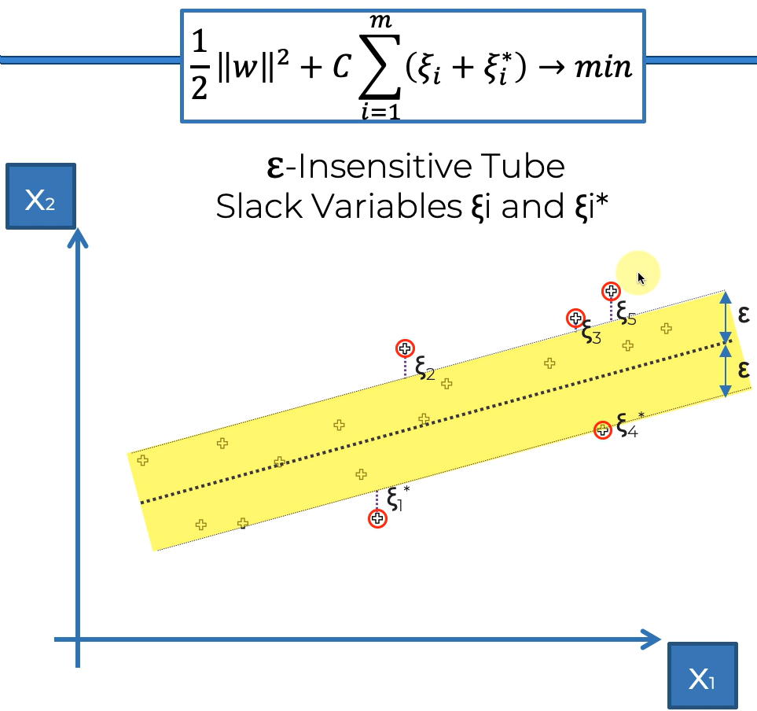

Additional reading: Chapter 4 – Support Vector Regression (from: Efficient Learning Machines: Theories, Concepts, and Applications for Engineers and System Designers) By Mariette Awad & Rahul Khanna (2015)  
Link: <https://core.ac.uk/download/pdf/81523322.pdf>Ruta: C:\Users\AlejandroDiezRedondo\OneDrive - Habber Tec\Formación\Udemy\Efficient Learning Machines.pdf

**104. SVR in Python - Step 1a**

We don’t have to apply feature scaling for linear regression models where you have indeed those coefficients that can compensate with the high values of the features (simple linear regression, multiple linear regression and polynomial regression).

When models have an implicit equation, implicit relationship between the dependent variable Y and the features X, for these models we have to apply feature scaling.

We will train the SVR model on the whole dataset, we won’t split the dataset into a test set and training set because we want to leverage the maximum data to learn these correlations between those position levels and the salaries.

**106. SVR in Python - Step 2a**

**Q:** Why didn’t we previously apply feature scaling to the dependent variable vector Y?   
**A:** The dependent variable vector Y was taking values: 0 and 1.  
**Q:** When do we apply feature scaling to this dependent variable, the salary?   
**A:** When the salary is way higher than the features, we must apply it so that the salary doesn’t get neglected.

You don’t apply feature scaling:

* dummy variables resulting from one-hot encoding
* when a dependent variable takes binary values like 0 and 1 (variables are already in the right range)

You have to apply feature scaling:

* when a dependent variable takes super high values respect to other features: to put the dependent variable and all the features in the same range
* whenever you want to split your dataset into the training set and the test set, you have to apply feature scaling after the split

Inverse feature scaling transformation: when you scale your features or your dependent variable, at some point, to get the final prediction and visualize the result, you need to inverse the feature scaling transformation to get the prediction in the original scale.

**109. SVR in Python - Step 3**

For any ML learning model that is not based on neural networks, SciKit-Learn is by far the best data science library.

<https://data-flair.training/blogs/svm-kernel-functions/>

### **Section 10: Decision Tree Regression**

Relevant videos: -  
Interesting videos: -

**115. Decision Tree Regression Intuition**

There are 2 types of trees: CART (Classification And Regression Trees)

Once you run your decision tree algorithm, the data gets split into leaves:

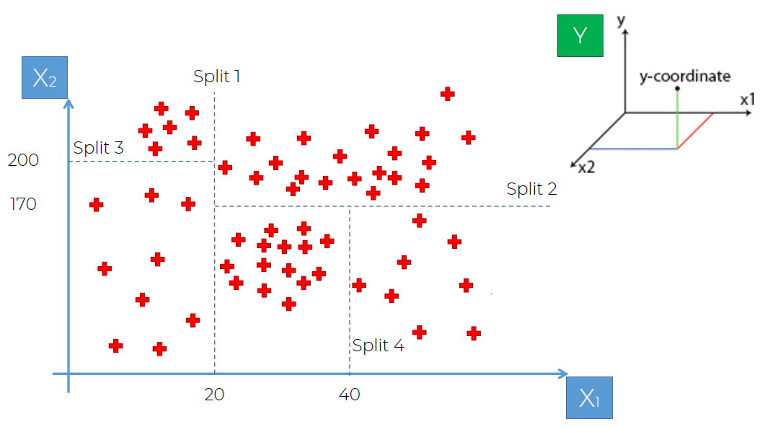

Then we can mark the different paths:

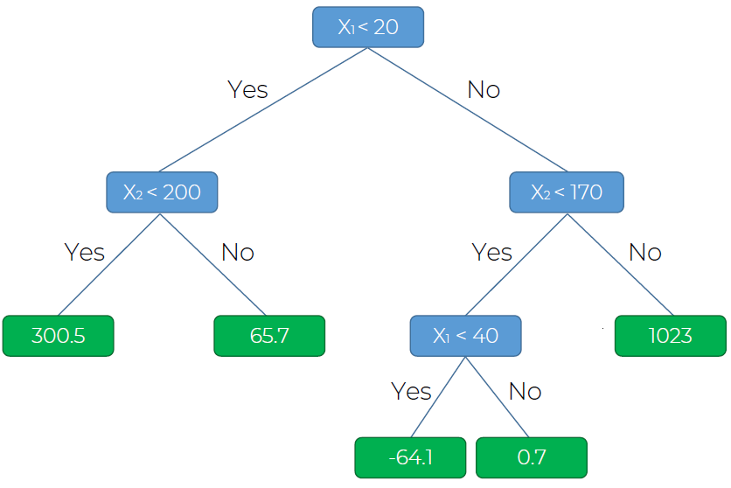

If a new point gets assigned to a leaf, the value it receives is the average value of the points within that leave.

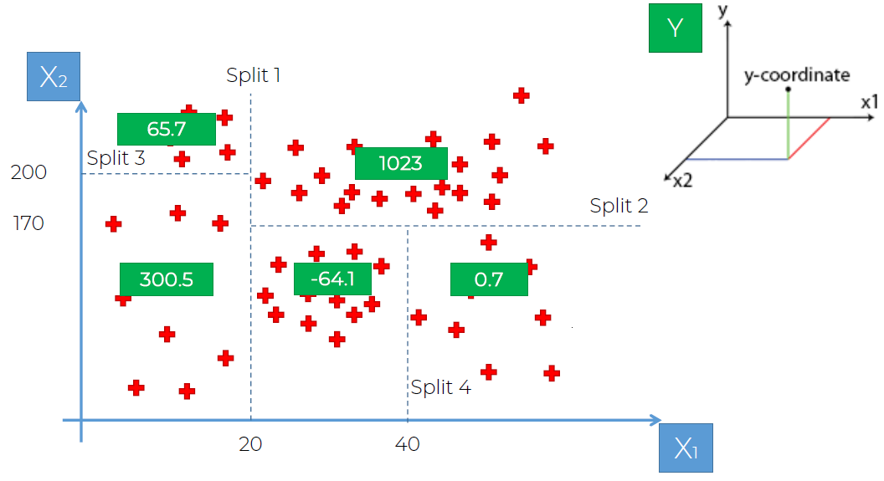

**116. Decision Tree Regression in Python - Step 1a**

The decision tree model is not well adapted for simple datasets.

You don’t have to apply feature scaling for decision tree regression and neither for random forest regression because they don’t use an equation to predict the results, they split the data through the different nodes of the tree.

### **Section 11: Random Forest Regression**

Relevant videos: -  
Interesting videos: -

**125. Random Forest Regression Intuition**

Random Forest is a version of ensemble learning. Ensemble learning is when you pick up an algorithm or the same algorithm multiple times and you put them together to make something much more powerful than the original.

Steps:

1. Pick up random K data points from the training set
2. Build the Decision Tree associated to these K data points
3. Choose the number Ntree of trees you want to build and repeat steps 1&2
4. For a new data point, make each one of your Ntree trees predict the value of Y for the data point in question, and assign the new data point the average across all of the predicted Y values.

Example: Jelly Beans Wild Guess Jar: make an average of the guesses of the people that guess how many jelly beans are there.

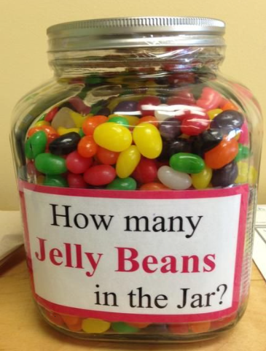

### **Section 12: Evaluating Regression Models Performance**

Relevant videos: -  
Interesting videos: 131, 132

**131. R-Squared Intuition**

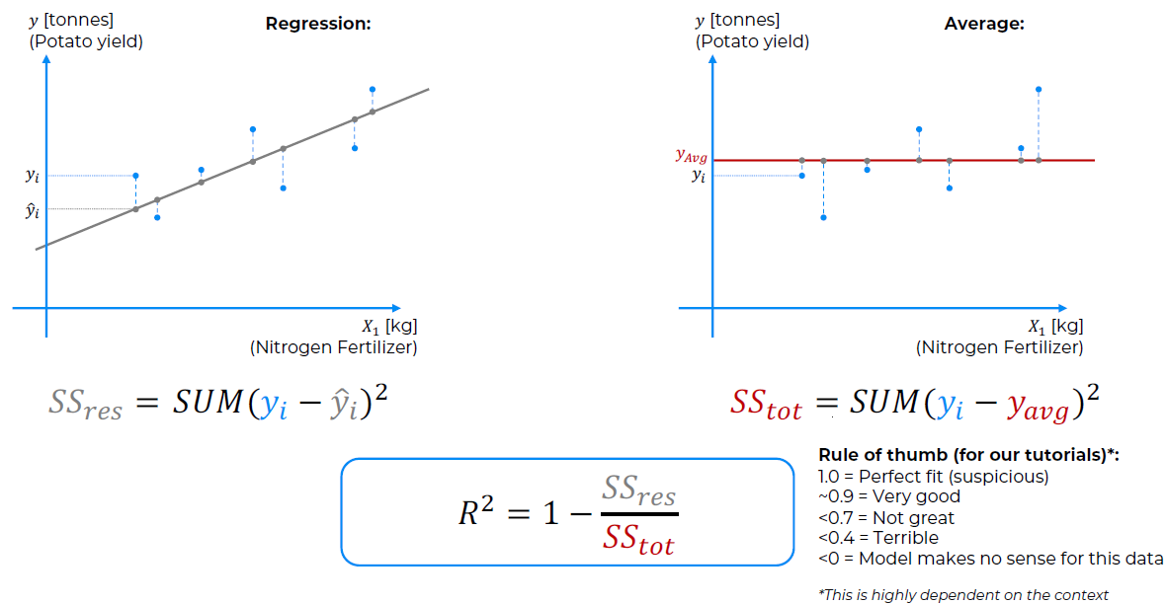

**132. Adjusted R-Squared Intuition**

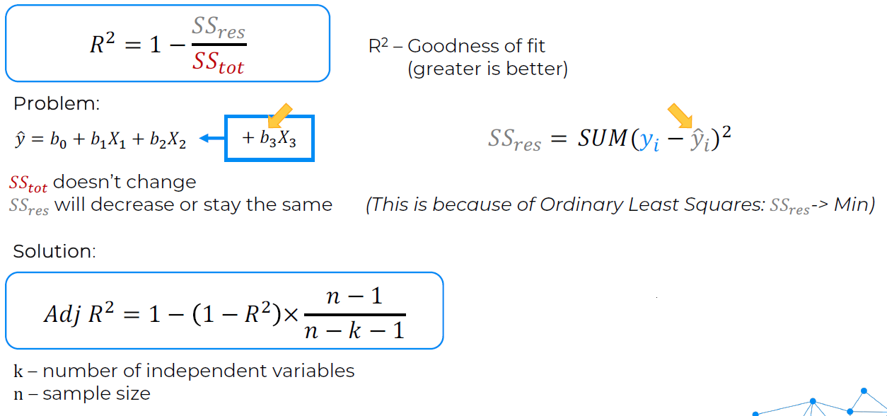

k – also known as p is the nº of regressors/predictors/independent variables

When we add another variable to our model, b3X3, SStot doesn’t change, but SSres will change: decrease or stay the same.

Adj R^2 penalizes us for adding new variables (increasing k). That’s what Adj R^2 is about, it’s about making sure that we only add variables when they bring substantial improvement to our model.

### **Section 13: Regression Model Selection in Python**

Relevant videos: -  
Interesting videos: -

**Q:** How do i select the best model?  
**A:** Try all your the models and select the best R^2 or adjusted R^2.

C:\Users\AlejandroDiezRedondo\Desktop\Machine Learning A-Z\Machine Learning A-Z (Codes and Datasets)\Part 02 - Regression\Section 13 - Regression Model Selection

### **Section 14: Regression Model Selection in R**

We are with python so we skip this.

## **Section 15: Part 3: Classification**

**144. Welcome to Part 3 - Classification**

Unlike regression where you predict a continuous number, **you use classification to predict a category**. There is a wide variety of classification applications from medicine to marketing. Classification models include linear models like Logistic Regression, SVM, and nonlinear ones like K-NN, Kernel SVM and Random Forests.

In this part, you will understand and learn how to implement the following Machine Learning Classification models:

1. Logistic Regression
2. K-Nearest Neighbors (K-NN)
3. Support Vector Machine (SVM)
4. Kernel SVM
5. Naive Bayes
6. Decision Tree Classification
7. Random Forest Classification

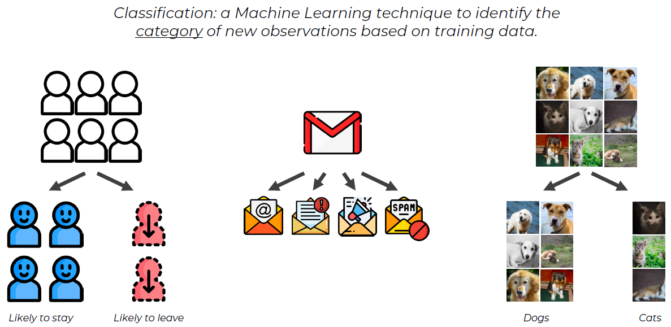

### **Section 16: Logistic Regression**

Relevant videos: -  
Interesting videos: 146, 147, 160

**146. Logistic Regression Intuition**

Logistic regression: predict a categorical dependent variable from a number of independent variables.

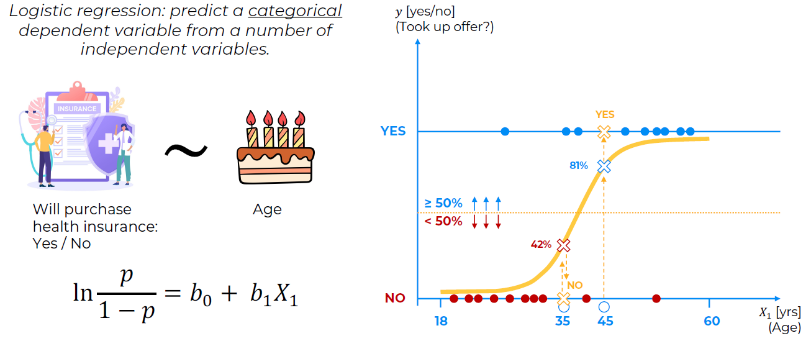

Logistic regression curve, orange S, also called the sigmoid curve.

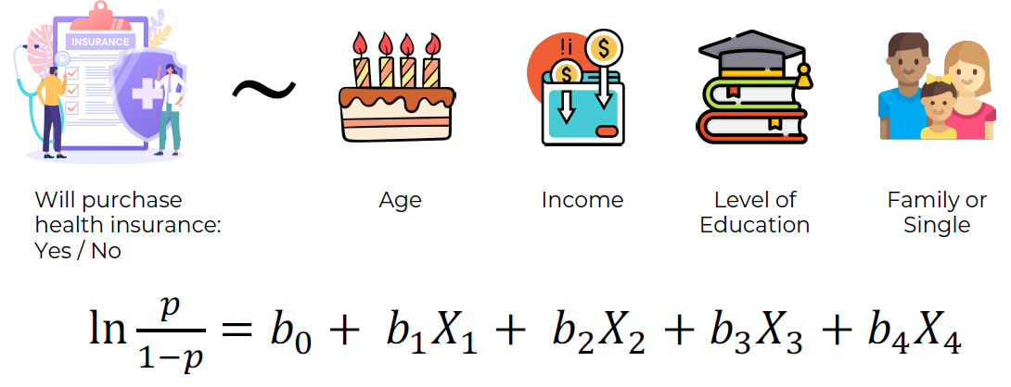

**147. Maximum Likelihood**

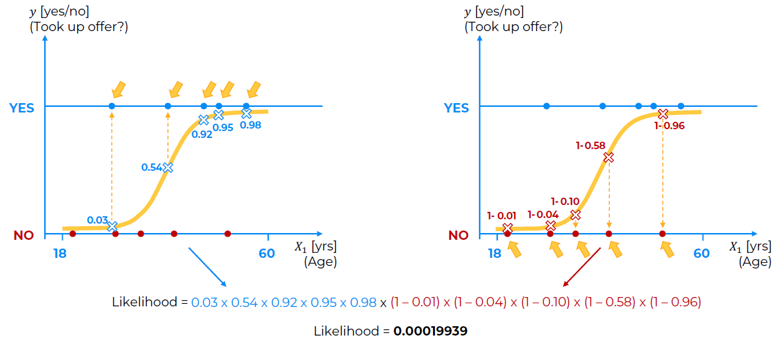

The point is to paint different S curves and choose the one with the maximum likelihood, that’s the best curve.

**173. Machine Learning Regression and Classification BONUS**

<https://www.superdatascience.com/blogs/the-ultimate-guide-to-regression-classification>

#### **Course: Logistic Regression Practical Case Study**

Relevant videos: -  
Interesting videos: -

Extra Udemy Content for the course.

Practical Case – Breast Cancer Detection: <https://www.udemy.com/course/logistic-regression-cancer-detection-case-study/learn/lecture/18888180#overview>

Machine learning repository: <https://archive.ics.uci.edu/>

**1. Getting started**

Datasets: <https://archive.ics.uci.edu/datasets>Task:

* Classification --> predict a category: winner of a footbal game, next president of the USA.
* Regression --> predict a continuous outcome: score of the football game, Tº of tomorrow, salary of a potential employee.
* Clustering --> unsupervised learning: find patterns in the data

We will predict if the tumor is benign or malignant.

### **Section 17: K-Nearest Neighbors (K-NN)**

Relevant videos: -  
Interesting videos: 175

**175. K-Nearest Neighbor Intuition**

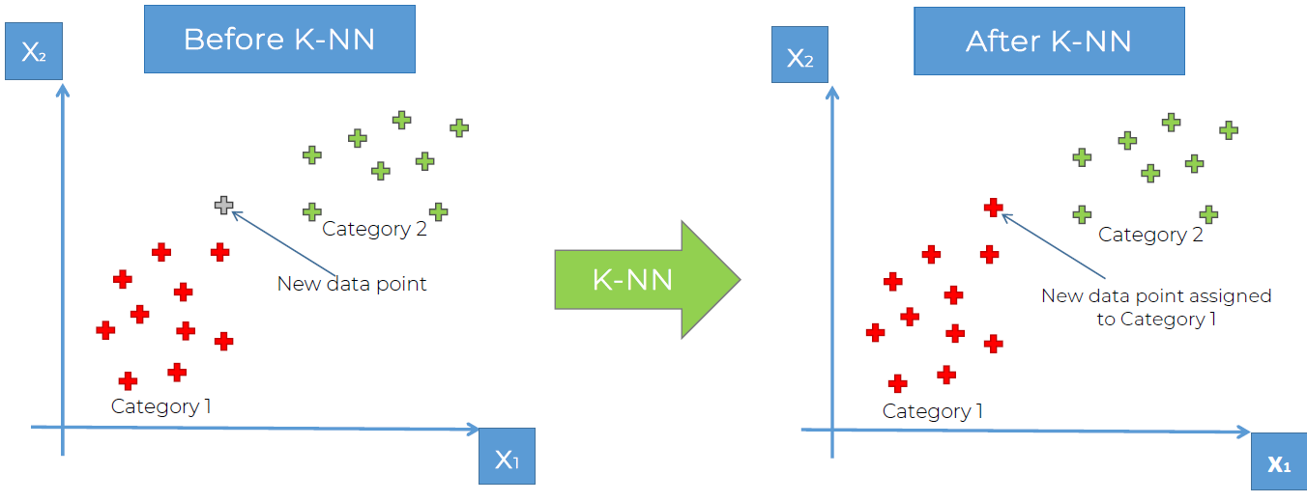

Steps:

1. Choose the number K of neighbours
2. Take the K nearest neighbours of the new data point, according to the euclidean distance
3. Among these K neighbours, count the number of data points in each category
4. Assign the new data point to the category where you counted the most neighbours
5. Model is ready!

Euclidean distance:

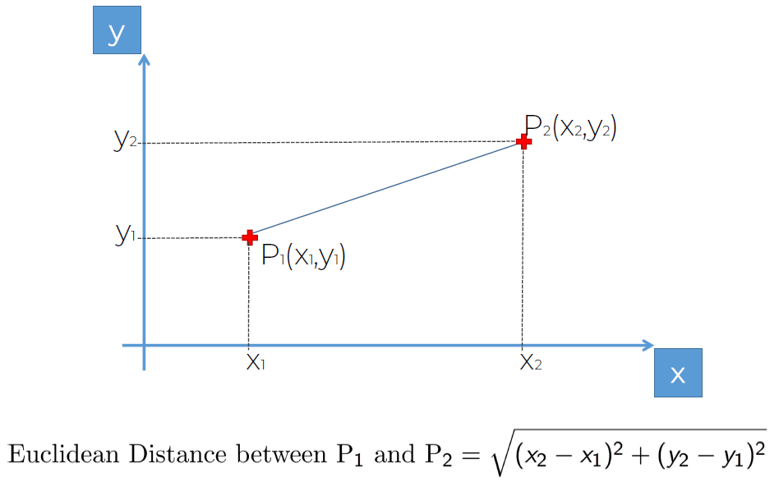

### **Section 18: Support Vector Machine (SVM)**

Relevant videos: -  
Interesting videos: 182

**182. SVM Intuition**

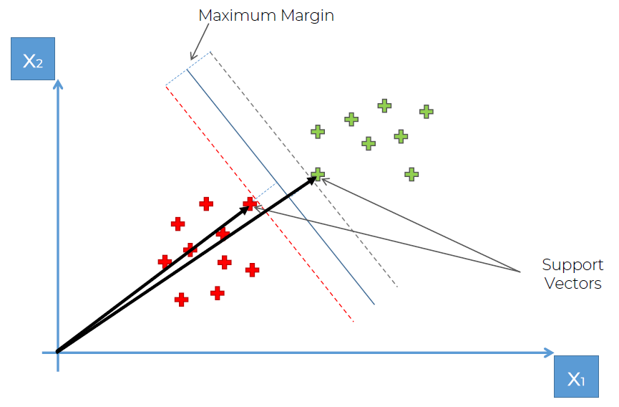

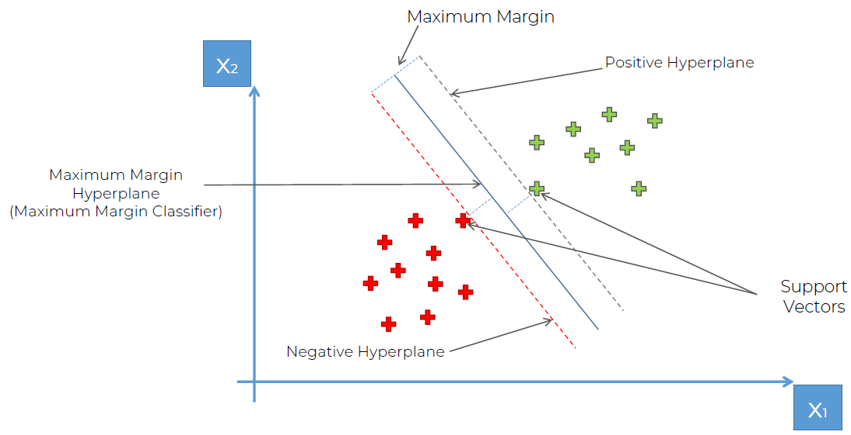

### **Section 19: Kernel SVM**

Relevant videos: -  
Interesting videos: 189, 190, 192

**188. Kernel SVM Intuition**

**Q:** What happens in SVM when you can’t find a linear boundary?

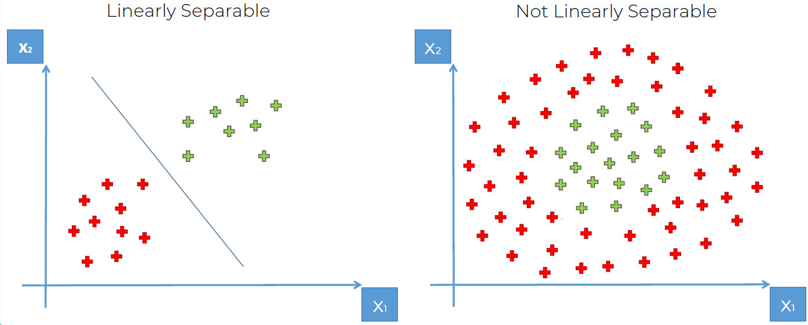

**189. Mapping to a higher dimension**

In today’s tutorial we will find out how we can take our non-linearly separable data set, map it to our higher dimension and get a linearly separable data set, invoke the support vector machine algorithm, build a decision boundary for our data set and then project all that back into our original dimensions.

In a 2d space the separator would be a line, in a 1d space the separator would be a dot, in a 3d it would be a plane.

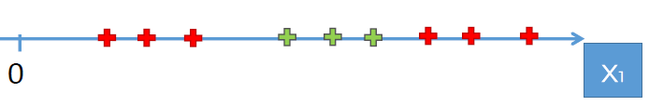

**Q:** Can we apply a method to increase the dimensionality of this space to make it a linearly separable data set in a higher dimension?

**A:** We build a mapping function.

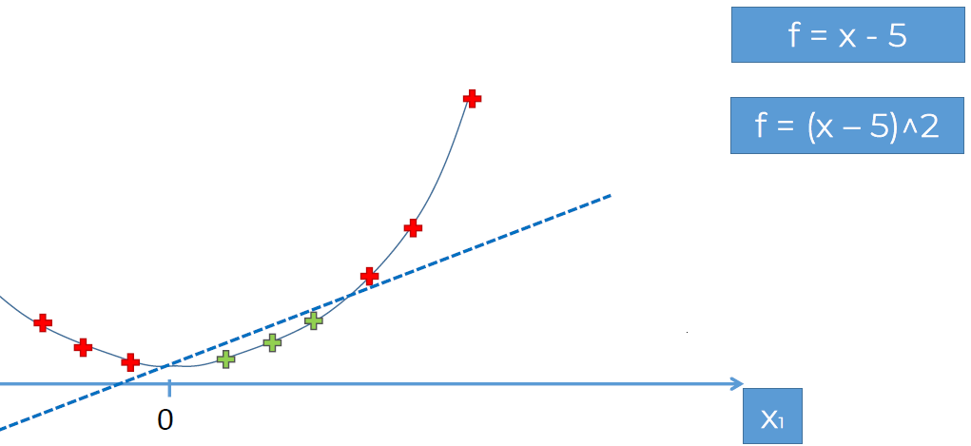

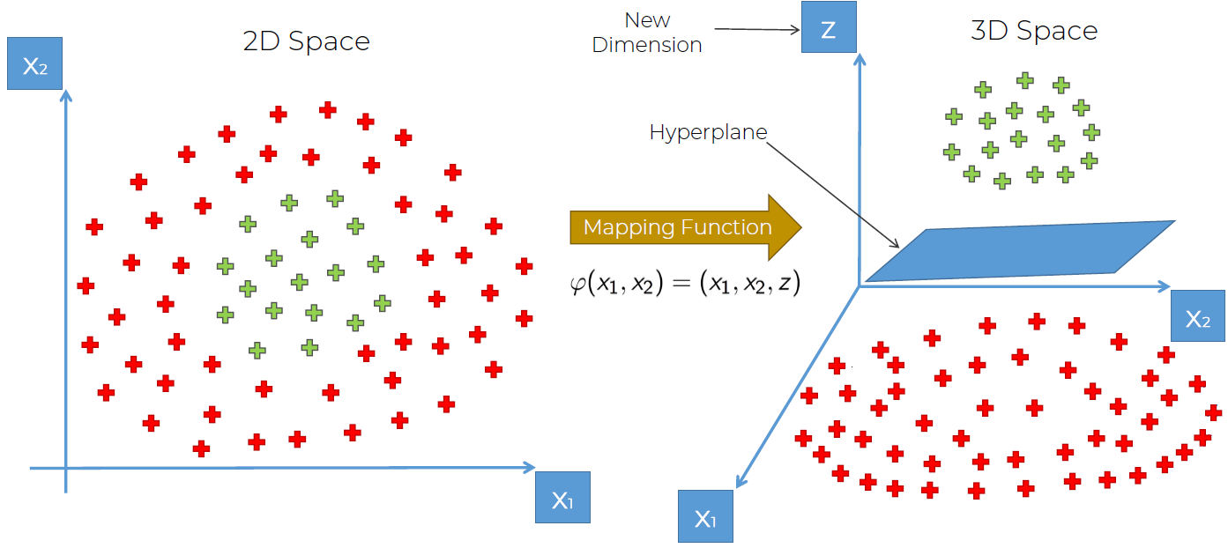

Mapping to a higher dimensional space can be highly compute-intensive.

**190. The Kernel Trick**

The Gaussian or the Radial Basis Function (RBF) Kernel

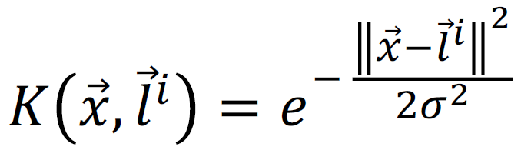

||x - l|| --> distance (module)

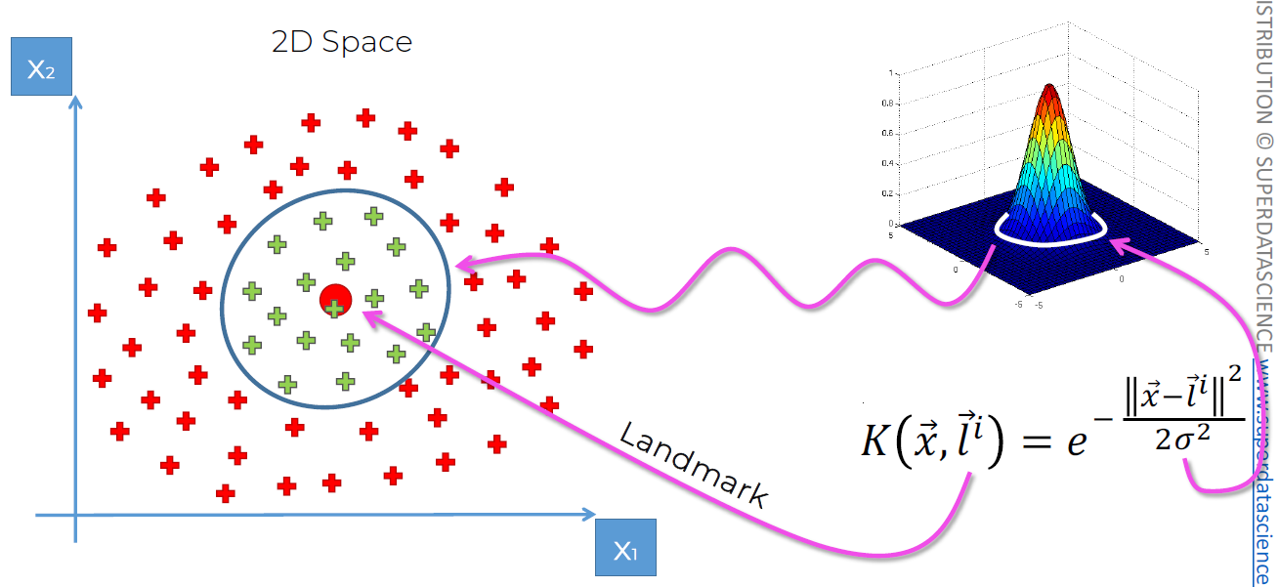

All the points inside the circumference will have a value above 0, the points outside the circumference will have a value very similar to 0.

Green: K(x,l) > 0  
Red: K(x, l) = 0

Increasing σ will increase the radio of the circumference.

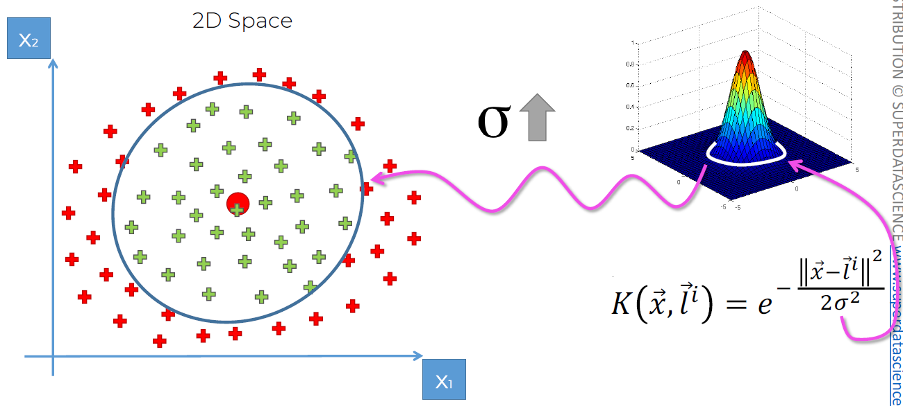

The point on doing the kernel function is that we don’t have to do the computations on a higher dimensional space, we can do them in the actual dimensional space.

**191. Types of Kernel Functions**

In this video we just show you that different types of kernel functions exist.

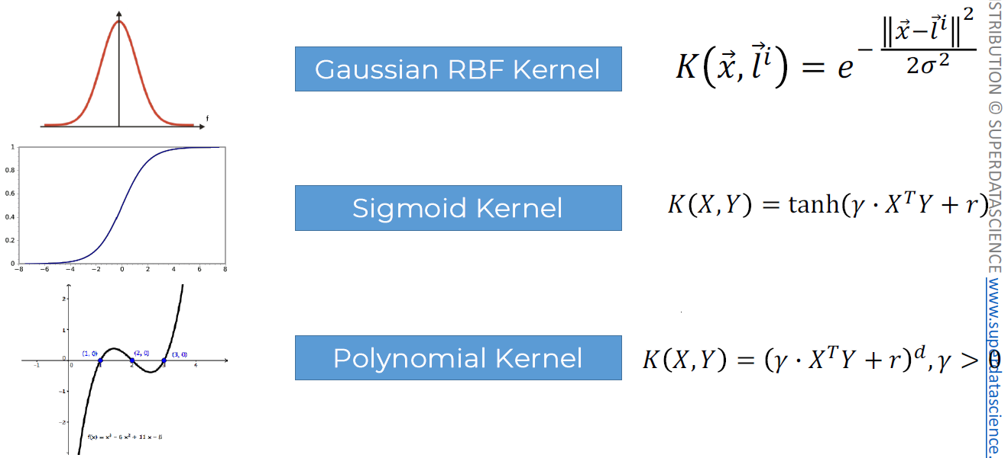

**192. Non-Linear Kernel SVR (Advanced)**

**Q:** How do we build a SVR fit into a nonlinear dataset?

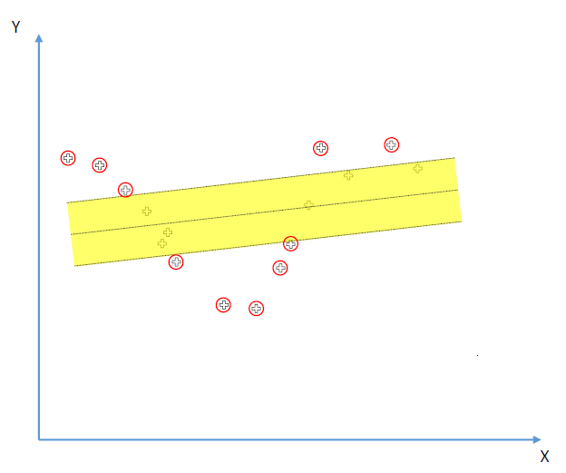

**A:** We need to go to a higher dimension and add a kernel function to parametrize it:

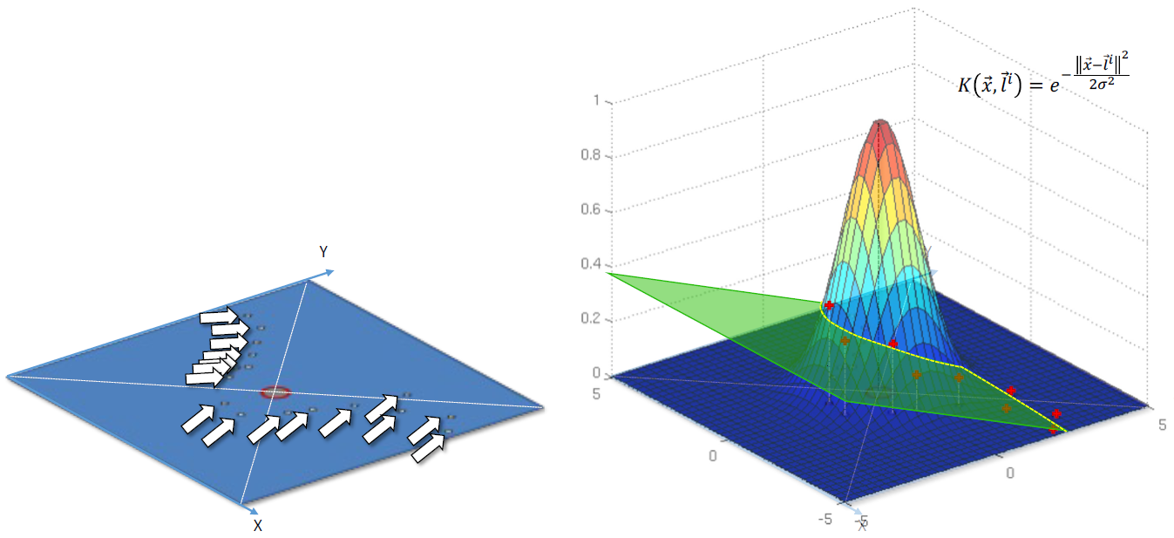

Instead of having an epsilon sensitive tube, we now have an epsilon sensitive space built with hyper planes: one is epsilon above and the other epsilon below.

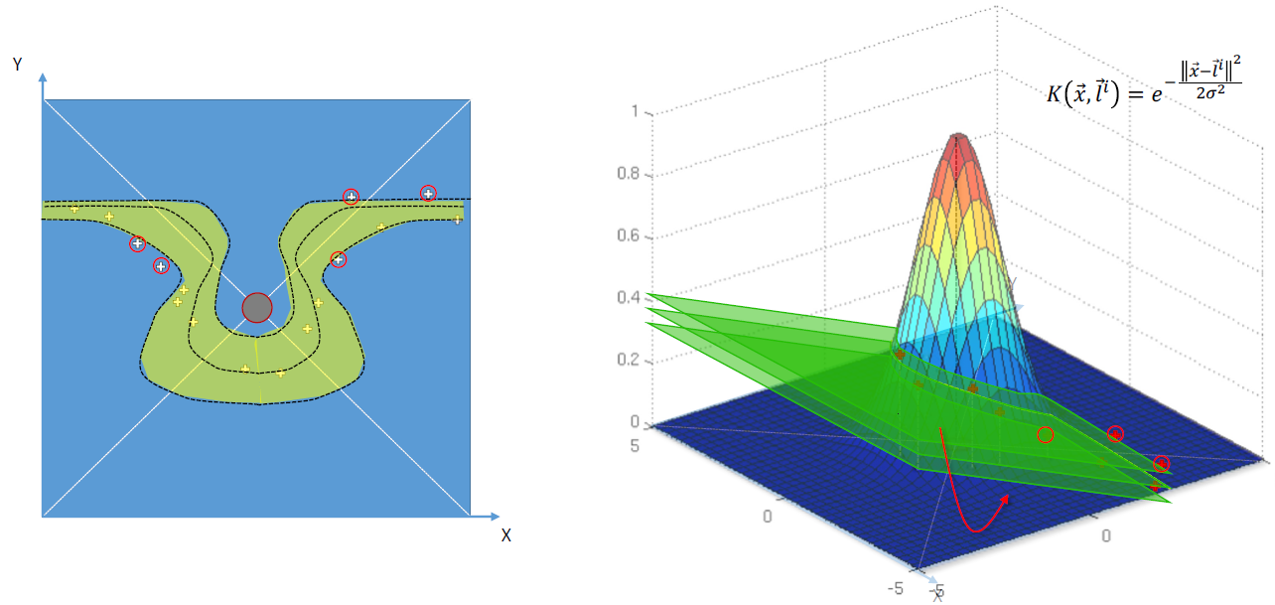

Remember that in reality, with the kernel trick, we don’t have to go to a higher dimension, we can make the computations in the lower one.

### **Section 20: Naive Bayes**

Relevant videos: 198, 199  
Interesting videos: 201  
Slides: 149-220

**198. Bayes Theorem**

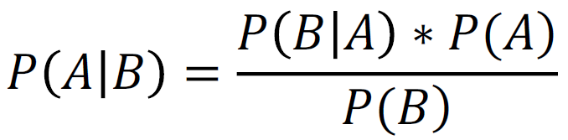

P(A|B) = P(B|A)*P(A)/P(B)

Wrenches (machine1 and machine2):

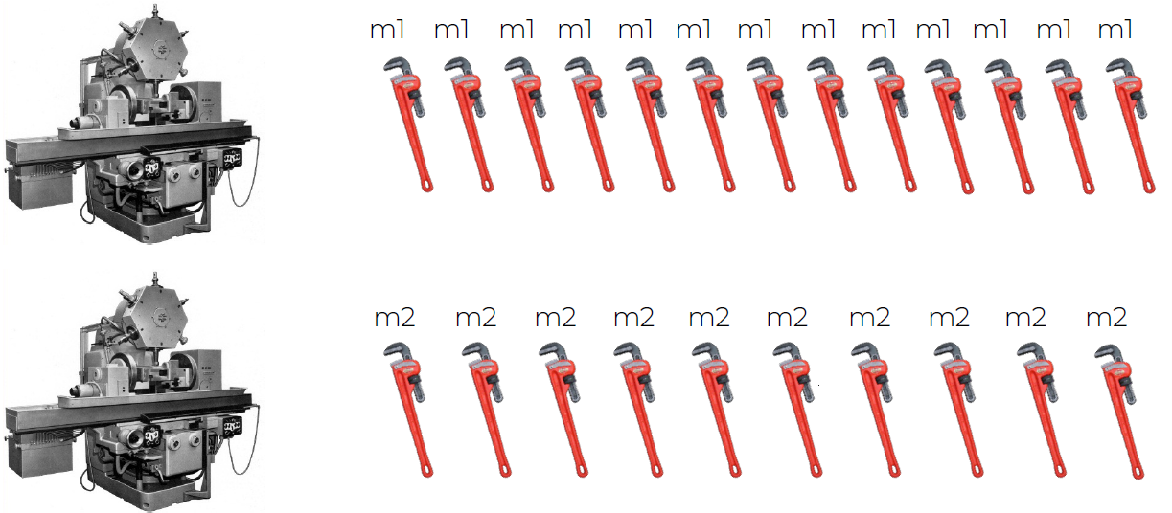

|  |  |
| --- | --- |
| Machine1: 30 wrenches/h | P(m1) = 30/50 = 0.6 |
| Machine2: 20 wrenches/h | P(m2) = 20/50 = 0.4 |
| Out of all the produced parts:  1% are defective | P(defect) = 1% = 0.01 |
| Out of all defective parts:  50% came from machine1  50% came from machine2  **P(mX/defect)**: probability that the part came from mX given  that it was defective. | P(m1/defect) = 50% = 0.5  P(m2/defect) = 50% = 0.5 |
| **P(defect/m2):** What is the probability that there is a defect  in a part produced by m2.  Probability that the part is defective given  that it comes from m2. | P(m2/defect)*P(defect)/P(m2) =  0.5*0.01/0.4 = 0.0125 = 1.25% |

**199. Naive Bayes Intuition**

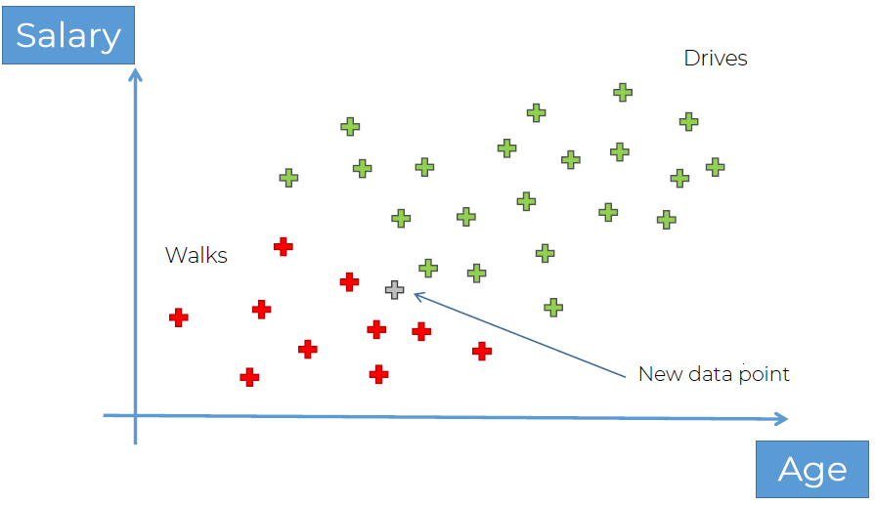

**Plan of Attack**:

**Step 1: P(Walks/X) -->** Probability that somebody walks given he has those features X.

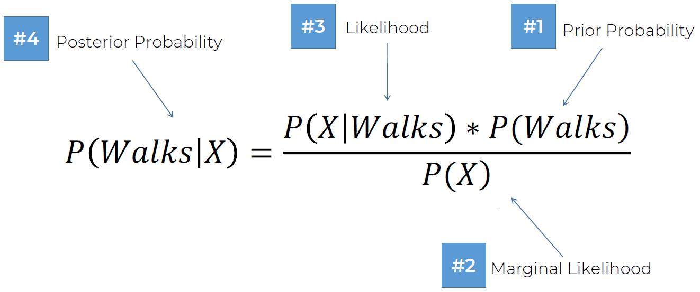

1. Prior probability: **P(Walks)**

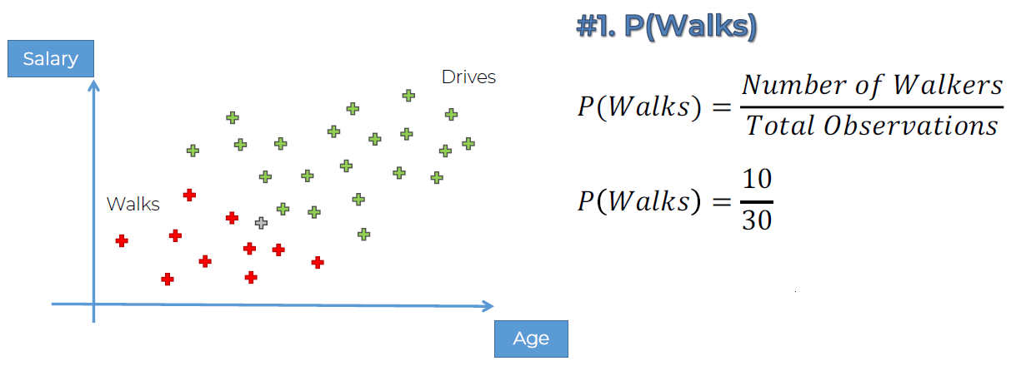

1. Marginal Likelihood: **P(X)**

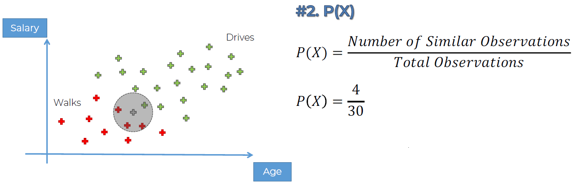

All the points inside the circle have similar characteristics X to the point we have chosen as the circle center. What is the likelihood of selecting a random point that it exhibits the characteristics of X?

1. Likelihood: **P(X|Walks)** **-->** Probability that somebody has the features X given that he walks.

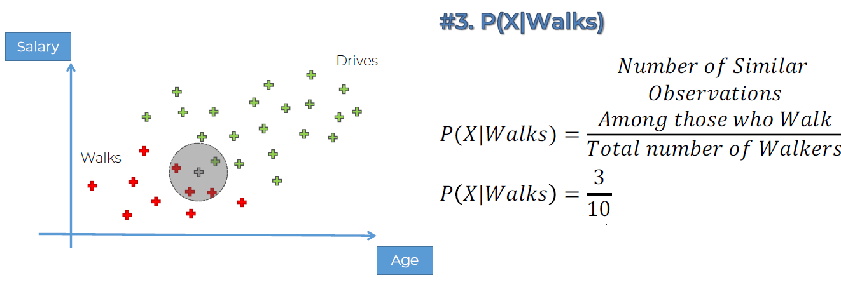

P(Walks|X) = P(X|Walks) * P(Walks) / P(X)

P(Walks|X) = (3/10) * (10/30) / (4/30) = 3/4 = 0.75 =75%

**Step 2: P(Drives/X) -->** Probability that somebody drives given that he has those features X.

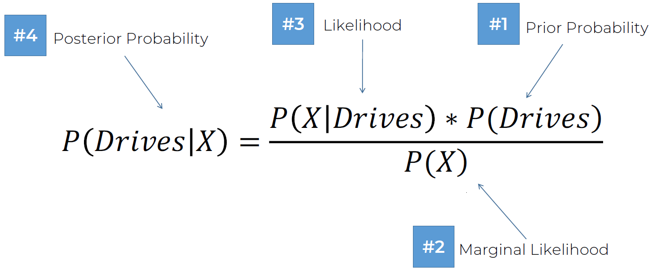

1. Prior probability: **P(Drives)** = 20/30  
   We suppose 20 green ones.
2. Marginal Likelihood: **P(X)** = 4/30
3. Likelihood: **P(X|Drives)** = 1/20 -->Probability that somebody has the features X given that he drives.

P(Drives|X) = P(X|Drives) * P(Drives) / P(X)

P(Drives|X) = (1/20) * (20/30) / (4/30) = 1/4 = 0.25 =25%

**Step 3: P(Walks/X) vs P(Drives/X)** --> 75% vs 25%

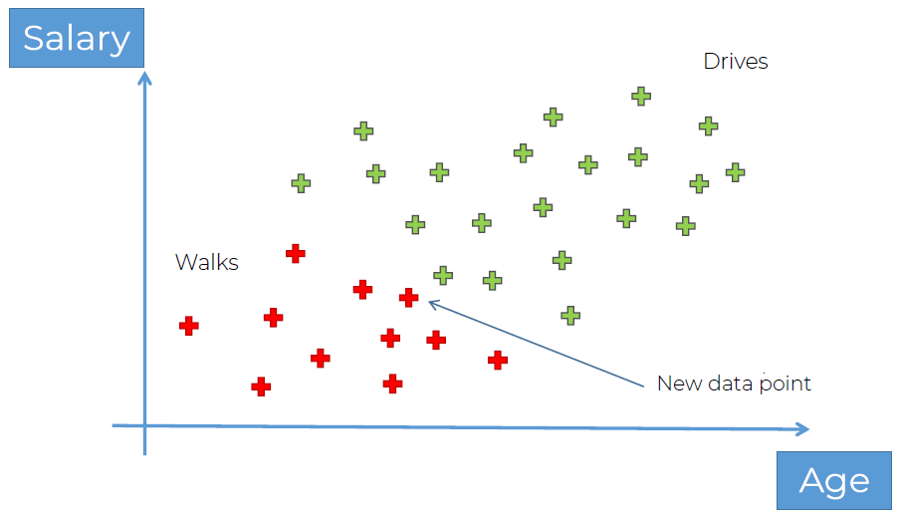

**201. Naive Bayes Intuition (Extras)**

It’s called naive because sometimes you don’t know if the variables or the features are not independent or completely independent.

Bayes theorem requires independence assumption which are sometimes incorrect, so it's seen as "naive"

Diego ha dicho que pase de todo esto y me meta al curso de coursera que me va a dar mucha mejor base.

Que termine de ver estas secciones:

Sección 38  
Sección 39  
Sección 44

Y a coursera!

20/12/2023 --> Vamos a continuar por donde lo dejamos y a ver qué tal

### **Section 21: Decision Tree Classification**

Relevant videos: -  
Interesting videos: 208

**208. Decision Tree Classification Intuition**

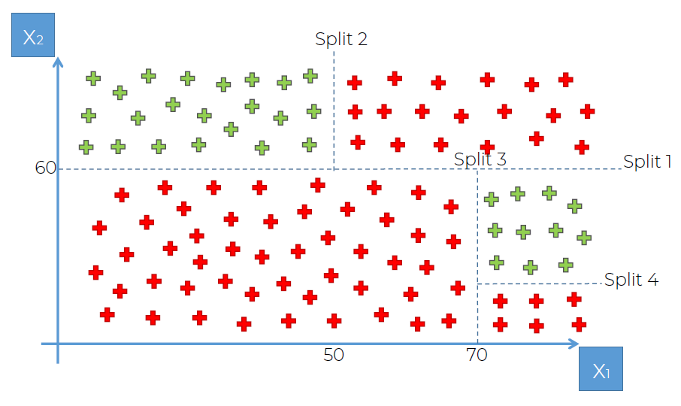

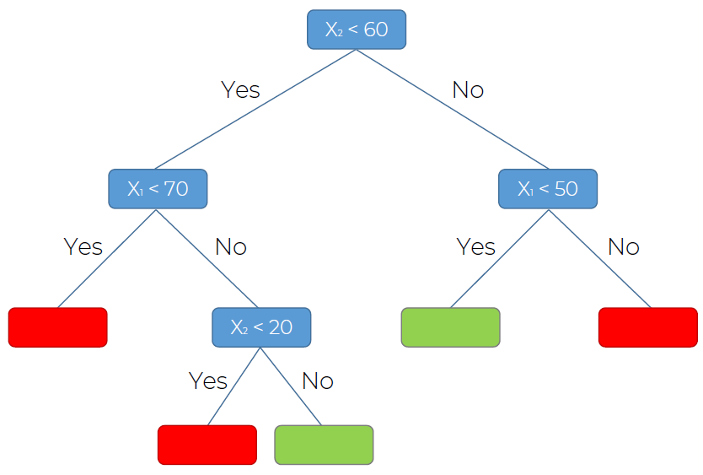

### **Section 22: Random Forest Classification**

Relevant videos: -  
Interesting videos: 214

**214. Random Forest Classification Intuition**

Ensemble Learning: when you take multiple ML algorithms and you put them together to create a bigger ML algorithm.

Step 1. Pick at random K data points from the Training set.  
Step 2. Build the Decision Tree associated to these K data points.  
Step 3. Choose the number Ntree of trees you want to build and repeat steps 1 & 2.  
Step 4. For a new data point, make each one of your Ntree trees predict the category to which the data points belongs, and assign the new data point to the category that wins the majority vote.

### **Section 23: Classification Model Selection in Python**

Relevant videos: -  
Interesting videos: -

Now we are finally going to get an answer to that ultimate question: How do I know which classification model to choose for a particular problem/dataset?

Well we are all going to answer this question together and to do this, I've prepared for you a folder containing all the classification code templates, and a generic real-world dataset which we will use to answer that question above.

**221. Confusion Matrix & Accuracy Ratios**

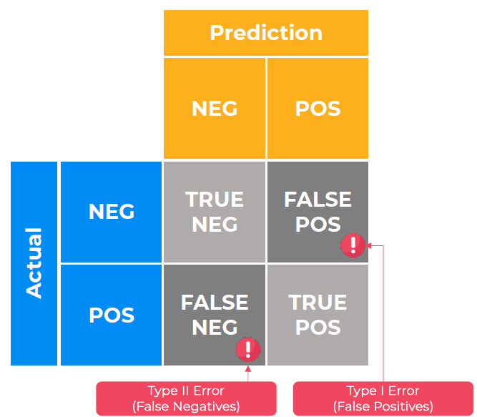

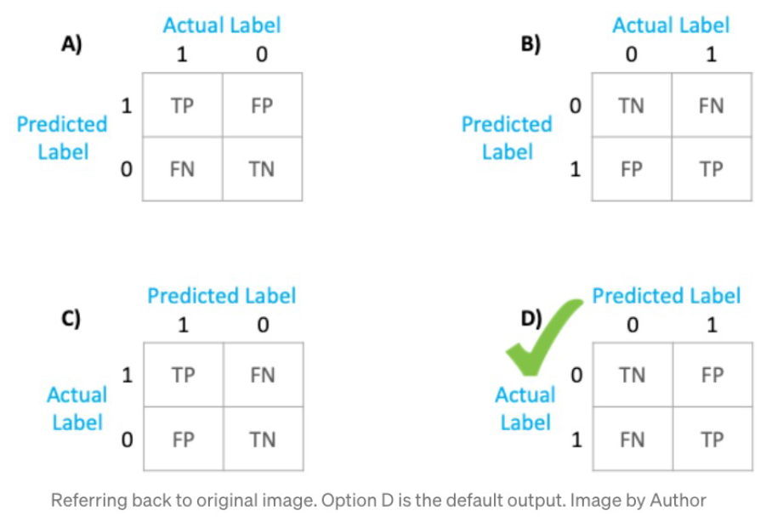

Link: <https://towardsdatascience.com/understanding-the-confusion-matrix-from-scikit-learn-c51d88929c79>

### **Section 24: Evaluating Classification Models Performance**

Relevant videos: -  
Interesting videos: -

**226. False Positives & False Negatives**

False positive (!+) --> Type I error: warning. E.g. Test says you are pregnant but in reality you are not.  
False negative (!-) --> Type II error: error. E.g. Test says you are not pregnant but in reality you are.

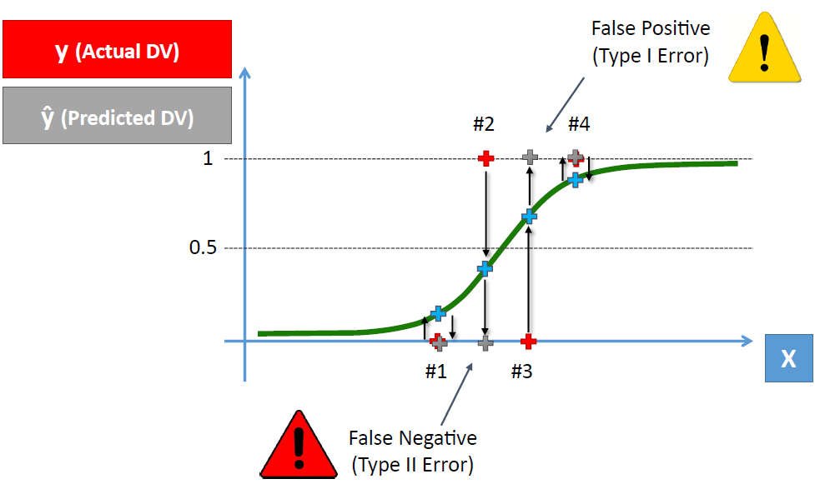

**228. Cumulative Accuracy Profile (CAP) Curve**

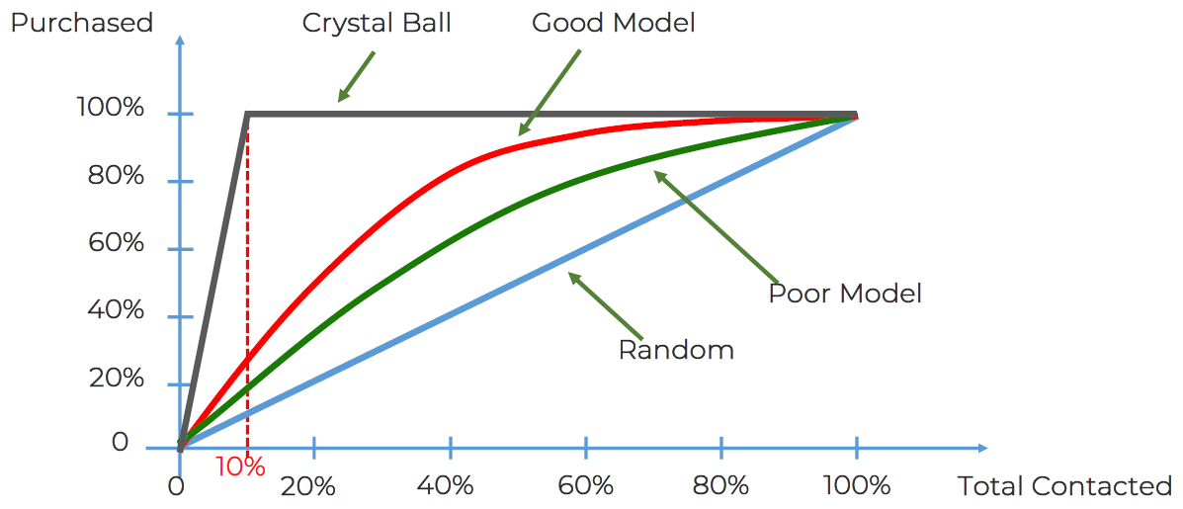

Crystall Ball (Perfect Model) > Good Model > Poor Model > Random

CAP (Cumulative Accuracy Profile): represents the cumulative number of positive outcomes along the y-axis versus the corresponding cumulative number of a classifying parameter along the x-axis.

ROC (Receiver Operating Characteristic): connects coordinate points with 1 – specificity (= false positive rate) as the x-axis and sensitivity as the y-axis at all cut-off values measured from the test results.

CAP != ROC: the ROC curve is similar to the CAP curve but whereas the CAP curve relates the hit rate to the rate of all alarms the ROC curve compares it with the rate of false alarms.

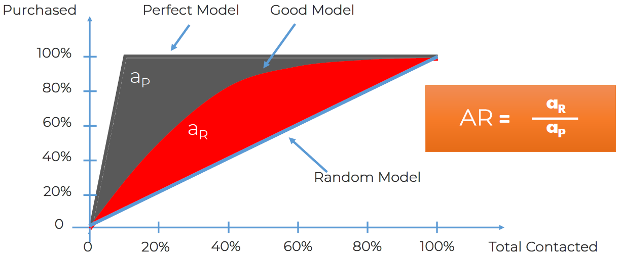

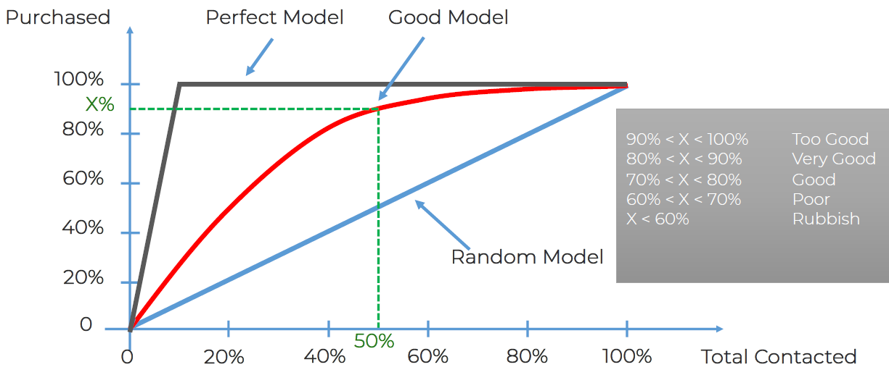

**230. Conclusion of Part 3 – Classification**

**Q: 1. What are the pros and cons of each model?**

Please find attached at the bottom of this article a cheat-sheet that gives you all the pros and the cons of each classification model. File: Classification_Pros_Cons.pdf

**Q: 2. How do I know which model to choose for my problem?**

Same as for regression models, you first need to figure out whether your problem is linear or non linear. You will learn how to do that in Part 10 - Model Selection. Then:

* If your problem is **linear**, you should go for Logistic Regression or SVM.
* If your problem is **non linear**, you should go for K-NN, Naive Bayes, Decision Tree or Random Forest.

Then which one should you choose in each case? You will learn that in Part 10 - Model Selection with k-Fold Cross Validation. Then from a business point of view, you would rather use:

* Logistic Regression or Naive Bayes when you want to rank your predictions by their probability. For example if you want to rank your customers from the highest probability that they buy a certain product, to the lowest probability. Eventually that allows you to target your marketing campaigns. And of course for this type of business problem, you should use Logistic Regression if your problem is linear, and Naive Bayes if your problem is non linear.
* SVM when you want to predict to which segment your customers belong to. Segments can be any kind of segments, for example some market segments you identified earlier with clustering.
* Decision Tree when you want to have clear interpretation of your model results.
* Random Forest when you are just looking for high performance with less need for interpretation.

**Q: 3. How can I improve each of these models ?**

Same answer as in Part 2:

In Part 10 - Model Selection, you will find the second section dedicated to Parameter Tuning, that will allow you to improve the performance of your models, by tuning them. You probably already noticed that each model is composed of two types of parameters:

* the parameters that are learnt, for example the coefficients in Linear Regression,
* the hyperparameters.

The hyperparameters are the parameters that are not learnt and that are fixed values inside the model equations. For example, the regularization parameter lambda or the penalty parameter C are hyperparameters. So far we used the default value of these hyperparameters, and we haven't searched for their optimal value so that your model reaches even higher performance. Finding their optimal value is exactly what Parameter Tuning is about. So for those of you already interested in improving your model performance and doing some parameter tuning, feel free to jump directly to Part 10 - Model Selection.

## **Section 25: Part 4: Clustering**

Clustering is similar to classification, but the basis is different. In Clustering you don’t know what you are looking for, and you are trying to identify some segments or clusters in your data. When you use clustering algorithms on your dataset, unexpected things can suddenly pop up like structures, clusters and groupings you would have never thought of otherwise.

In this part, you will understand and learn how to implement the following Machine Learning Clustering models:

* K-Means Clustering
* Hierarchical Clustering

### **Section 26: K-Means Clustering**

Relevant videos: -  
Interesting videos: 232, 233

**232. What is Clustering? (Supervised vs Unsupervised Learning)**

Clustering can be defined as grouping unlabeled data.

**Supervised learning**: you give the model an opportunity to train where it has the answers.  
**Unsupervised learning**: you don’t have the answers to supply to the model.

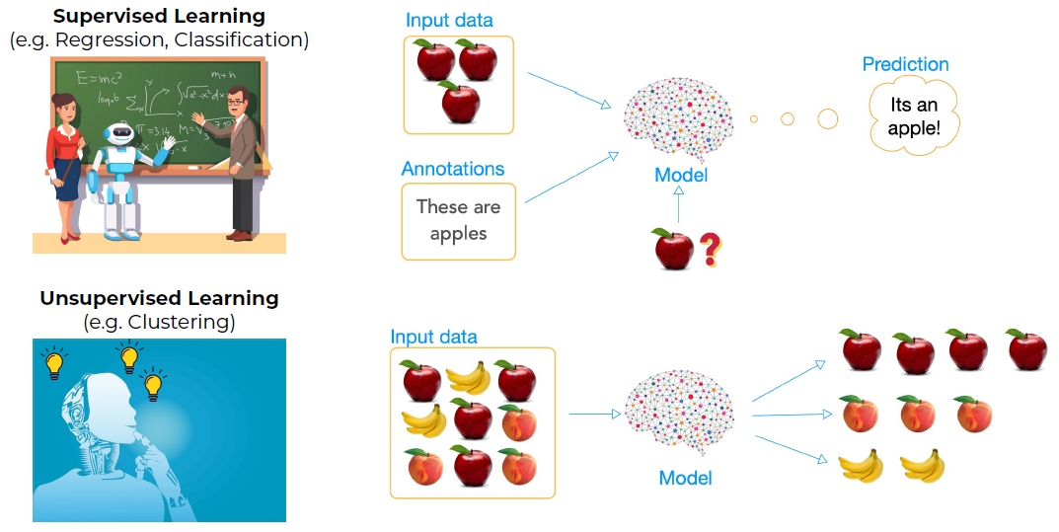

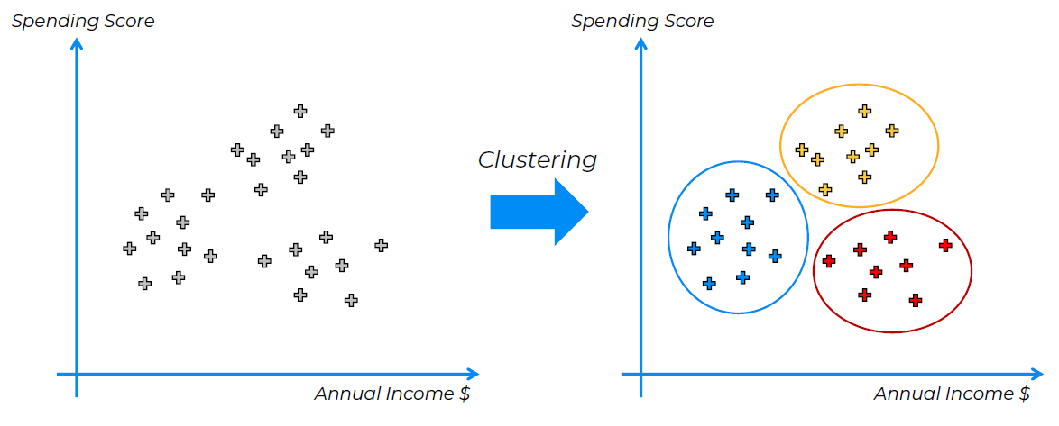

**233. K-Means Clustering Intuition**

You put centroids and then you group the points nearby with the "gravity pull" from the centroid.

1. Calculate the center of mass of the points
2. Draw the dividing line
3. Reassign the points to the closest centroid
4. Go back to step 1)

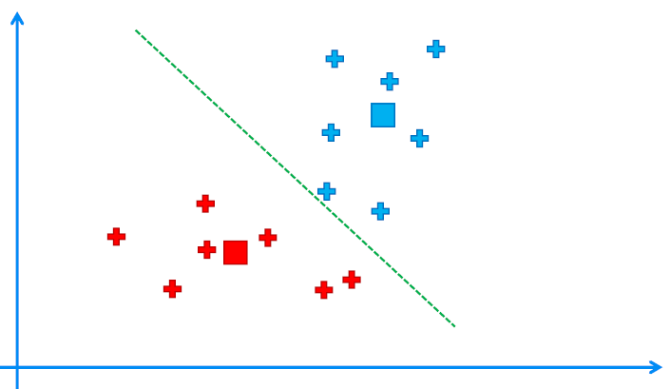 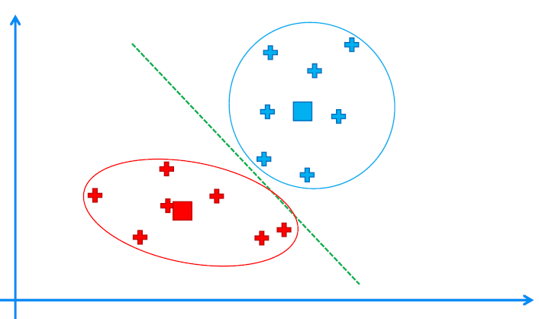

**234. The Elbow Method**

Within Cluster Sum of Squares:

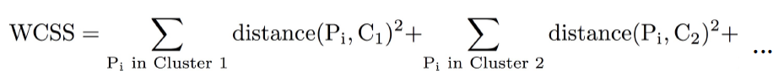

The more clusters you have, the smaller the CSS will be:

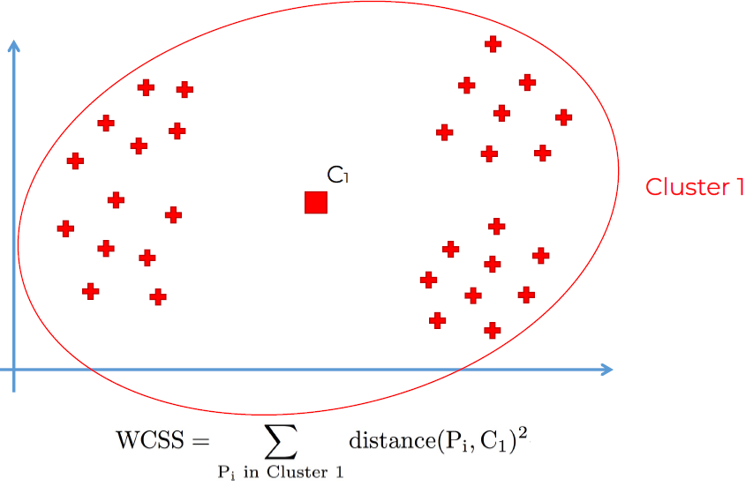

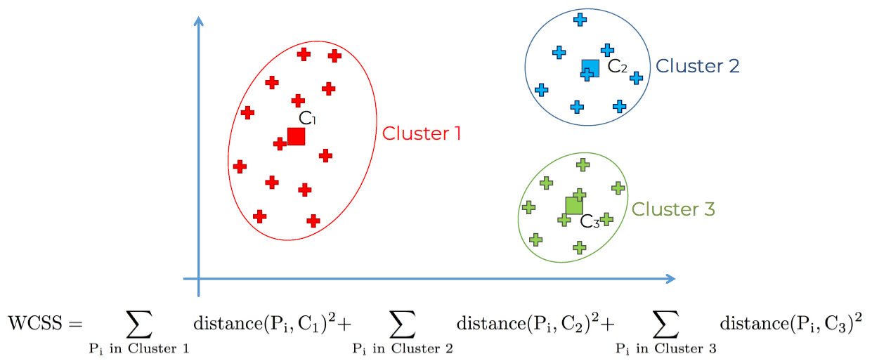

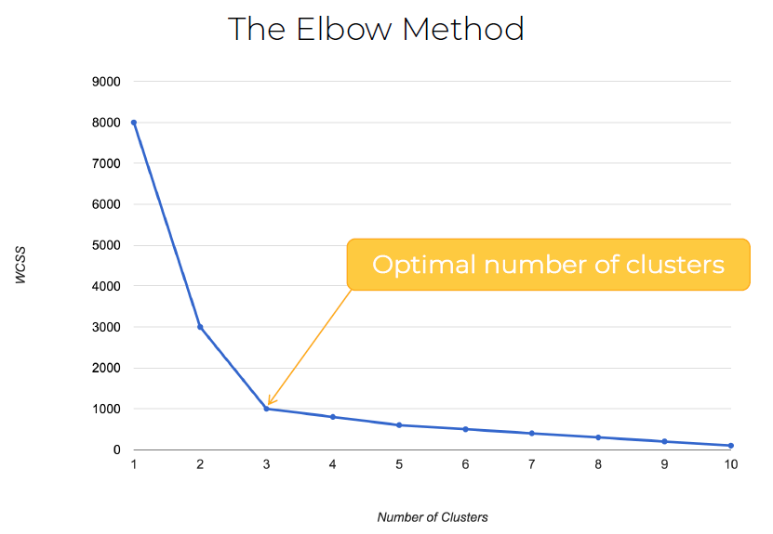

**235. K-Means++**

Step 1. Choose 1st centroid at random among data points.  
Step 2. For each of the remaining data points compute the distance (D) to the nearest out of already selected centroids.  
Step 3. Choose next centroid among remaining data points using weighted random selection, weighted by D^2.  
Step 4. Repeat steps 2 and 3 until all k centroids have been selected.  
Step 5. Proceed with standard k-means clustering.

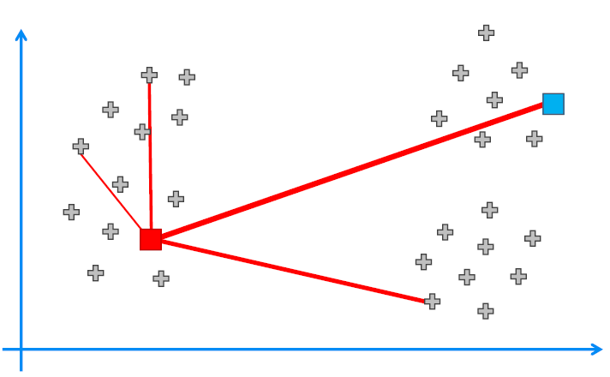

### **Section 27: Hierarchical Clustering**

Relevant videos: -  
Interesting videos: 249

**249. Hierarchical Clustering Intuition**

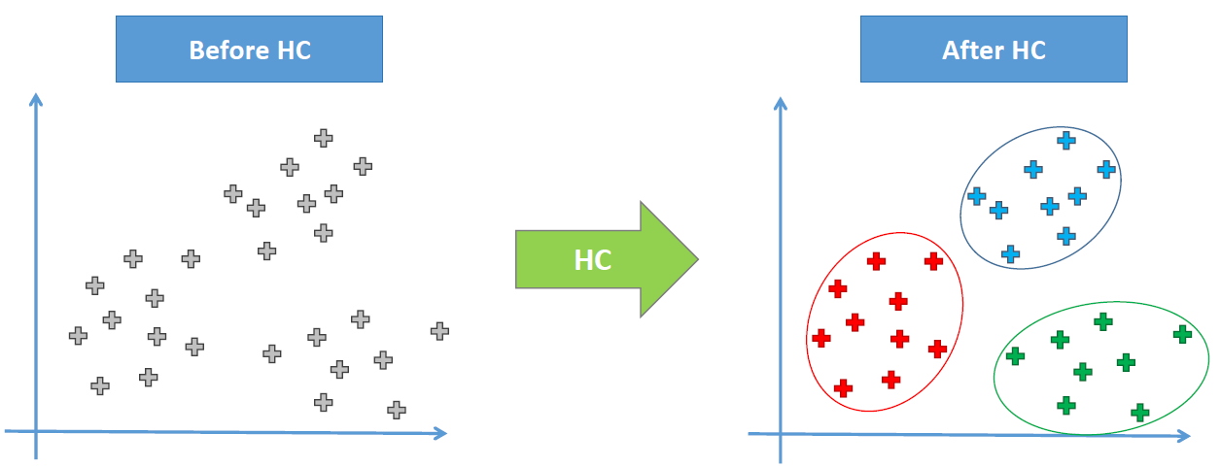

Agglomerative HC:

**STEP 1**: Make each data point a single-point cluster --> That forms N clusters.  
**STEP 2**: Take the two closest data points and make them one cluster --> That forms N – 1 clusters.  
**STEP 3**: Take the two closest clusters and make them one cluster --> That forms N – 2 clusters.  
**STEP 4**: Repeat STEP 3 until there is only one cluster.

Distance between 2 Clusters:

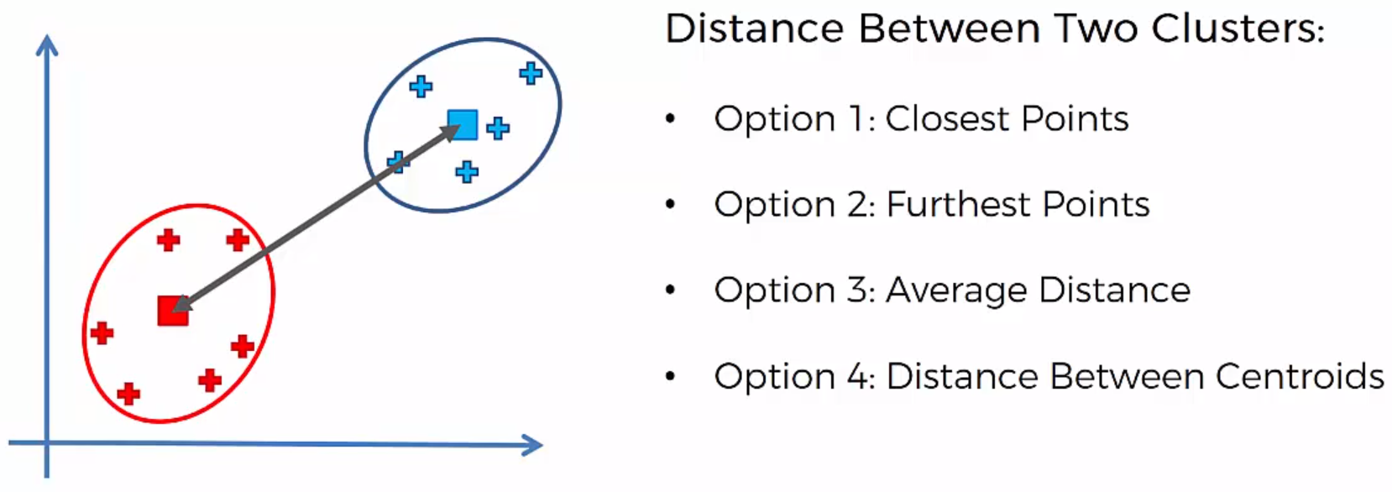

The way the hierarchichal clustering algorithm works is that it maintains a memory of how we went through this process.

**250. Hierarchical Clustering How Dendrograms Work**

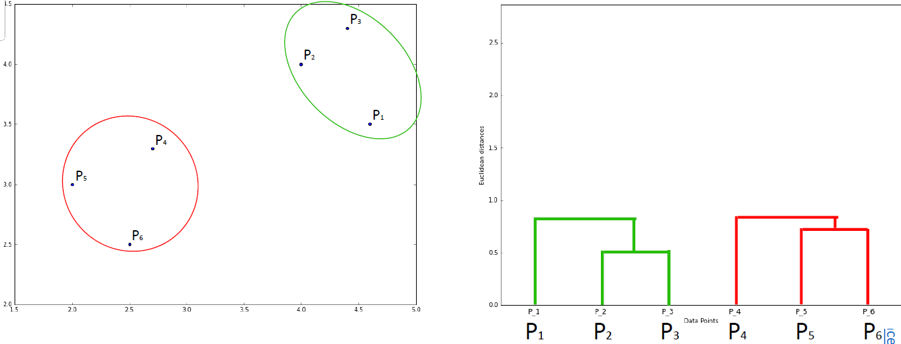

**251. Hierarchical Clustering Using Dendrograms**

4 clusters: the line cuts 4 times:

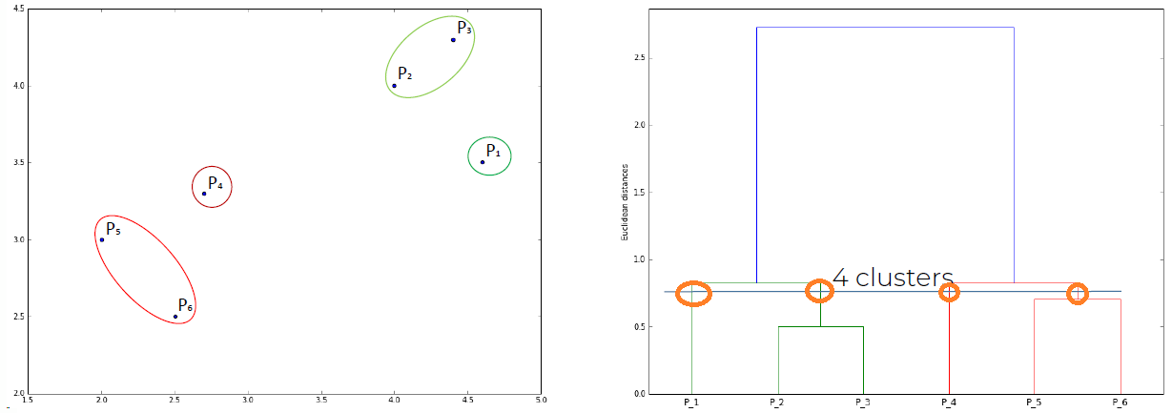

6 clusters: the line cuts 6 times:

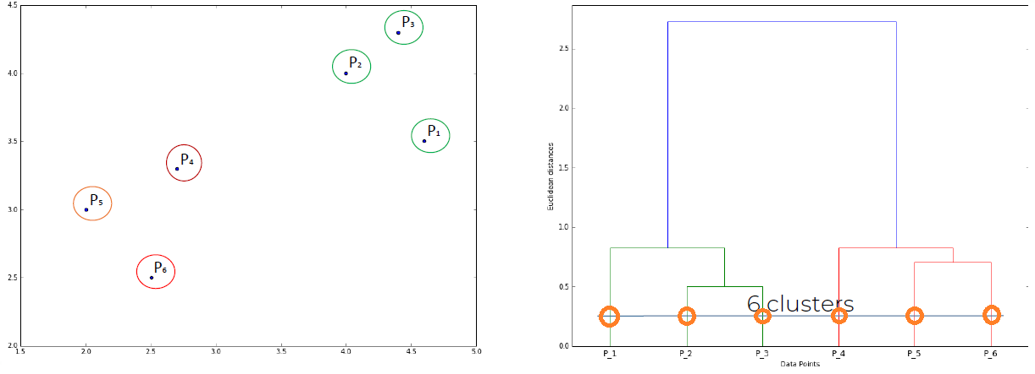

**Q:** Is the dendogram giving us any clues on how many number of clusters should we have?  
**A:** The standard approach is to look for the higher vertical distance that we can find on the dendogram that doesn’t cross an horizontal line. You go from an horizontal line onto the next horizontal line.

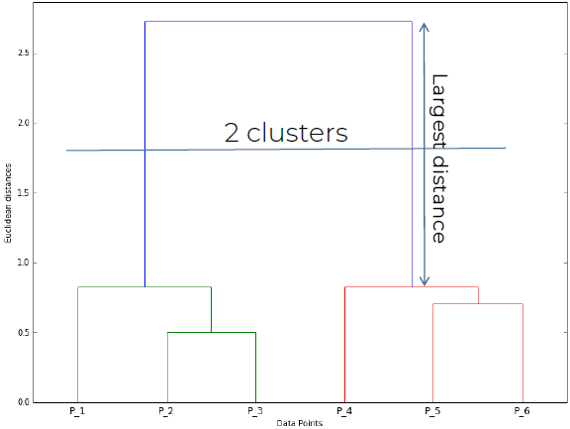

**263. Conclusion of Part 4 – Clustering**

C:\Users\AlejandroDiezRedondo\Desktop\Machine Learning A-Z\Materials\Clustering-Pros-Cons.pdf

## **Section 28: Part 5: Association Rule Learning**

**264. Welcome to Part 5 - Association Rule Learning**

In this part, you will understand and learn how to implement the following Association Rule Learning models:

1. A priori
2. Eclat

### **Section 29: Apriori**

Relevant videos: 265,  
Interesting videos: -

**265. Apriori Intuition**

A priori intuition is about: people who bought something also bought something.   
E.g. people who bought diapers between 18:00-21:00 also bought beers (this is a real case).

We want to find the very strong "correlations".

A priori algorithm has 3 parts: support, confidence and the lift.

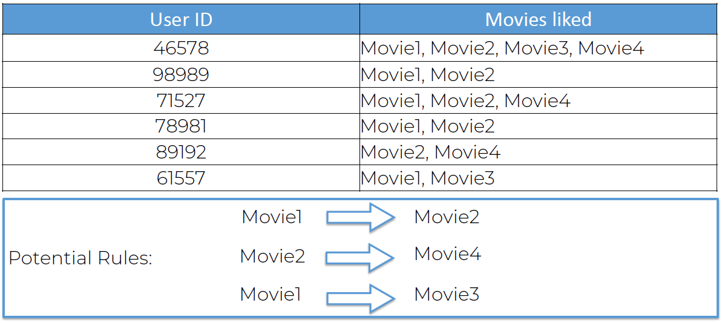

1. Support

Support = nº of users who watched movie Interestellar (M) / total nº of users  
Support = 10/100 = 10%

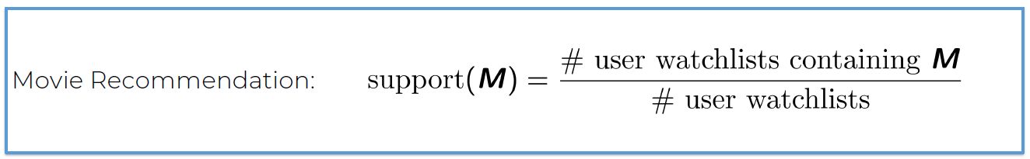

1. Confidence

How many people that have seen Interestellar (40), have seen Ex-Machina (7)?  
Confidence = 7/40 = 17.5%

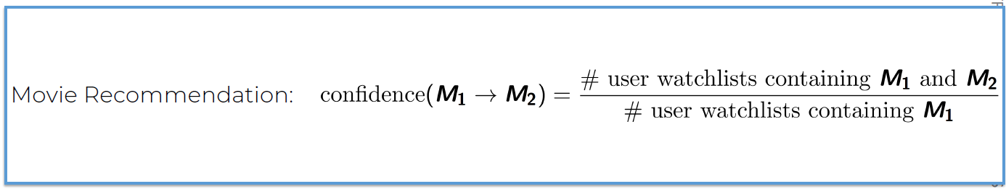

1. Lift

Lift = 17.5%/10% = 1.75



A priori Algorithm steps:

1. Set a minimum support and confidence
2. Take all the subsets in transactions having higher support than minimum support
3. Take all the rules of these subsets having higher confidence than minimum confidence
4. Sort the rules by decreasing lift

### **Section 30: Eclat**

Relevant videos: 273  
Interesting videos: -

**273. Eclat Intuition**

In the Eclat model we only have support.

Steps:

1. Set a minimum support
2. Take all the subsets in transactions having higher support than minimum support
3. Sort these subsets by decreasing support

## **Section 31: Part 6: Reinforcement Learning**

Reinforcement Learning is a powerful branch of Machine Learning. It is used to solve interacting problems where the data observed up to time t is considered to decide which action to take at time t + 1. It is also used for Artificial Intelligence when training machines to perform tasks such as walking. Desired outcomes provide the AI with reward, undesired with punishment. Machines learn through trial and error.

In this part, you will understand and learn how to implement the following Reinforcement Learning models:

* Upper Confidence Bound (UCB)
* Thompson Sampling

Also, a great complementary resource for this chapter is the following book (you will recognize the author):

Book: **AI Crash Course: A fun and hands-on introduction to machine learning, reinforcement learning, deep learning, and artificial intelligence with Python by Hadelin de Ponteves**

In this book you will find the theory of Reinforcement Learning and Thompson Sampling clearly explained in text, as well as many more practical activities. It will definitely help you understand this chapter better. You will also find other AI models such as Q-Learning, Deep Learning, Deep Q-Learning, Deep Convolutional Q-Learning, and Convolutional Neural Networks.

### **Section 32: Upper Confidence Bound (UCB)**

Relevant videos: -  
Interesting videos: 277, 278  
Slide: 352

**277. The Multi-Armed Bandit Problem**

Multi-armed bandig: is a slot machine.



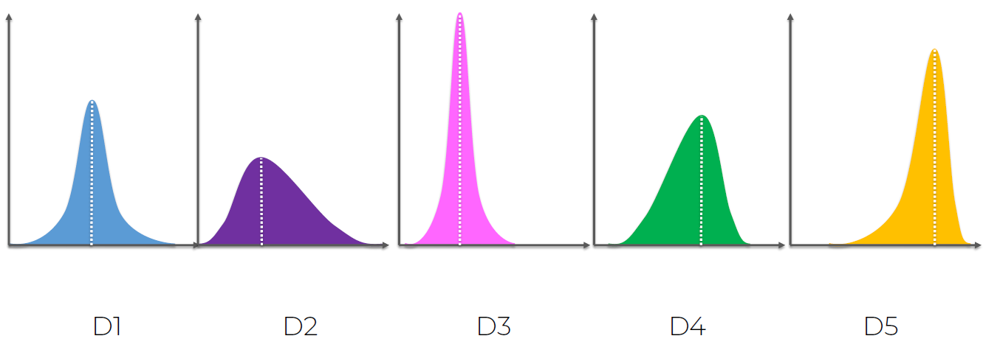

D5 is the optimal machine, it has the best return (x axis intersection). It’s the most left skewed because it tails on the left. It’s got the most favorable outcomes, it’s got the highest mean, median and mode.

There are 2 factors in play: exploration and exploitation. Explore the machines to see which one is the best one and exploit the machines as soon as you find a good one to maximize the returns.

There is a paper on regret: "Using Confidence Balance for Exploitation and Exploration of trade offs" by Peter Auer.

Whenever you use a non-optimal machine you have regret: difference between the optimal machine vs actual machine.

The most common modern application of this that we can think of is advertising. You have to find the best one before the campaign launches over, not after, not during, that’s the challenge.

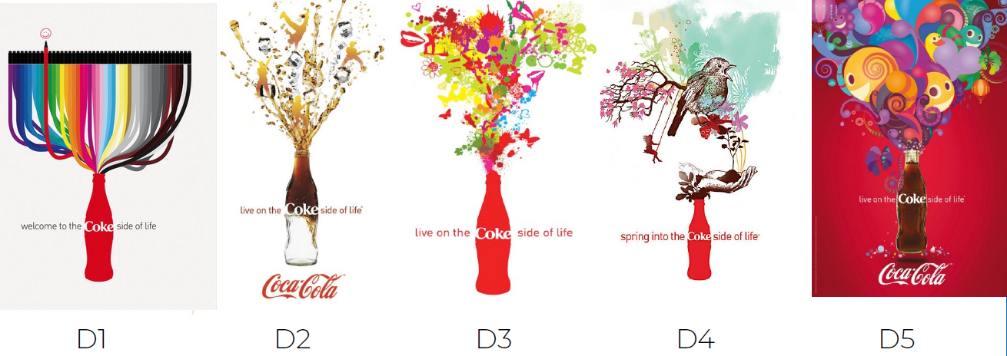

**278. Upper Confidence Bound (UCB) Intuition**

You combine exploration with exploitation, you discover which is the best machine and then exploit it.

Summary of the multi-armed bandit problem:

* We have d arms. For example, arms are ads that we display to users each time they connect to a web page.
* Each time a user connects to this web page, that makes a round.
* At each round n, we choose one ad to display to the user.
* At each round n, ad i gives reward r_i(n) belongs to {0, 1}: r_i(n) = 1 if the user clicked on the ad i, 0 if the user didn’t
* Our goal is to maximize the total reward we get over many rounds.

***Starting situation***: the confidence band (gray area) is designed in such a way that it will include the actual expected return (red line).

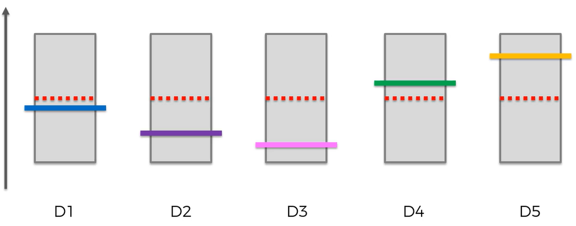

***Ending situation:*** after building up the sample size.

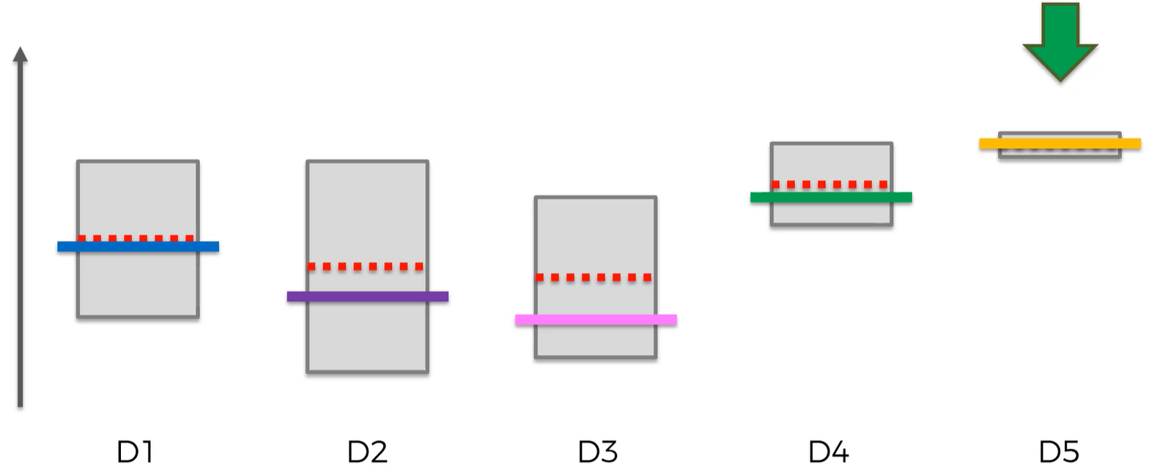

**UCB algorithm:**

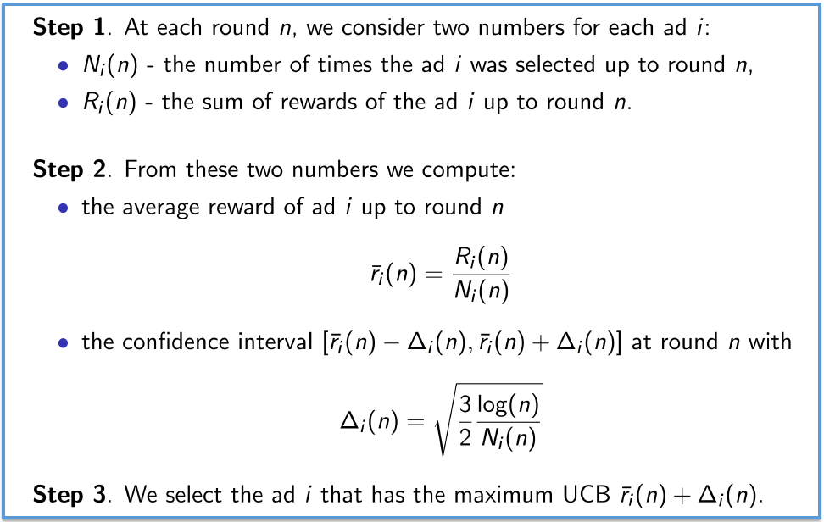

**279. Upper Confidence Bound in Python - Step 1**

It is one of the most exciting branches of ML because it is the one closest to artificial intelligence, we’re making some programs that play some actions just like a robot. So, this is very exciting, "this is one of my favorite branches if not the nº1. So, I'm so excited right now to teach you about the fundamentals of reinforcement learning, and specially I'm so excited to implement 2 of the best reinforcement learning models with you: UCB and Thompson Sampling."

### **Section 33: Thompson Sampling**

Relevant videos: -  
Interesting videos: 290, 291  
Slides: 402

**290. Thompson Sampling Intuition**

We are going to use this algorithm to solve the multi-armed bandit problem (again).

Multi-armed bandig: is a slot machine.



Summary of the multi-armed bandit problem:

* We have d arms. For example, arms are ads that we display to users each time they connect to a web page.
* Each time a user connects to this web page, that makes a round.
* At each round n, we choose one ad to display to the user.
* At each round n, ad i gives reward r_i(n) belongs to {0, 1}: r_i(n) = 1 if the user clicked on the ad i, 0 if the user didn’t
* Our goal is to maximize the total reward we get over many rounds.

Bayesian inference: we are not going to go deep into this math rn

Thompson Sampling Algorithm:

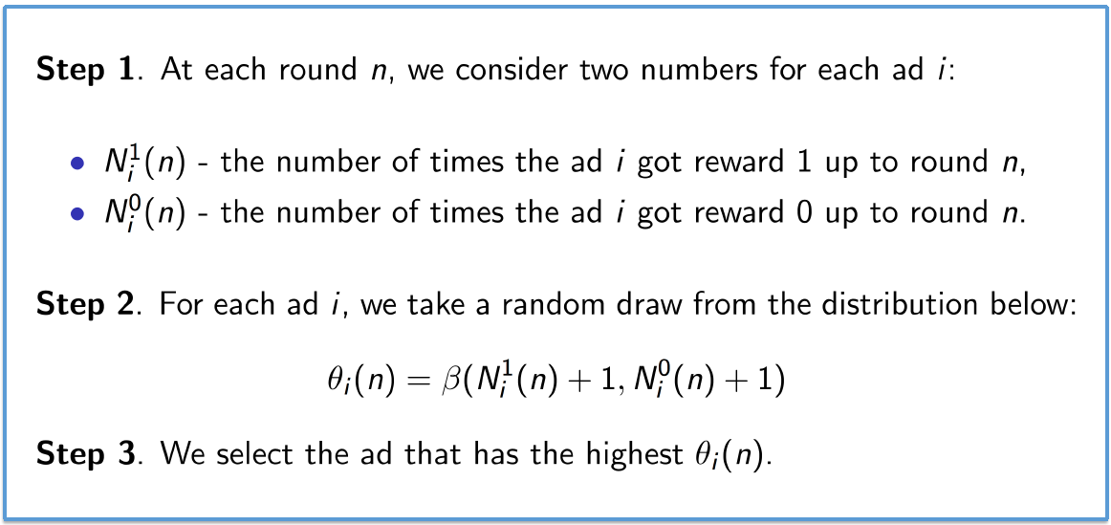

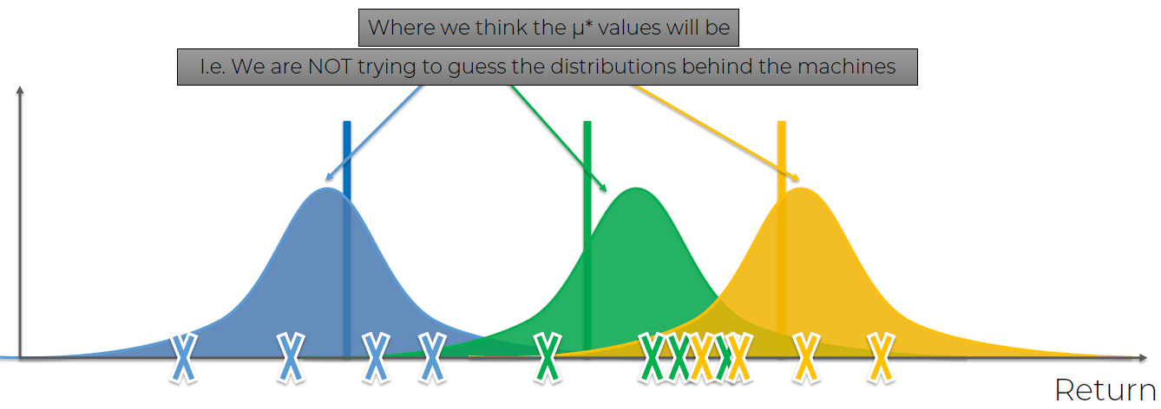u* es donde creemos que esta el palito (el máximo de la distribución), que podría estar a lo largo de toda la distribución.

Es un algoritmo probabilístico, el anterior, UPB (Upper Confidence Bound) era determinístico.

Con 3 valores podemos generar nuestra propia bandit configuration, cogeriamos la X que se encuentra más a la derecha porque nos garantiza el mayor retorno.

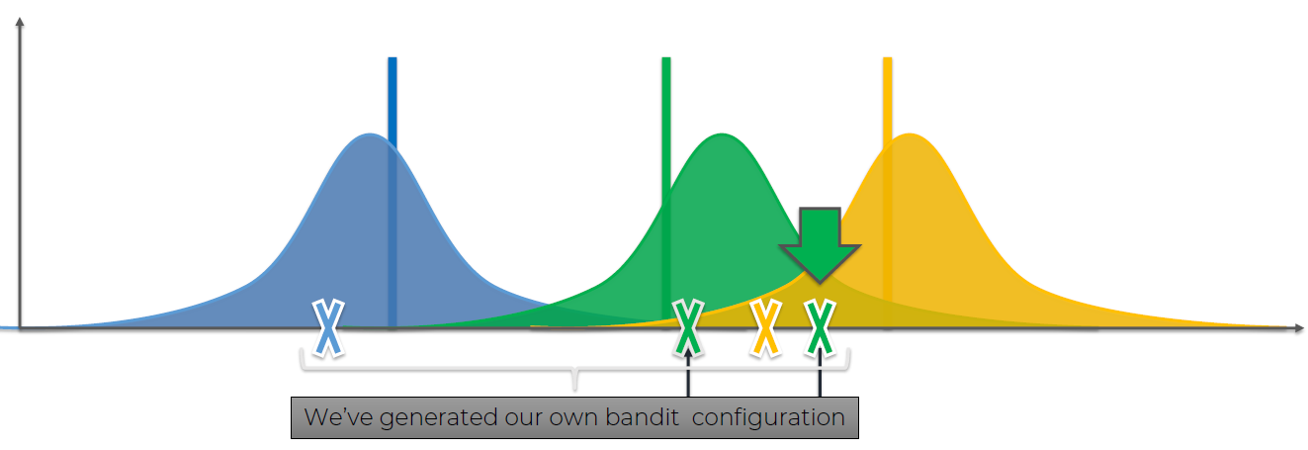

**291. Algorithm Comparison: UCB vs Thompson Sampling**

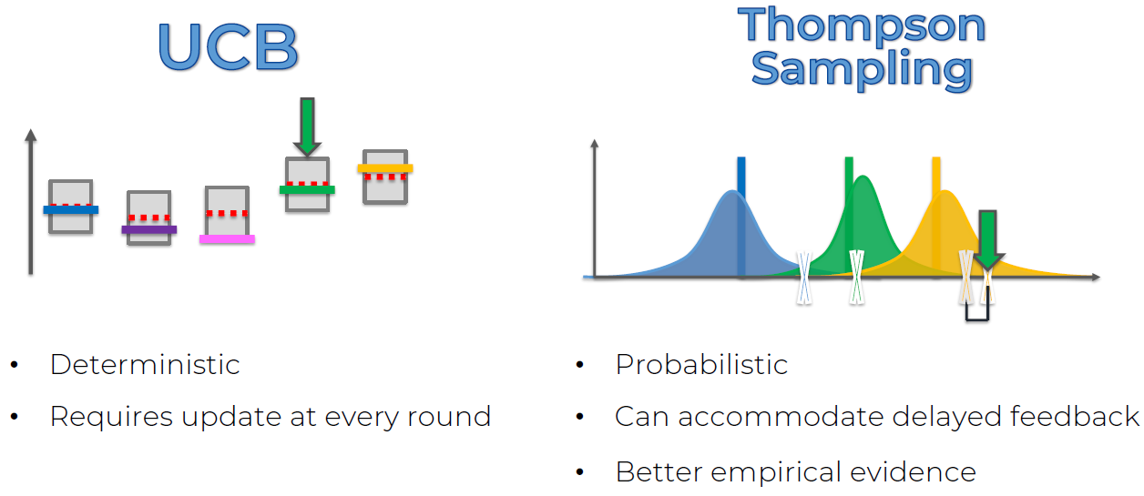

|  |  |
| --- | --- |
| **UCB** | **Thompson Sampling** |
| * Deterministic | * Probabilistic |
| * Requires update at every round | * Can accommodate delayed feedback |
|  | * Better empirical evidence |

**296. Additional Resource for this Section**

Hello my friends,

If you want the full explanation of this same practical activity in a book, then my “AI Crash Course” book might be helpful to you. It contains all the theory of Thompson Sampling including the math explained in details, plus the whole same case study where each line of code is explained step by step. And of course if you like Reinforcement Learning and want to study it in more depth, you will find in this same book some other Reinforcement Learning models such as Q-Learning, Deep Learning, Deep Q-Learning, Convolutional Neural Networks and Deep Convolutional Q-Learning.

Check it out below if you feel this can help:

Amazon US:

<https://www.amazon.com/Crash-Course-hands-introduction-reinforcement-ebook/dp/B07Z9DC228/ref=sr_1_1?dchild=1&keywords=ai+crash+course&qid=1590262315&sr=8-1>

## **Section 34: Part 7: Natural Language Processing**

Relevant videos: -  
Interesting videos: 300, 301, 302, 303  
Slides: 424

Natural Language Processing (or NLP) is applying Machine Learning models to text and language. Teaching machines to understand what is said in spoken and written word is the focus of Natural Language Processing. Whenever you dictate something into your iPhone / Android device that is then converted to text, that’s an NLP algorithm in action.

You can also use NLP on a text review to predict if the review is a good one or a bad one. You can use NLP on an article to predict some categories of the articles you are trying to segment. You can use NLP on a book to predict the genre of the book. And it can go further, you can use NLP to build a machine translator or a speech recognition system, and in that last example you use classification algorithms to classify language. Speaking of classification algorithms, most of NLP algorithms are classification models, and they include Logistic Regression, Naive Bayes, CART which is a model based on decision trees, Maximum Entropy again related to Decision Trees, Hidden Markov Models which are models based on Markov processes.

A very well-known model in NLP is the Bag of Words model. It is a model used to preprocess the texts to classify before fitting the classification algorithms on the observations containing the texts.

**In this part, you will understand and learn how to:**

1. Clean texts to prepare them for the Machine Learning models,
2. Create a Bag of Words model,
3. Apply Machine Learning models onto this Bag of Worlds model.

**300. NLP Intuition**

What we will learn:

* Types of Natural Language Processing
* Classical vs Deep Learning Models
* End-to-end DL Models
* Bag-Of-Words

We will NOT talk about Seq2Seq or ChatBots

**301. Types of Natural Language Processing**

Green: NLP  
Blue: DL  
Purple: DNLP

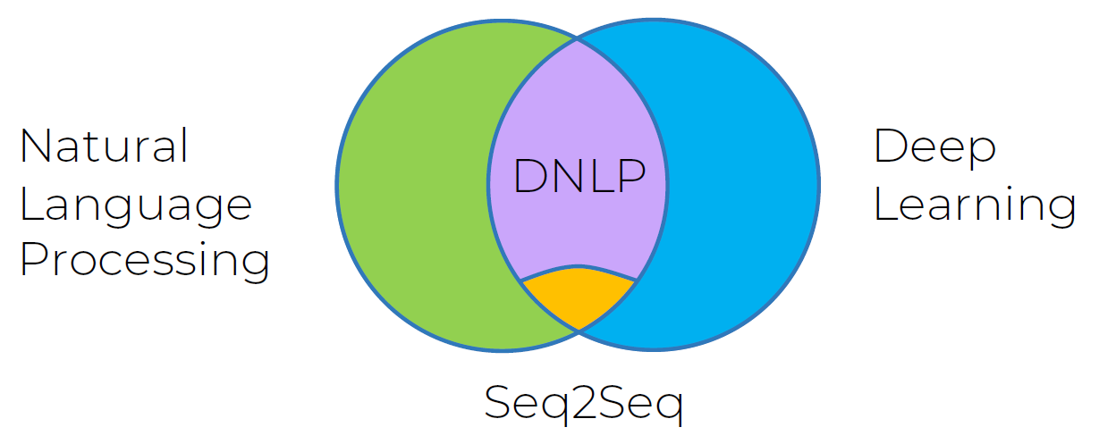

**302. Classical vs Deep Learning Models**

Examples:

1. If/Else Rules (is the origin of Chatbot) (NLP)
2. Audio frequency components analysis (Speech Recognition) (NLP)
3. Bag-of-words model (Classification) (NLP)
4. CNN (Convolutional Neural Network) for text Recognition (Classification) (DNLP)
5. Seq2Seq (many applications) (Seq2Seq)

**303. Bag-Of-Words Model**

The 1st model we are going to create is one that does yes/no responses.

Adult native test-takers range from 20.000 - 35.000 words. So we will make a vector that is 20.000 elements long:

[0, 0, 0, 0, 0, 0, 0, 0, 0, 0, 0, 0, 0, 0, 0, ... , 0]

1st element is reserved for SOS: Start Of Sentence  
2nd element is reserved for EOS: End Of Sentence  
Last element is reserved for: Special Words: e.g. names

We convert a sentence into a vector of words:

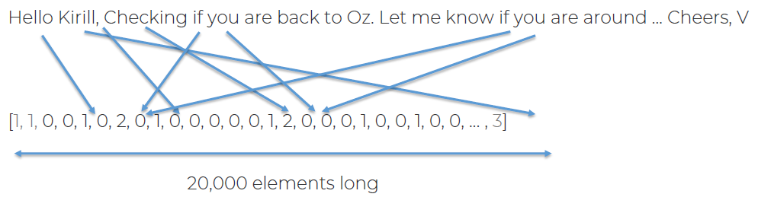

Training data:  
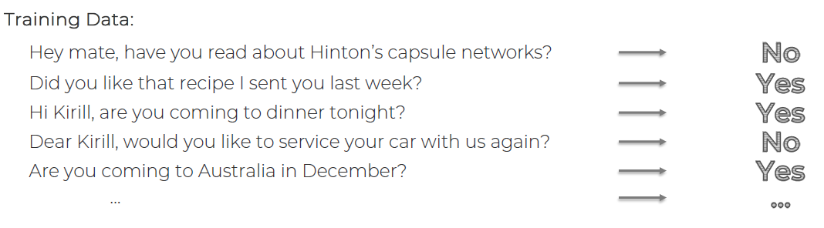

Training data converted to vectors, each 20.000 elements long:  
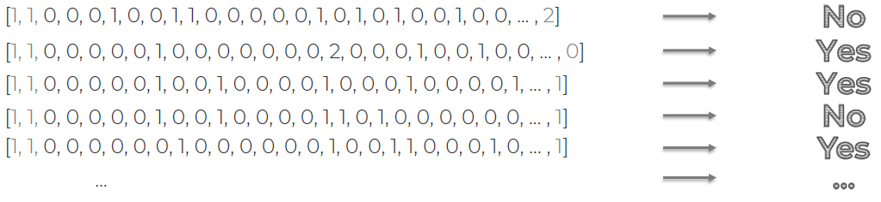

We now feed it into the model (logistic regression or neural network) to obtain an answer with it:  
We are using NLP & DNLP:

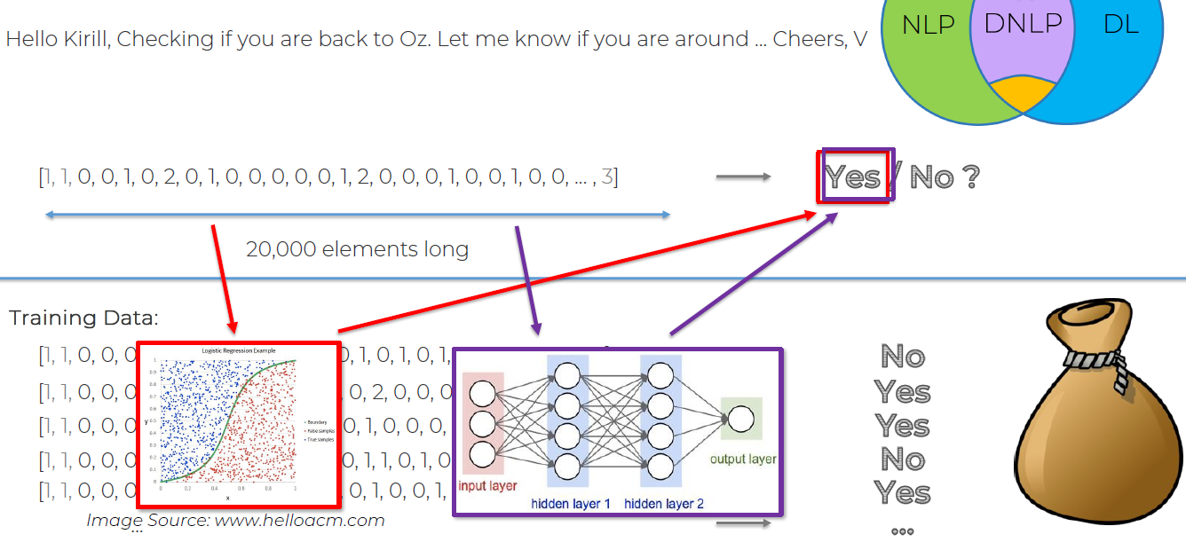

**304. Natural Language Processing in Python - Step 1**  
We are going to cover the basics (NO chatbots NOR machine translations): sentiment analysis (YES)

You can try diverse ML models to tackle the problem, but the essential part of our implementation will be to build the bag of words model.

.csv: commas separated variables  
.tsv: tab separated variables

**311. Homework Challenge**

Hello students,

Congratulations for having completed Part 7 - Natural Language Processing. If you are up for some practical activities, here is a little challenge:

1. Run the other classification models we made in Part 3 - Classification, other than the one we used in the last tutorial.

2. Evaluate the performance of each of these models. Try to beat the Accuracy obtained in the tutorial. But remember, Accuracy is not enough, so you should also look at other performance metrics like Precision (measuring exactness), Recall (measuring completeness) and the F1 Score (compromise between Precision and Recall). Please find below these metrics formulas (TP = # True Positives, TN = # True Negatives, FP = # False Positives, FN = # False Negatives):

Accuracy = (TP + TN) / (TP + TN + FP + FN)  
Precision = TP / (TP + FP)  
Recall = TP / (TP + FN)  
F1 Score = 2 * Precision * Recall / (Precision + Recall)

3. Try even other classification models that we haven't covered in Part 3 - Classification. Good ones for NLP include:

CART  
C5.0  
Maximum Entropy

Submit your results in the Q&A for this Lecture or by pm and justify in few words why you think it's the most appropriate model.

Enjoy Machine Learning!

Best to all,

Hadelin

## **Section 35: Part 8: Deep Learning**

Relevant videos: -  
Interesting videos: 325  
Slides: 449

Welcome to Part 8 - Deep Learning!

Deep Learning is the most exciting and powerful branch of Machine Learning. Deep Learning models can be used for a variety of complex tasks:

* Artificial Neural Networks for Regression and Classification.
* Convolutional Neural Networks for Computer Vision.
* Recurrent Neural Networks for Time Series Analysis.
* Self Organizing Maps for Feature Extraction.
* Deep Boltzmann Machines for Recommendation Systems.
* Auto Encoders for Recommendation Systems.

In this part, you will understand and learn how to implement the following Deep Learning models:

1. Artificial Neural Networks for a Business Problem
2. Convolutional Neural Networks for a Computer Vision task

**325. What is Deep Learning?**

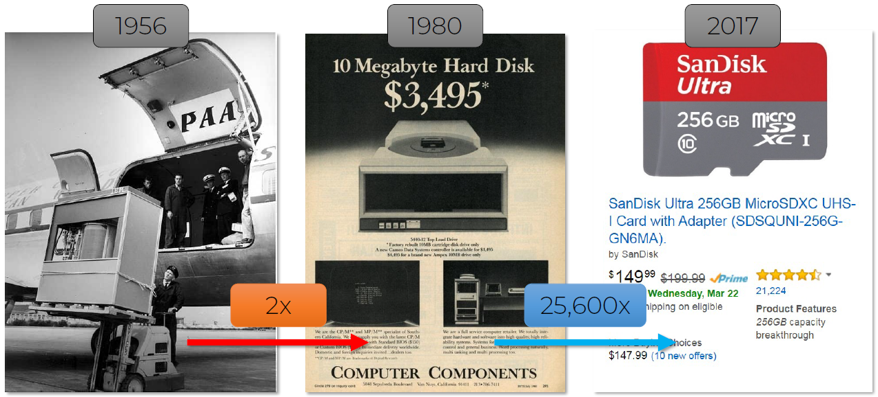

1956 --> 5 MegaByte HD

Now some people are investigating using DNA storage:

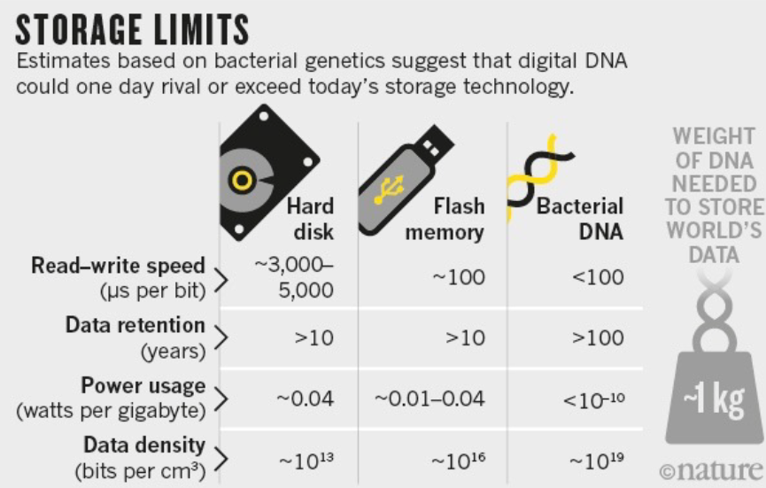

Processing capacity change:

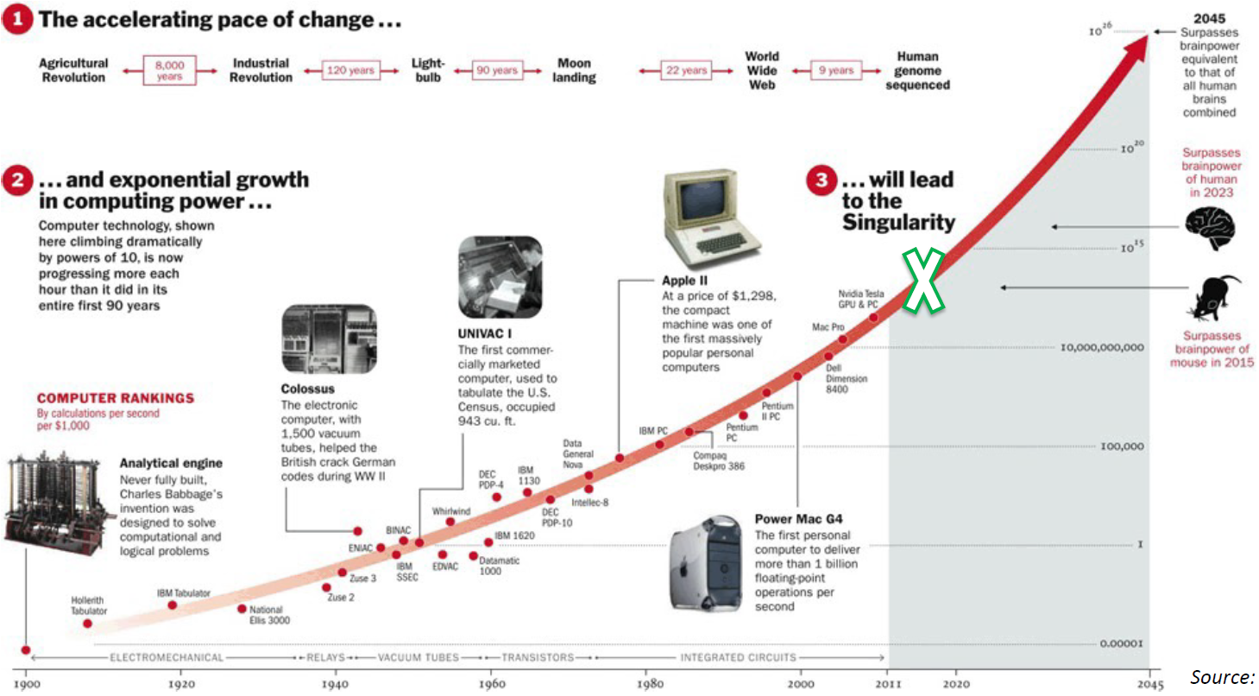

Geoffrey Hinton is known as the godfather of DL:



DL usually has quite some more hidden layers:

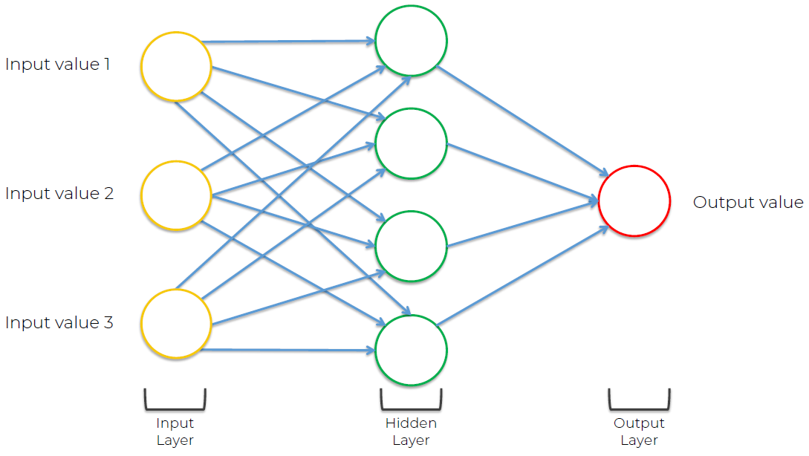

### **Section 36: Artificial Neural Networks**

Relevant videos: -  
Interesting videos: 327, 328, 329, 330, 331, 332, 333  
Slides: 465

**326. Plan of attack**

What we will learn in this section:

* The Neuron
* The Activation Function
* How do Neural Networks work? (example)
* How do Neural Networks learn?
* Gradient Descent
* Stochastic Gradient Descent
* Backpropagation

**327. The Neuron**

A neuron by itself can’t do much, but when they work together they can do magic; like ants. Biology:

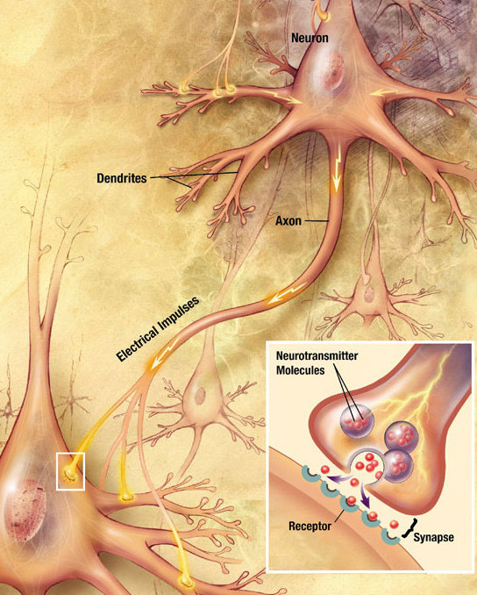

The neuron in computer science:

X1, X2 ... Xm are all independent variables, they come from a single observation, 1 row from the dataset. It must be said that these independent variables must be standardize [0 – 1]

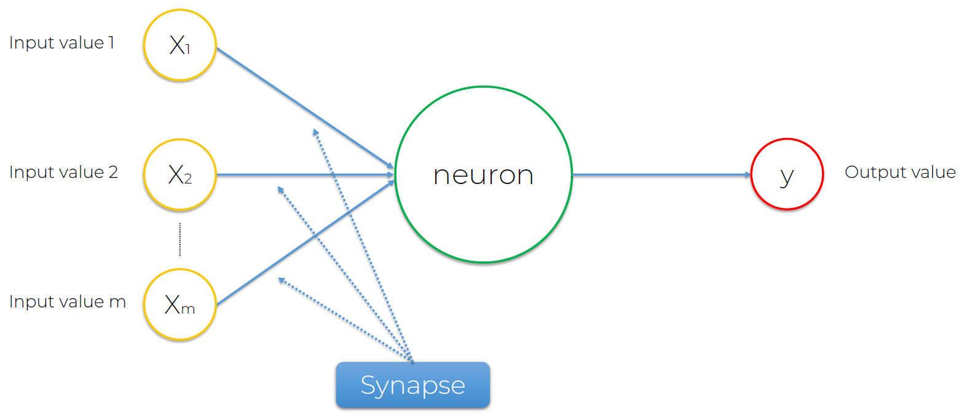

Additional reading:

Efficient BackProp by Yann Lecun et al. (1998)  
Link: <https://cseweb.ucsd.edu/classes/wi08/cse253/Handouts/lecun-98b.pdf>

The output variable doesn’t have to be just 1 (y), it can be several output values (y1, y2 ... ym)

Synapses all get assigned weights, which are crucial to neural networks (NN), because weights is how NN learn, when you are training an Artificial Neural Network (ANN), you are basically adjusting weights.

1st step. Inside the neuron (green circle) all the weighted inputs are added up.

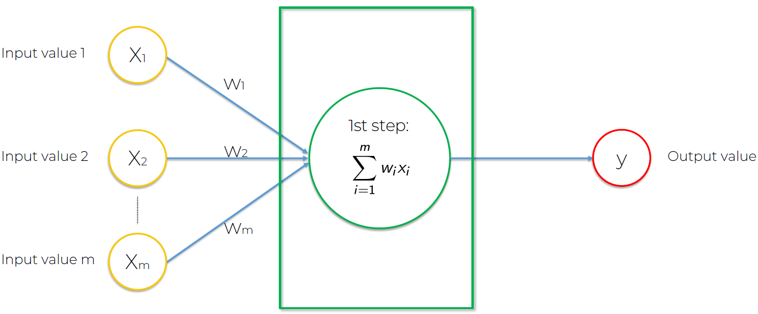

2n step. Inside the neuron (green circle), an activation function (phi) awaits. If the neuron is activated, it will pass the signal (3rd step), otherwise it won’t.

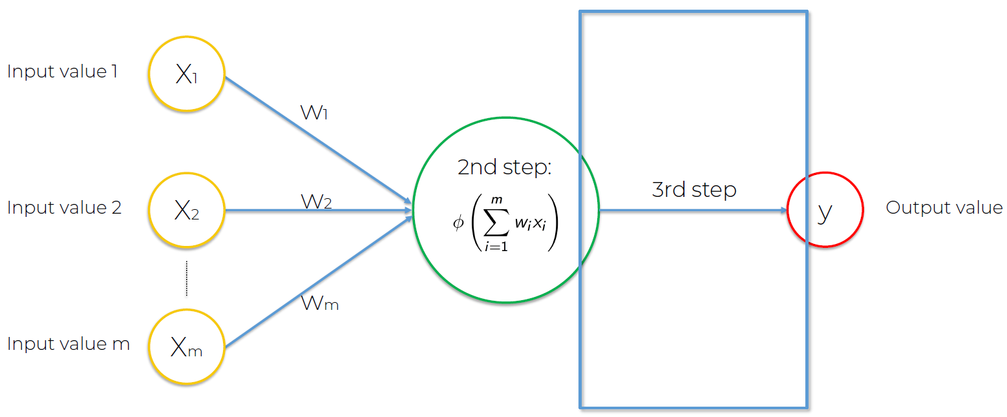

**328. The Activation Function**

2nd step (green circle)

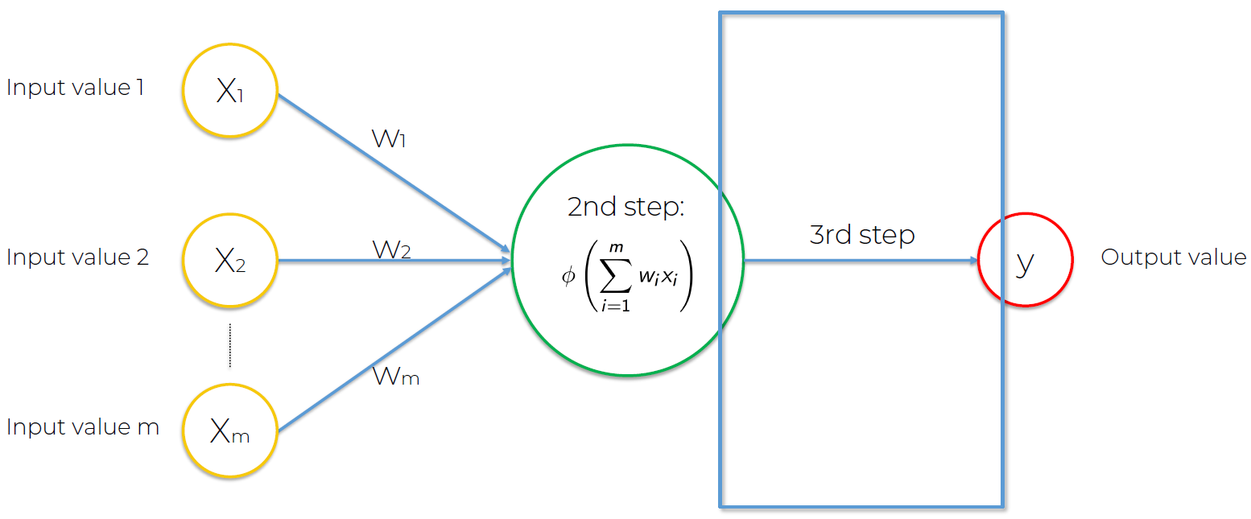

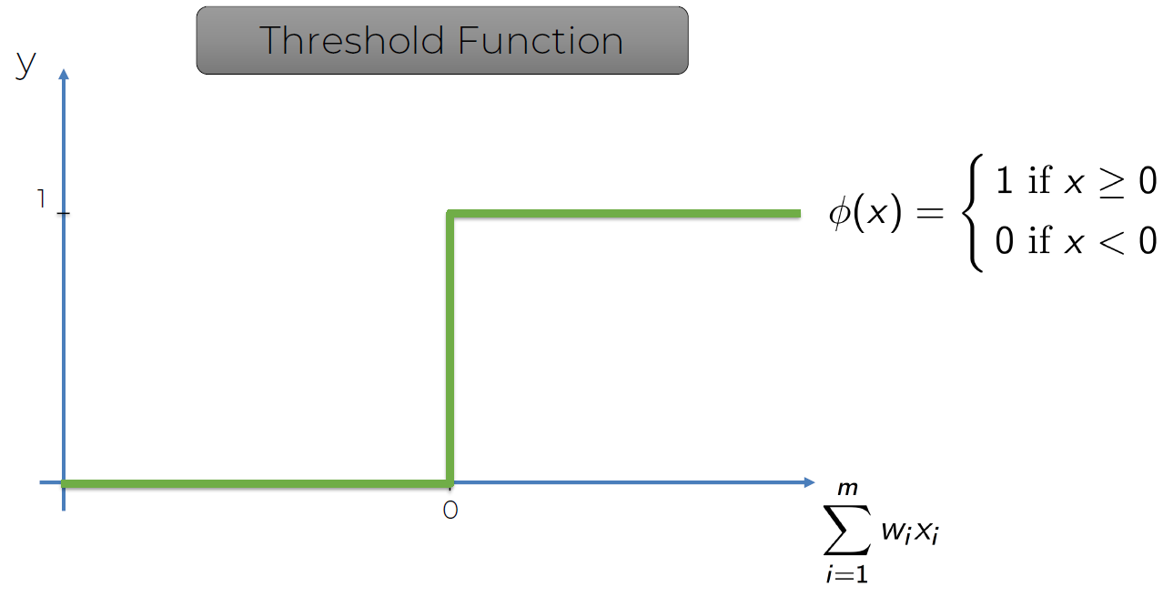 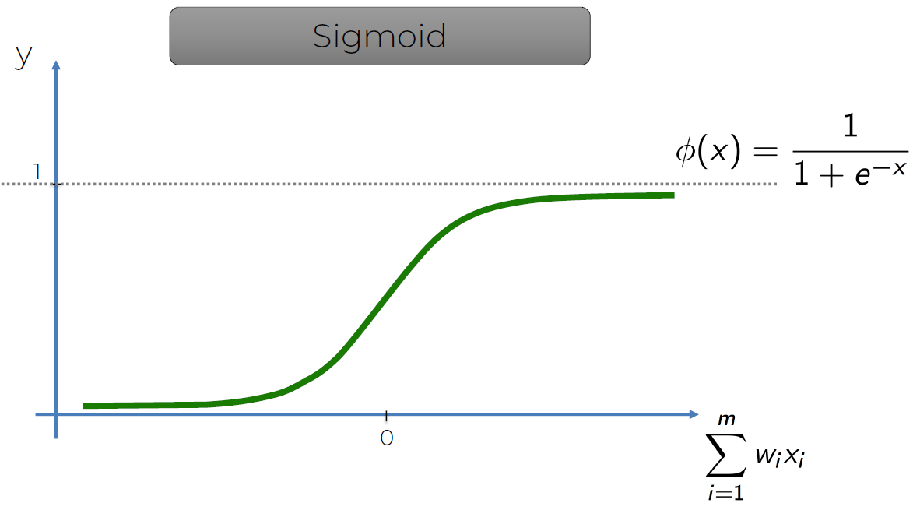

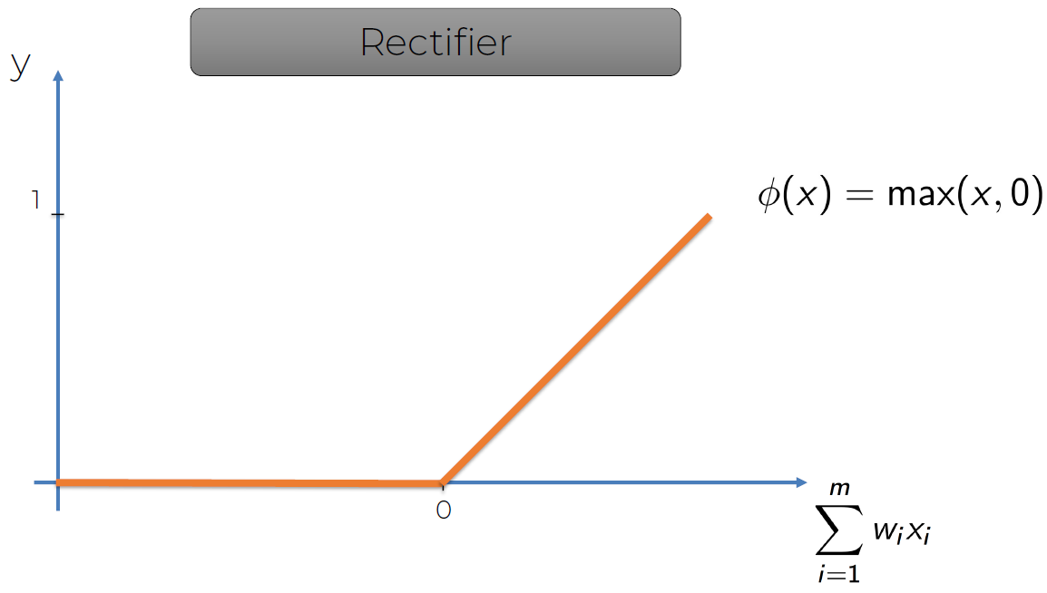 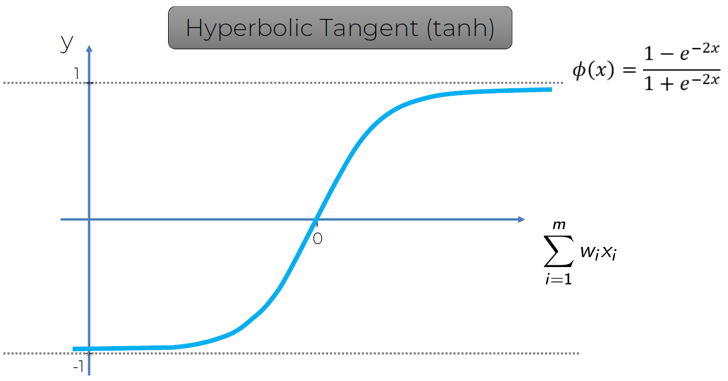

Additional Reading to understand why the rectifier function is so popular:  
Deep sparse rectifier neural networks By Xavier Glorot et al. (2011)  
Link: <https://proceedings.mlr.press/v15/glorot11a/glorot11a.pdf>

**329. How do Neural Networks work?**

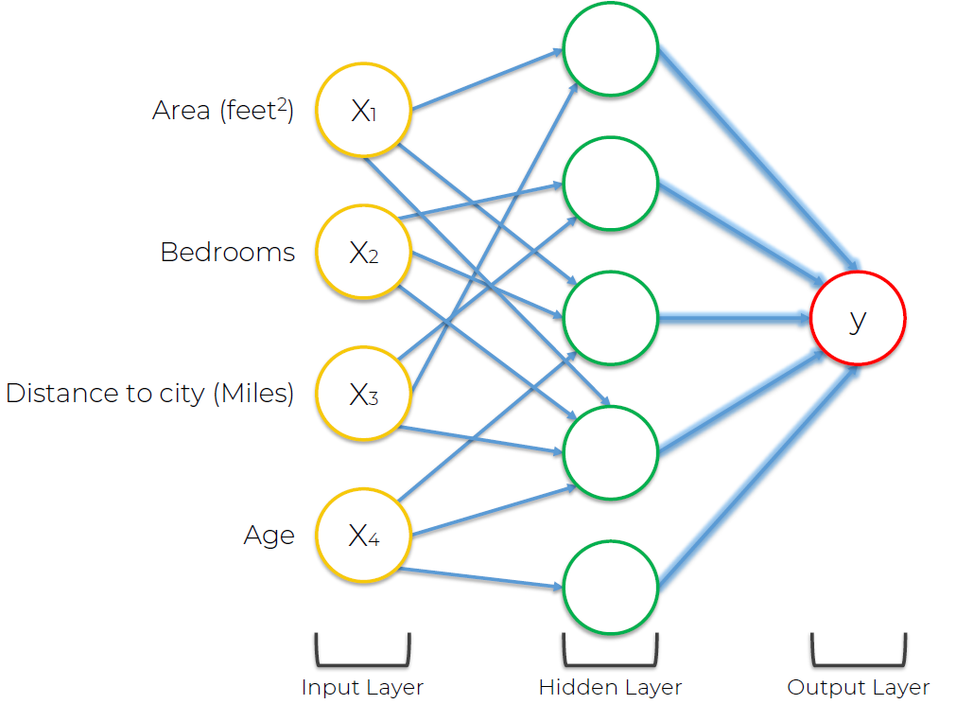 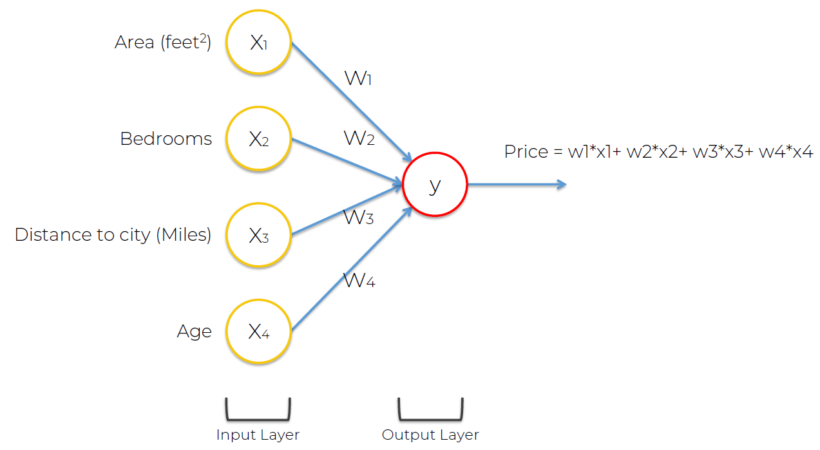

**330. How do Neural Networks learn?**

The 2nd step, the green circle where the activation function is stored is called perceptron.

C (Cost Function): it tells us what is the error that we have in our prediction, there are many kinds of cost functions and the reason we use this one is because of gradient descent. Our goal is to minimize the cost function, so that y^ is closer to y, we do this by updating the weights (w1, w2 ... wm).

In order for a NN to learn, what needs to happen is backpropagation.

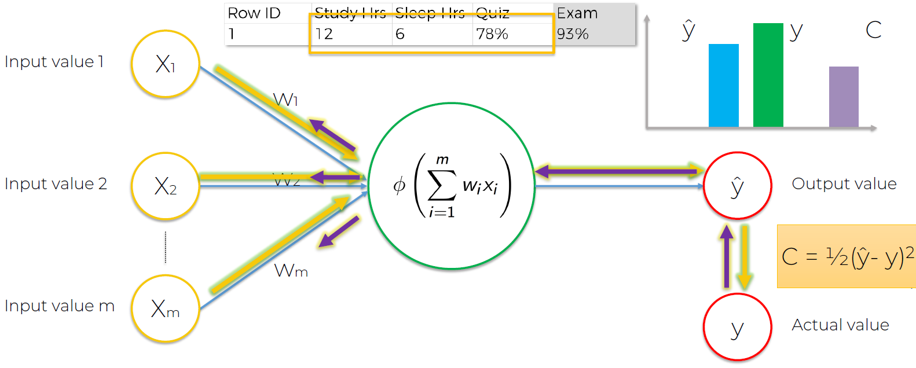

Additional Reading: A list of cost functions used in neural networks, alongside applications. CrossValidated (2015)

Link: <https://stats.stackexchange.com/questions/154879/a-list-of-cost-functions-used-in-neural-networks-alongside-applications>

**331. Gradient Descent**

In this video we are going to learn how the weights are adjusted.

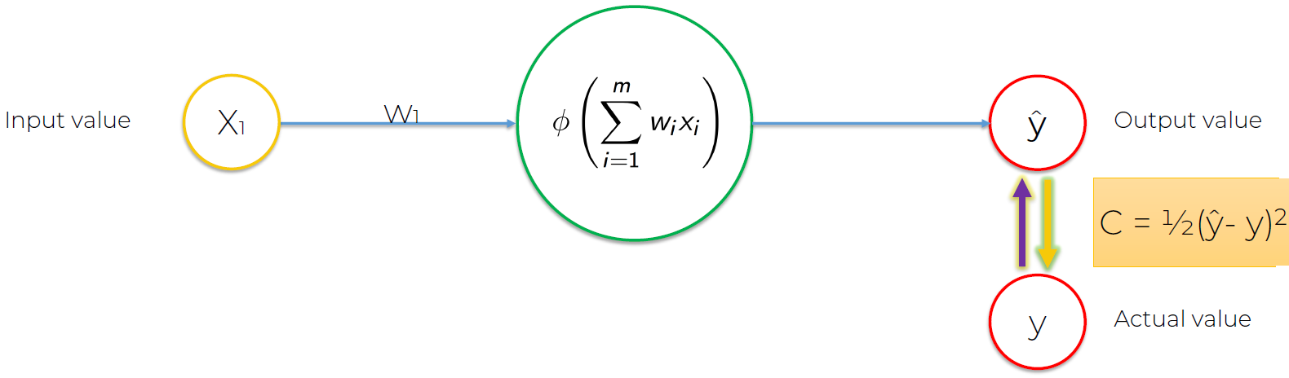

It’s easy for 1 weight, but as you increase the number of weights, you have to face the curse of dimensionality:

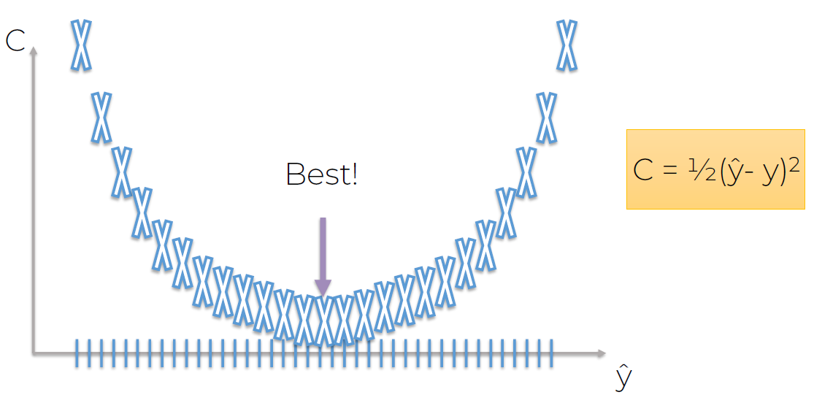

If we have 1 hidden layer and 25 weights , how could we bruteforce our way through a network of this size?  
If we have 1000 combos, that means:

1000^25 = 10^75 total number of combos  
World’s fastest Super Computer: Sunway TaihuLight: 93 PFLOPS = 93x10^15 FLOPS

That means 10^75/(93x10^15) = ~10^58 seconds = 3.42x10^50 years > universe age --> this is a NONO

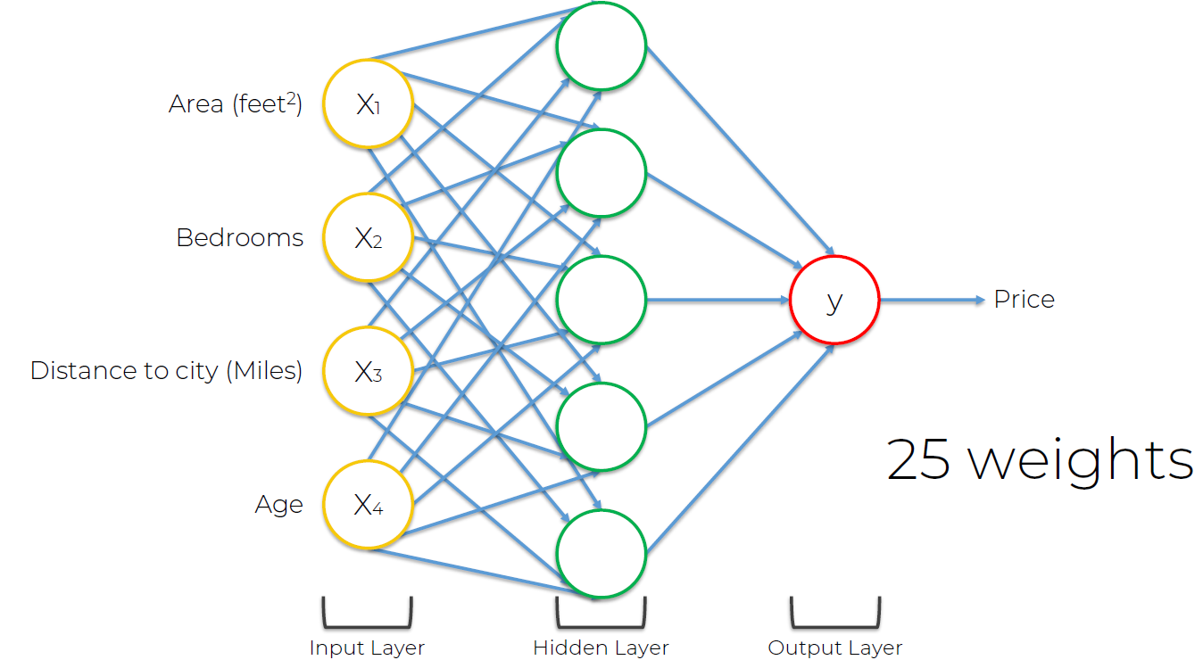

Gradient descent is a zig-zag type of method, negative slope means downward, positive slope means upward.

1D example:

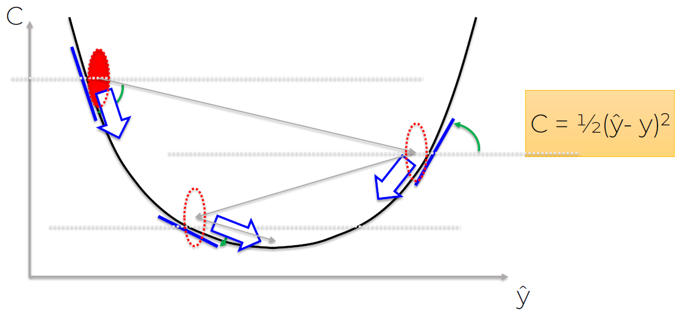

2D example: it’s called gradient descent because you are descending into the minimum of the cost function.

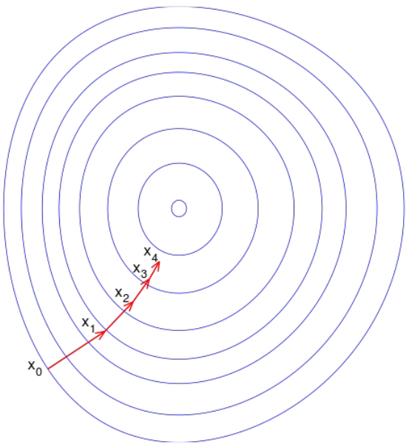

3D example: it zig-zags it’s way into the minimum.

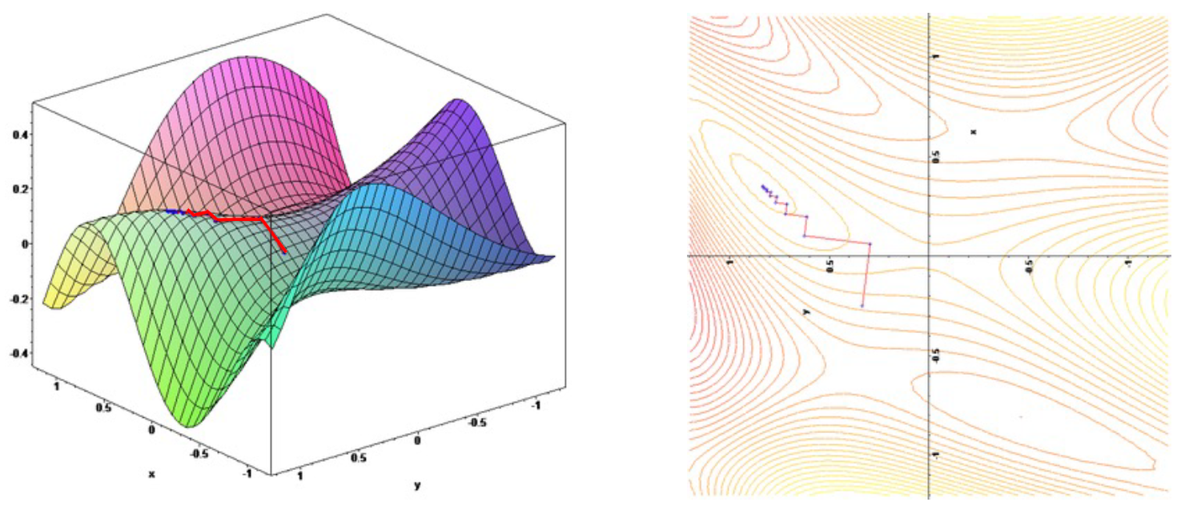

**332. Stochastic Gradient Descent**

The thing with gradient descent is that it requires the cost function to be convex (it has 1 global minimum and that’s the one we are going to find).

Not convex:

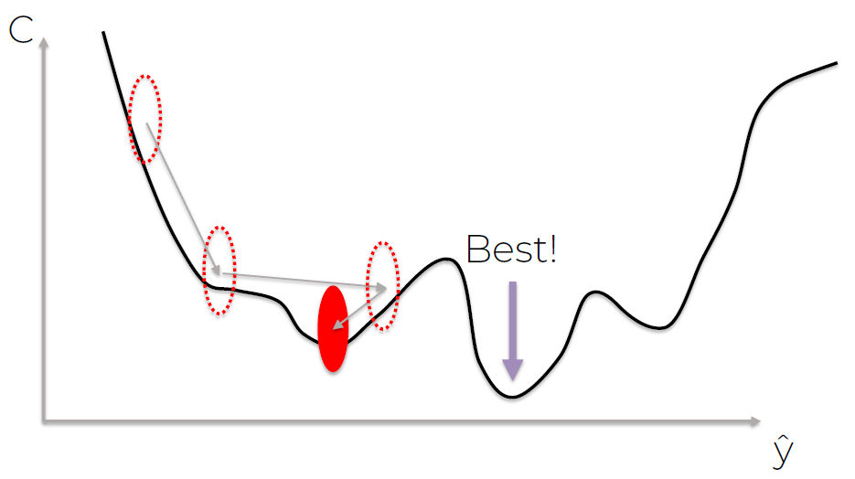

* Batch gradient descent updates (upd) the weights in a whole batch. It’s deterministic, as long as you have the same starting weights for your NN, every time you run the batch gradient descent you will get the same result.
* Stochastic gradient descent updates (upd) the weights row by row. It’s stochastic (non-deterministic == random), you are updating your NN in a stochastic manner.
* There’s a method that combines the 2 of them.

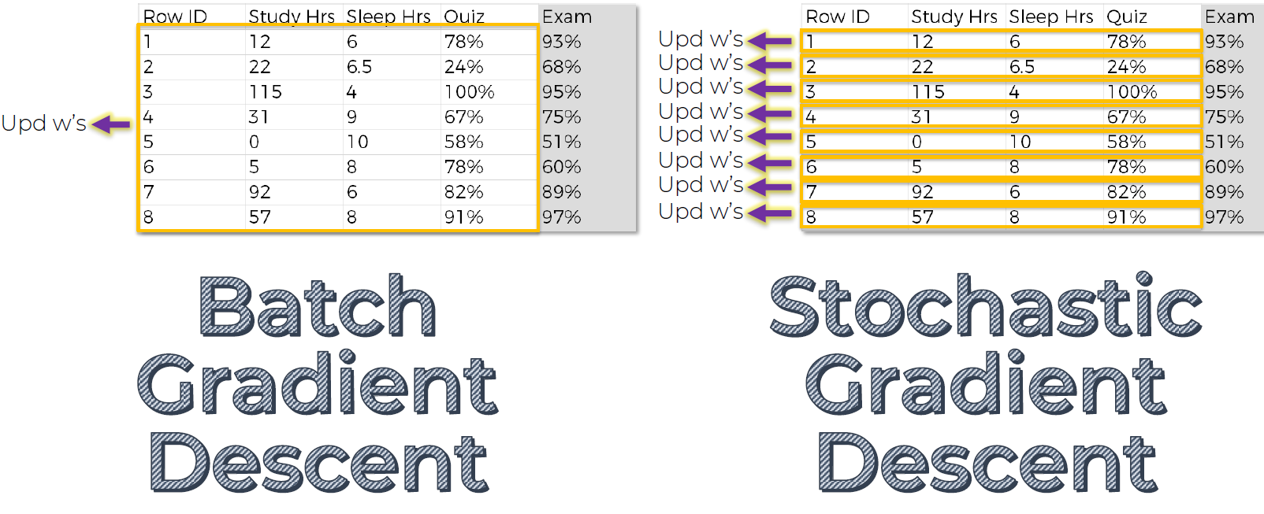

Additional reading:

A Neural Network in 13 lines of Python (Part 2 – Gradient Descent)  
By: Andrew Trask (2015)  
Link: <https://iamtrask.github.io/2015/07/27/python-network-part2/>

Heavier read (more mathematical):

Neural Networks and Deep Learning  
By: Michael Nielsen (2015)  
Link: <http://neuralnetworksanddeeplearning.com/chap2.html>

**333. Backpropagation**

Backpropagation is when errors are propagated backwards so that weights can be adjusted.

Huge advantage of backpropagation: during the process of backpropagation, you know which part of the error each of your weights in the NN is responsible for, that’s the key underlying principle of backpropagation and why it picked up so rapidly in the 1980s. Important to remember: it adjusts all of the weights at the same time.

Additional Reading: Neural Networks and Deep Learning  
By: Michael Nielsen (2015)  
Link: <http://neuralnetworksanddeeplearning.com/chap2.html>

Training the ANN with Stochastic Gradient Descent:

**STEP 1**: Randomly initialise the weights to small numbers close to 0 (but not 0).  
**STEP 2**: Input the first observation of your dataset in the input layer, each feature in one input node.  
**STEP 3**: Forward-Propagation: from left to right, the neurons are activated in a way that the impact of each neuron’s activation is limited by the weights. Propagate the activations until getting the predicted result y.

**STEP 4**: Compare the predicted result to the actual result. Measure the generated error.  
**STEP 5**: Back-Propagation: from right to left, the error is back-propagated. Update the weights according to how much they are responsible for the error. The learning rate decides by how much we update the weights.

**STEP 6**: Repeat Steps 1 to 5 and update the weights after each observation (Reinforcement Learning). Or: Repeat Steps 1 to 5 but update the weights only after a batch of observations (Batch Learning).

**STEP 7**: When the whole training set passed through the ANN, that makes an epoch. Redo more epochs.

**335. ANN in Python - Step 1**

Deep Learning (DL) consists in building an artificial brain. Now we are going to build an artificial brain, use DL, with TensorFlow 2.0

We will now do a practical case to see if the customer stays in the bank or leaves the bank.

**344. Deep Learning Additional Content**

<https://www.superdatascience.com/blogs/the-ultimate-guide-to-artificial-neural-networks-ann>

### **Section 36: Artificial Neural Network for Regression (345. EXTRA CONTENT: ANN Case Study)**

Dataset: <https://archive.ics.uci.edu/dataset/294/combined+cycle+power+plant>

### **Section 37: Convolutional Neural Networks**

Relevant videos: -  
Interesting videos: 347, 348, 349, 350, 351,352, 353, 354  
Slides: 549

**346. Plan of attack**

* What are Convolutional Neural Networks?
  + Features, brain comparation
* Step 1 - Convolution Operation
  + Feature detectors, filters, feature maps
* Step 1(b) - ReLU Layer
  + Rectified Linear Unit, but we want non-linearity in our network for image recognition
* Step 2 – Pooling
  + How pooling works, max pooling, mean pooling, sum pooling
* Step 3 – Flattening
  + Tutorial to proceed from pooled layers to your flattened layers
* Step 4 - Full Connection
  + Puts everything into perspective
* Summary
* EXTRA: Softmax & Cross-Entropy

**347. What are convolutional neural networks?**

If we look to the left margin we see a person looking at us.  
If we look to the right margin we see the side face of a person.

This proves that our brain seeks features and classifies images according to them.



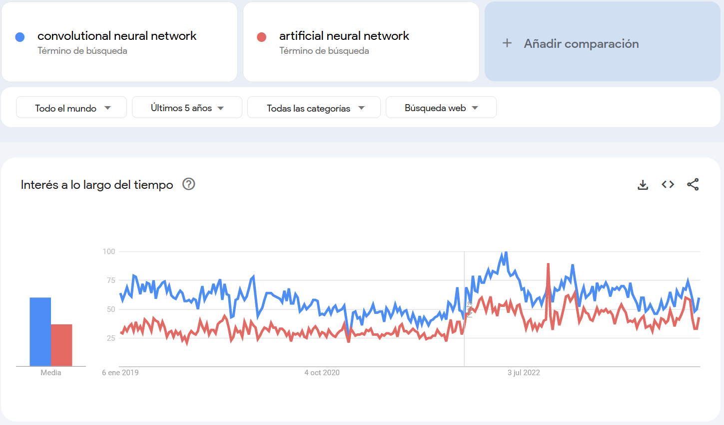

(10/01/2024)

Yann Lecun is the godfather of CNN:



Example of what a CNN does:

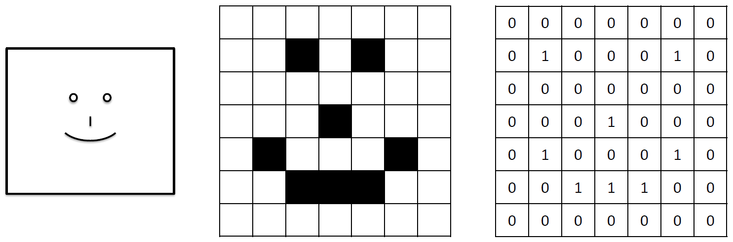

CNN steps:  
Step 1. Convolution  
Step 2. Max Pooling  
Step 3. Flattening  
Step 4. Full Connection

Additional Reading:

Gradient-Based Learning Applied to Document Recognition  
By: Yann LeCun et al. (1998)  
Link: <http://yann.lecun.com/exdb/publis/pdf/lecun-01a.pdf>

**348. Step 1 - Convolution Operation**

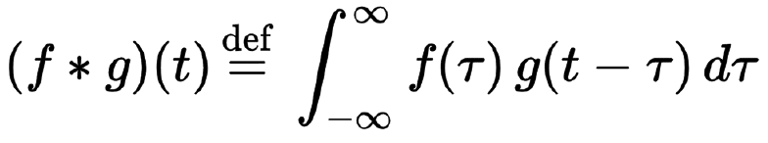

Additional Reading: Introduction to Convolutional Neural Networks  
By Jianxin Wu (2017)  
Link: <http://cs.nju.edu.cn/wujx/paper/CNN.pdf>

You 'pass' (multiply) the input submatrix through the feature detector filter, you multiply each position by each position and add them up. It’s not a 'usual' matrix multiplication.

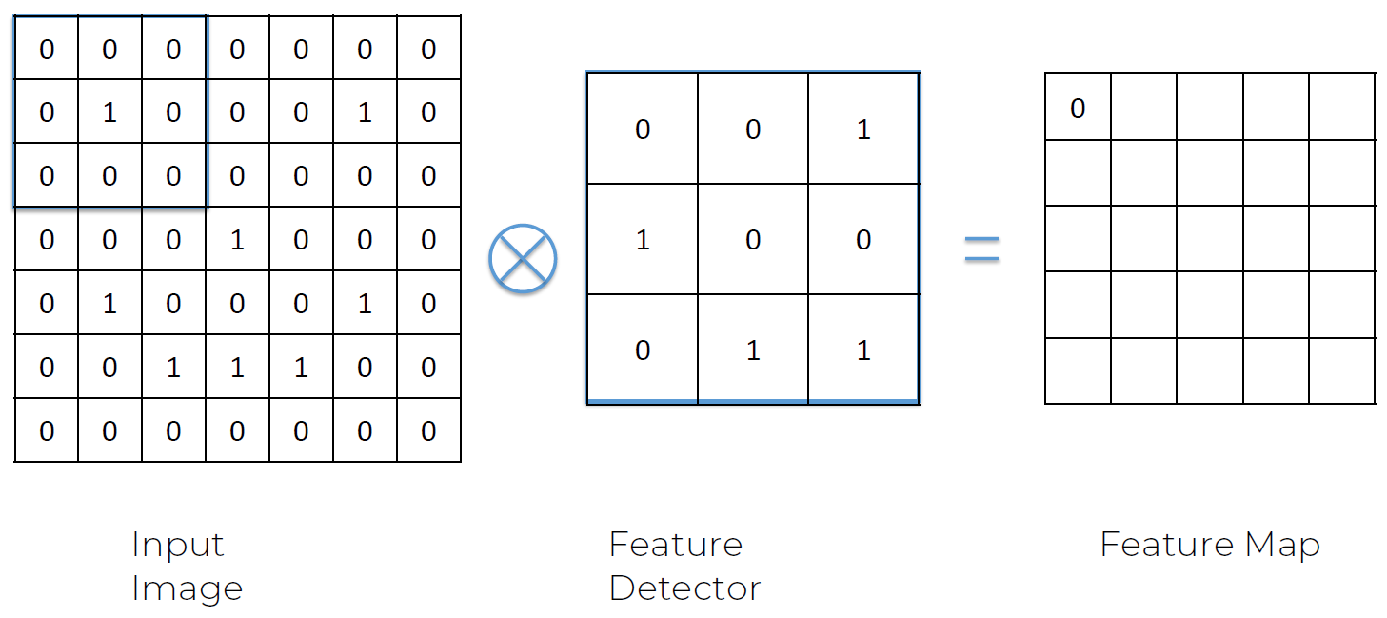

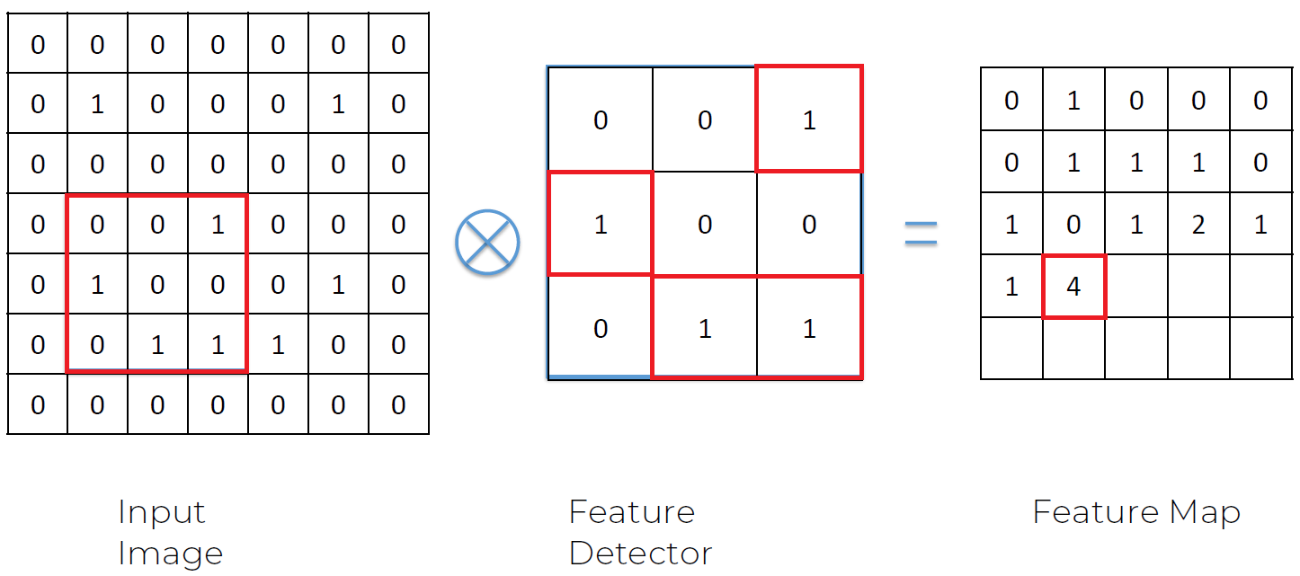

The feature detector makes the image smaller so it is easier to process.

A convolutional layer is made up of many feature maps. For example, one can detect a hat, the next one can detect the nose, the next can detect if it is wearing a suit..., this is based on the belief that we detect, our perception works through features.

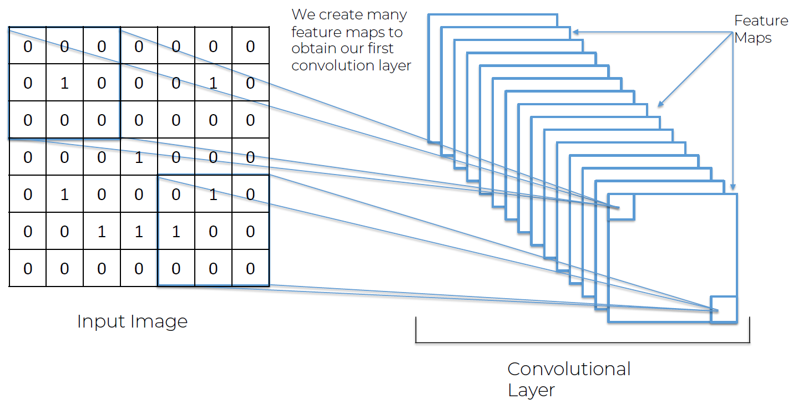

We can use convolution to apply several filters, like instagram filters:

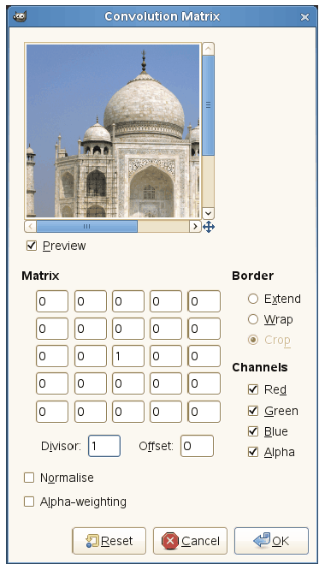 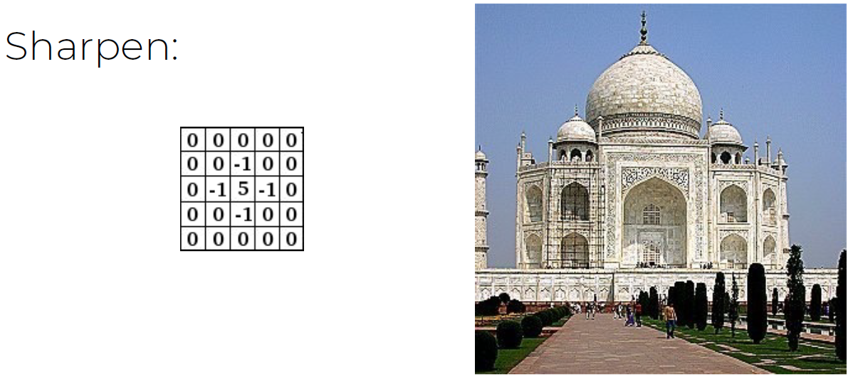 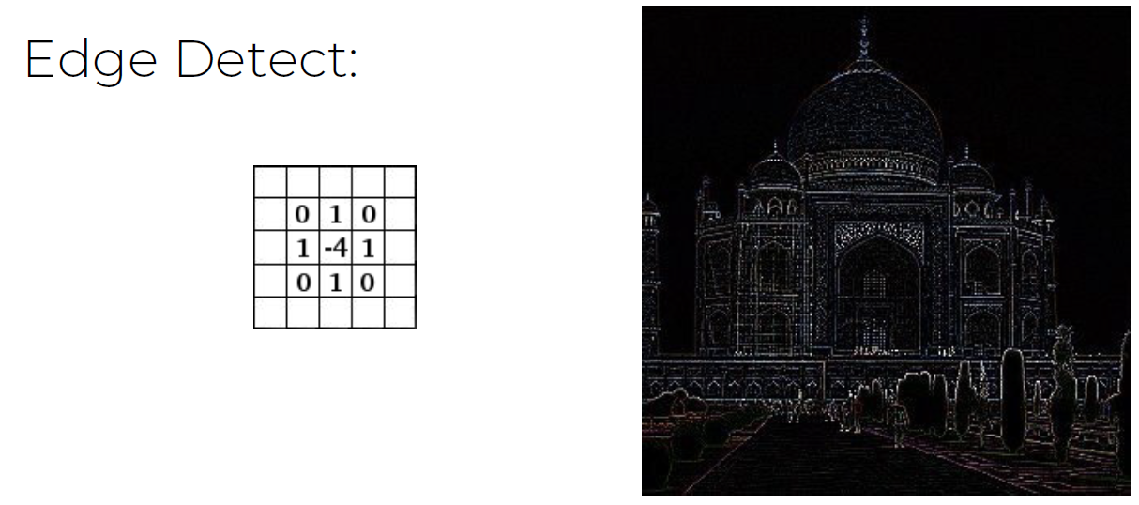 

**349. Step 1(b) - ReLU Layer**

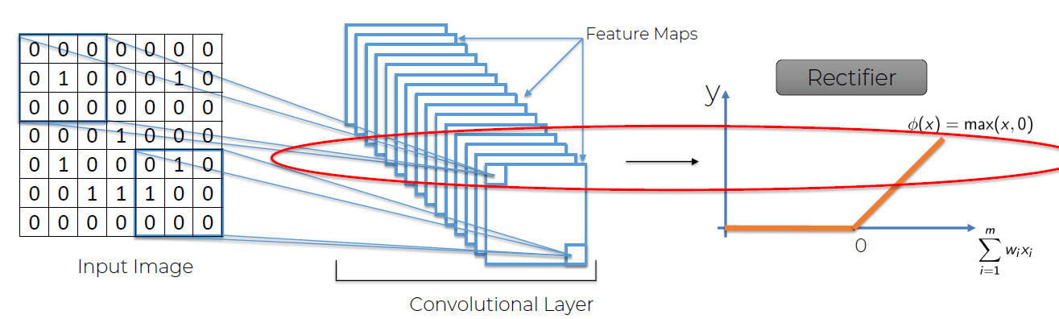

A rectified linear unit (ReLU) is an activation function that introduces the property of nonlinearity to a deep learning model and solves the vanishing gradients issue. The reason why we are introducing a rectifier is because we want to increase non-linearity. A rectifier access as that filter/function, that breaks up linearity.

Before the rectifier:

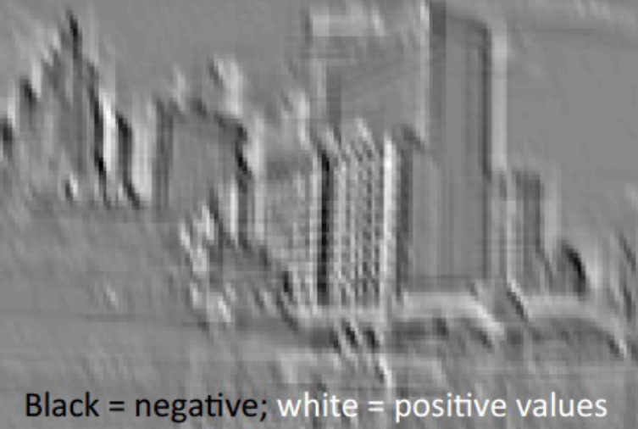

After the rectifier: increasing non-linearity:

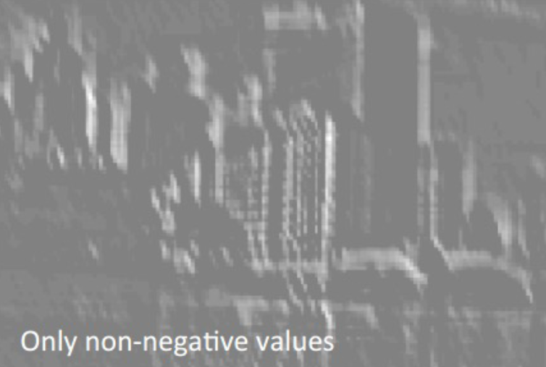

Additional Reading:

Understanding Convolutional Neural Networks with A Mathematical Model  
By C.-C. Jay Kuo (2016)  
Link: <https://arxiv.org/pdf/1609.04112.pdf>

Delving Deep into Rectifiers: Surpassing Human-Level Performance on ImageNet Classification  
By Kaiming He et al. (2015)  
Link: <https://arxiv.org/pdf/1502.01852.pdf>

**350. Step 2 – Pooling**

What is pooling and why do we need it? We want the NN to recognize all the cheetah images, we want spatial invariance, independence of the allocation of the feature, flexibility for the feature location. For example, in the case of cheetahs, a distinctive feature is their 'black tears', we want to recognize that feature:

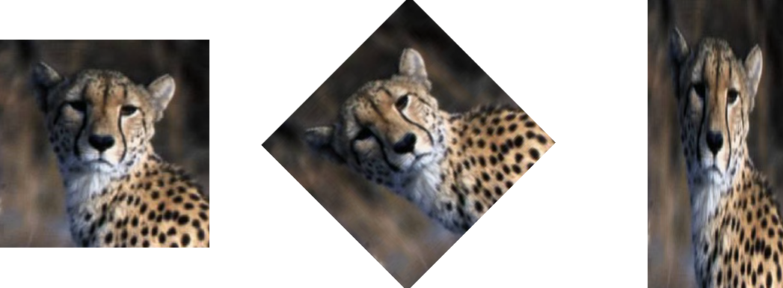

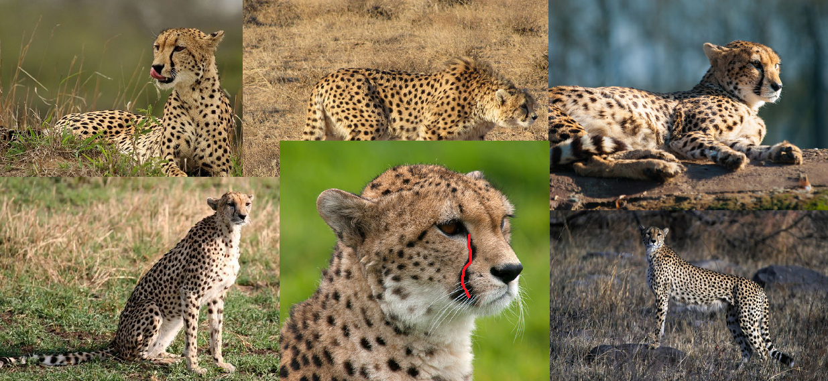

From the feature map, you get a 2x2 box for example and put the maximum value into the pooled feature map:

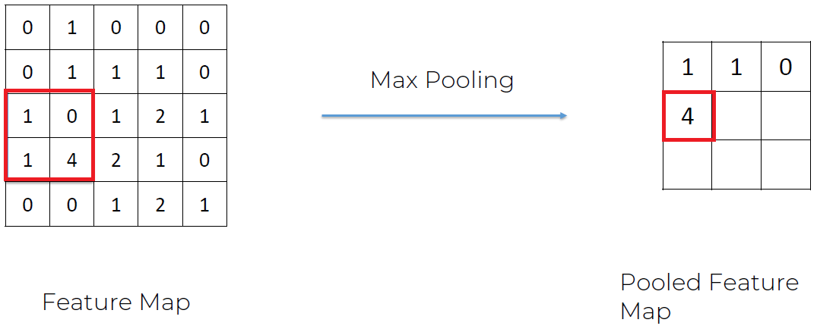

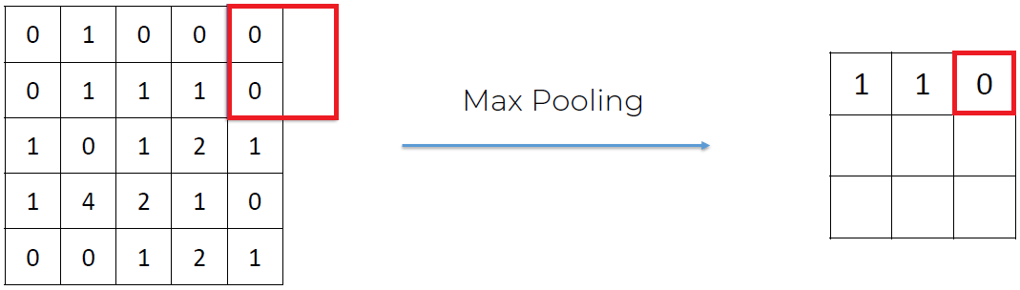

Benefits: we preserve the features, we’re introducing spatial invariance, we’re reducing the size by 75% by reducing the number of parameters and we’re preventing overfitting.

Additional Reading (very easy to read, ir recommend starting here):

Evaluation of Pooling Operations in Convolutional Architectures for Object Recognition  
By Dominik Scherer et al. (2010)  
Link: <http://ais.uni-bonn.de/papers/icann2010_maxpool.pdf>

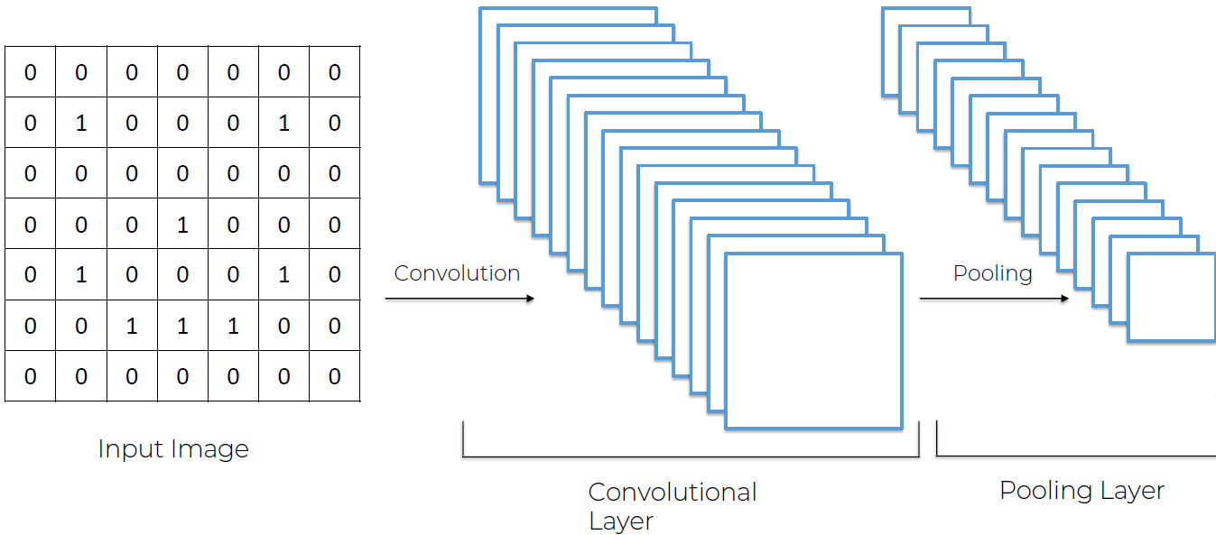

0º row: your number  
1º row: your convolution step  
2º row: your pooling step  
3º row: convolution layer  
4º row: pooling layer  
5º row: fully connected layers and so on

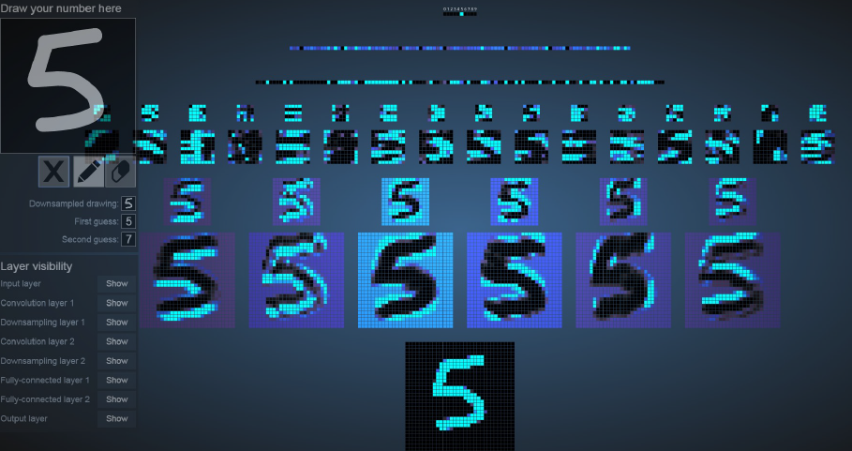

**351. Step 3 – Flattening**

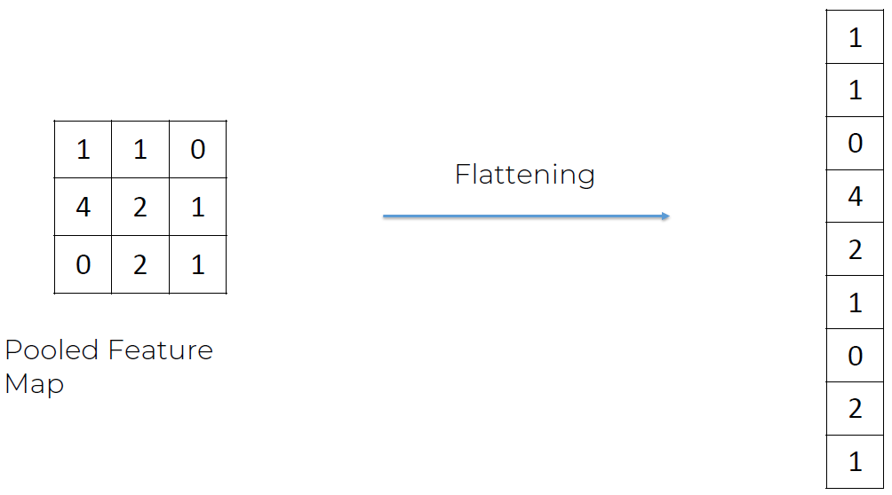

We want to introduce the 'flattened vector' into an ANN (Artificial Neural Network) for future processing.

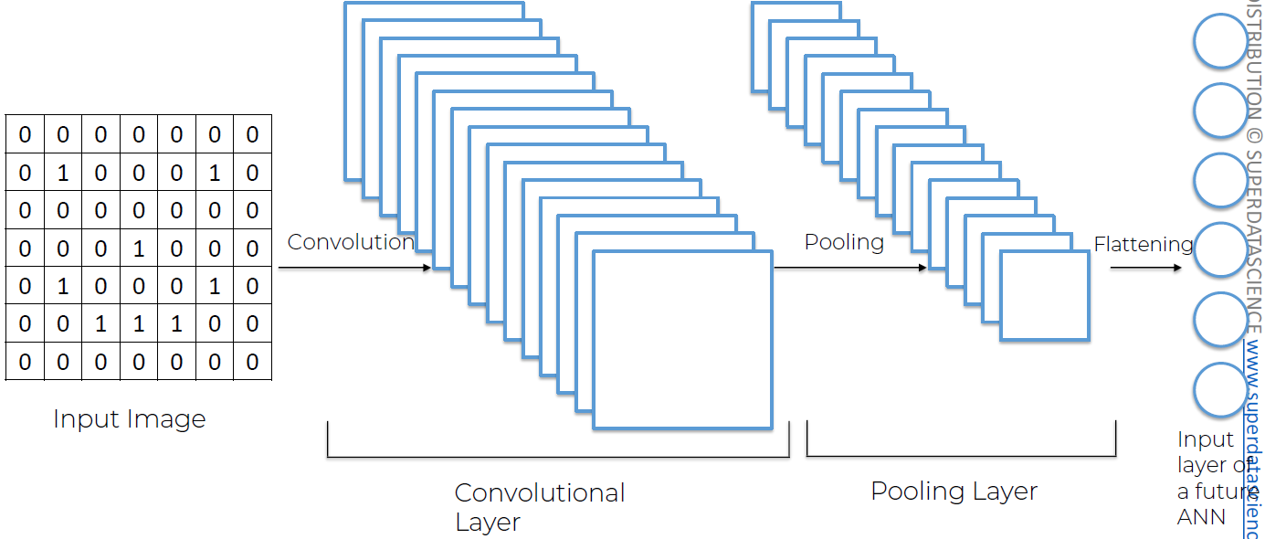

**352. Step 4 - Full Connection**

In this step we are adding a full ANN to our CNN. Fully connected layers are hidden layers:

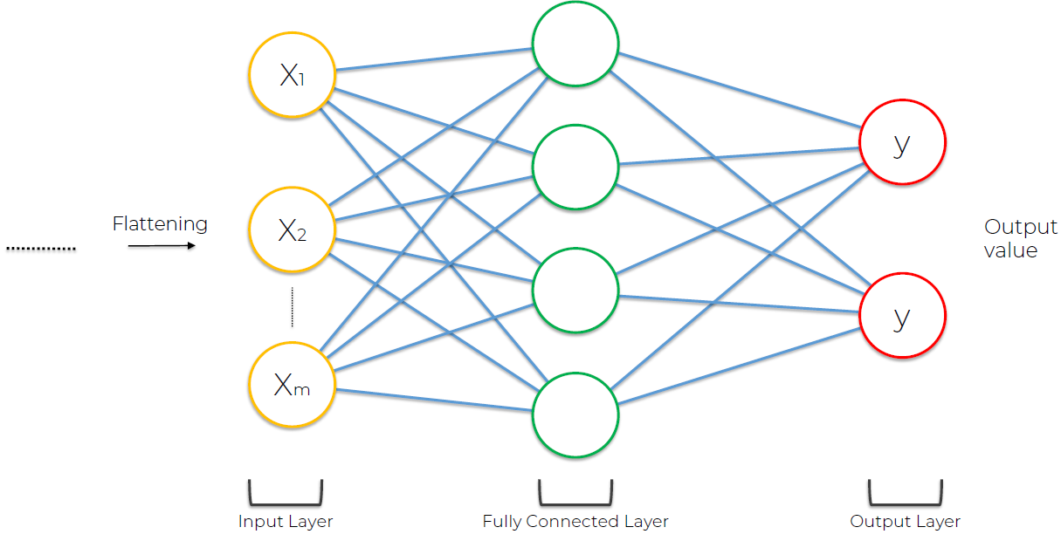

For example, according to the weight of the neurons, 1 means it is very confident it found a certain feature in the picture and 0 means it didn’t find it, we can know which are the most relevant neurons to predict if it is a dog or a cat. Priorities are assigned if the neuron lights up very often and the result is correct, if the 0.9 neuron lights up often and it is a dog, it will get a higher importance, otherwise the neuron is disregarded.

Through lots of iterations we discovered the important neurons to know if it is a dog, the weight of the neuron seems to symbolize it has detected a relevant feature that characterizes a dog and how certain it is of it. The output signal of the 0.9 neuron goes both to the dog and to the cat, so it is up to the dog and the cat to decide whether or not to take into account that signal and learn from it or not.

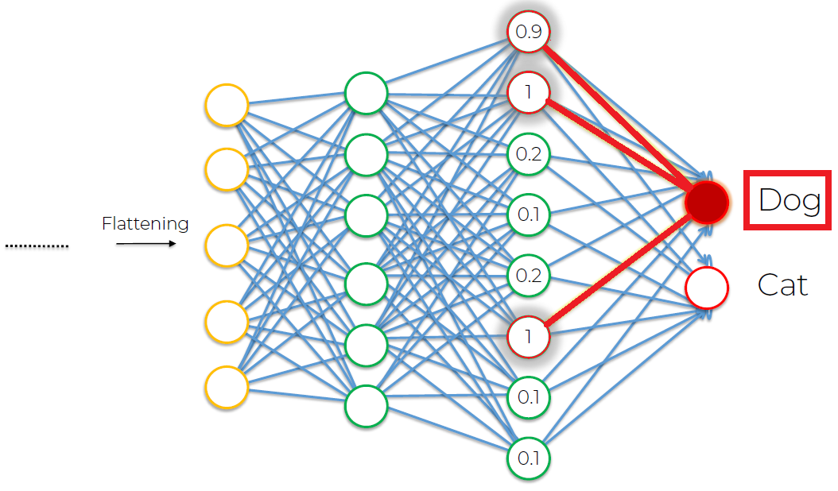

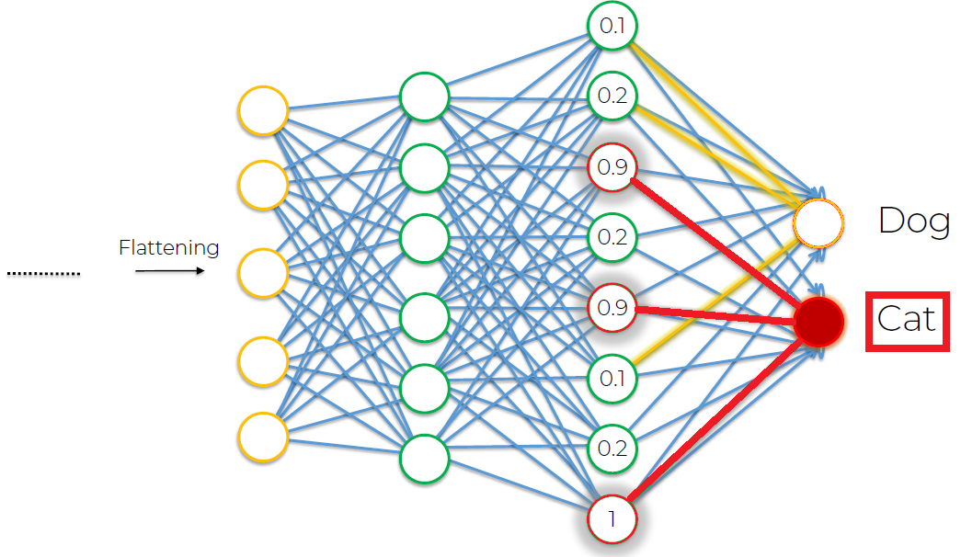

This is what happens:

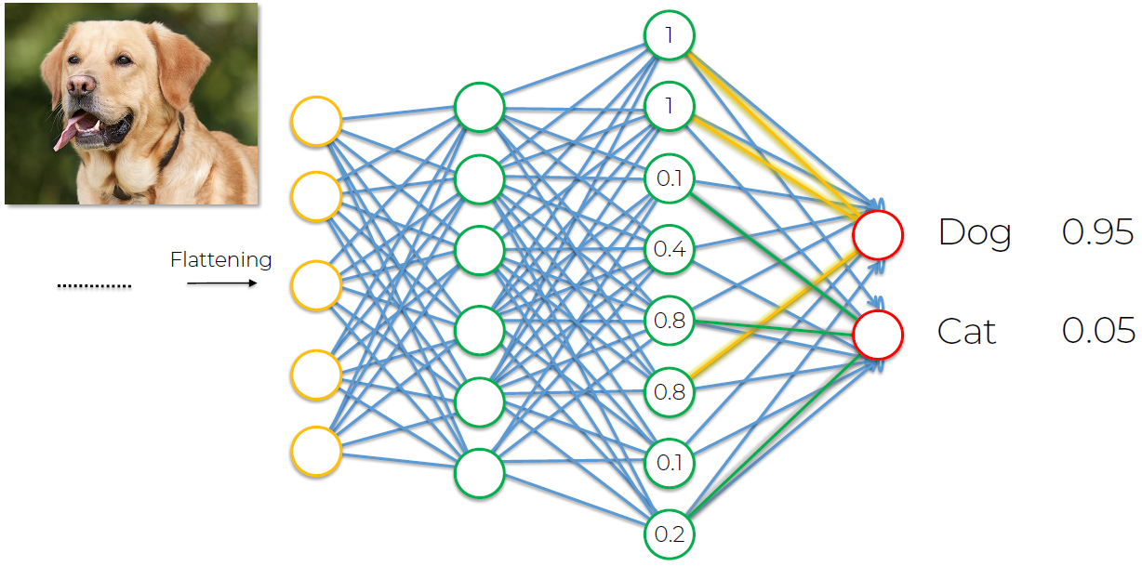

(the values add up to 1)

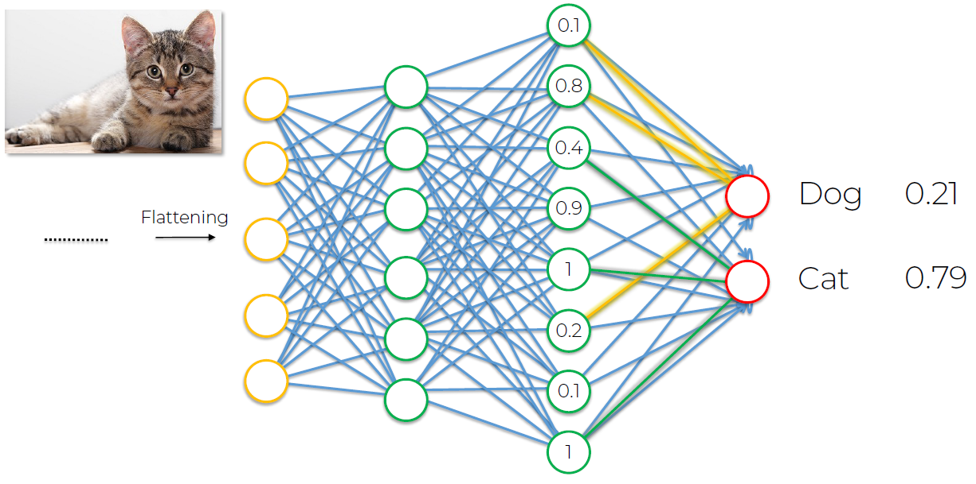

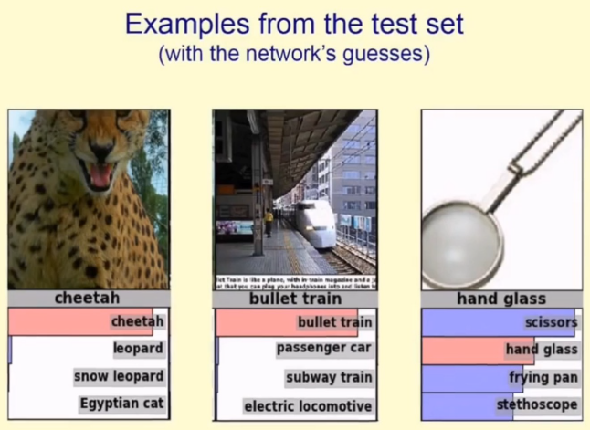

**353. Summary**

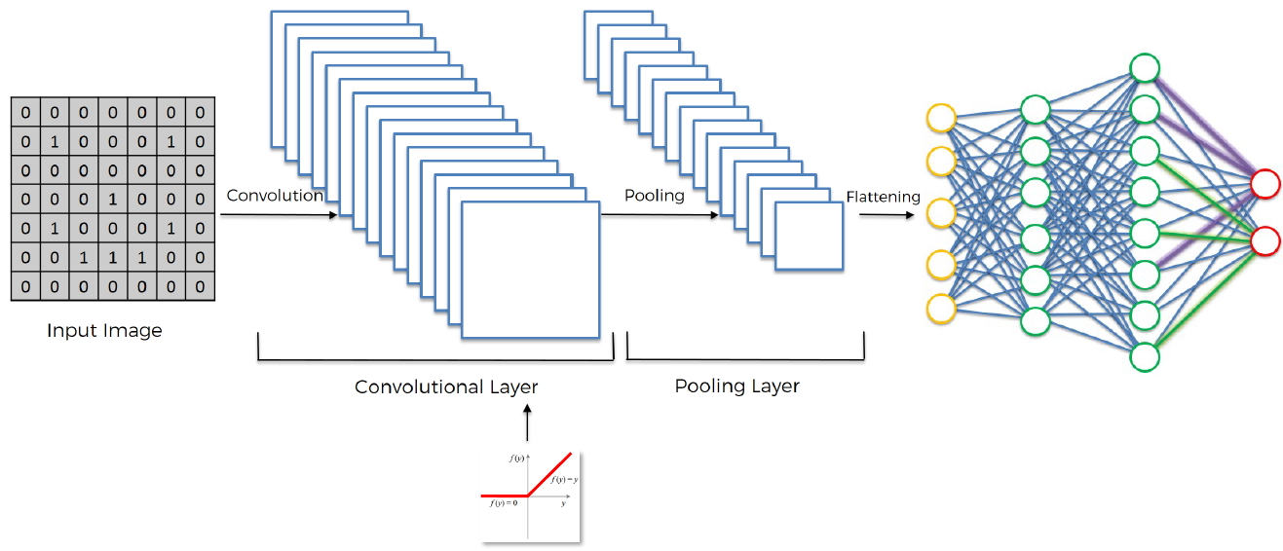

Additional Reading:

The 9 Deep Learning Papers You Need To Know About (Understanding CNNs Part 3)  
Adit Deshpande (2016)  
Link: <https://adeshpande3.github.io/adeshpande3.github.io/The-9-Deep-Learning-Papers-You-Need-To-Know-About.html>

He has a very nice webpage, followed him on github. He also recommends the following books:

#### Books I’d Highly Recommend

* *When Breath Becomes Air* - Paul Kalanithi
* *Option B* - Sheryl Sandberg
* *Quiet: The Power of Introverts in a World That Can’t Stop Talking* - Susan Cain
* *Emotional Agility* - Susan David
* *Chasing the Scream* - Johann Hari
* *The Elegant Universe* - Brian Greene
* *10% Happier* - Dan Harris
* *Sapiens: A Brief History of Humankind* - Yuval Noah Harari
* *Homo Deus: A Brief History of Tomorrow* - Yuval Noah Harari
* *Born a Crime* - Trevor Noah
* *The Spirit Catches You and You Fall Down* - Anne Fadiman
* *Tuesdays with Morrie* - Mitch Albom
* *Out of Mao’s Shadow: The Struggle for the Soul of a New China* - Philip P. Pan
* *Just Mercy* - Bryan Stevenson

NNs and CNNs are like an architecture challenge, you have to come up with an idea and then structure it and then adjust it and tweak it to get the best possible design, the best possible and optimal performance.

**354. Softmax & Cross-Entropy**

Slides: 650

The softmax function or the normalized exponential function, is a generalization of the logistic function that squashes a k-dimensional vector of arbitrary real values to a k-dimensional vector of real values in the range of 0-1 that add up to 1.

We introduce the softmax function in order to have the probabilities add up to 1, so we don’t have for example the probability of a dog (40%) and the probability of a cat (80%), this wouldn’t make sense.

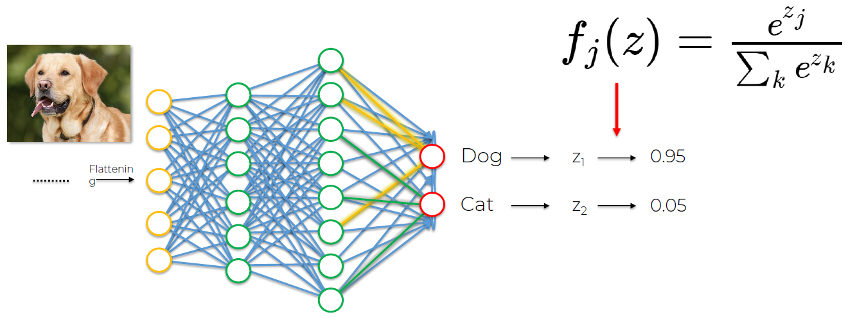

Cross-Entropy function, we will be using the 2nd one:

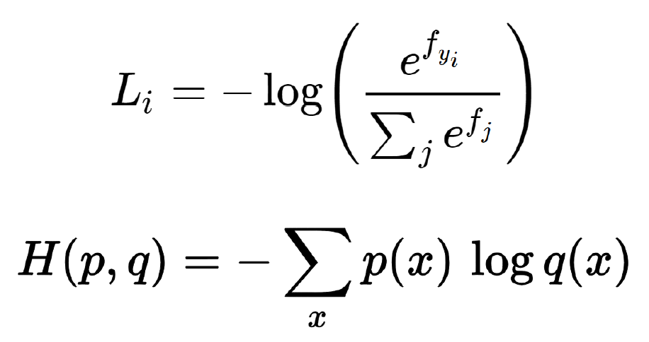

Previously we had the mean squared error (MSE) function, which we used as the cost function for assessing our network performance and our goal was to minimize the MSE in order to optimize our network performance.

In convolutional networks you can still use the MSE, but a better option turns out to be the cross-entropy function. In CNN, we don't call it the cost function anymore, we call it the loss function.

The loss function is something we want to minimize in order to maximize performance of our network.

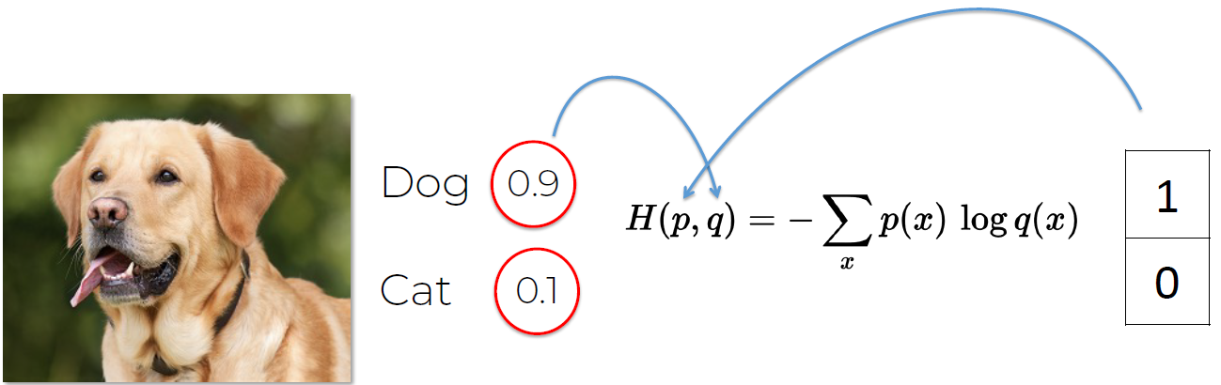

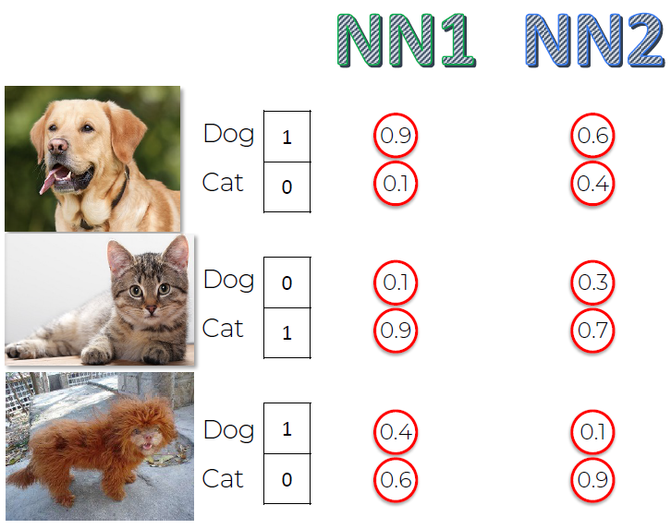

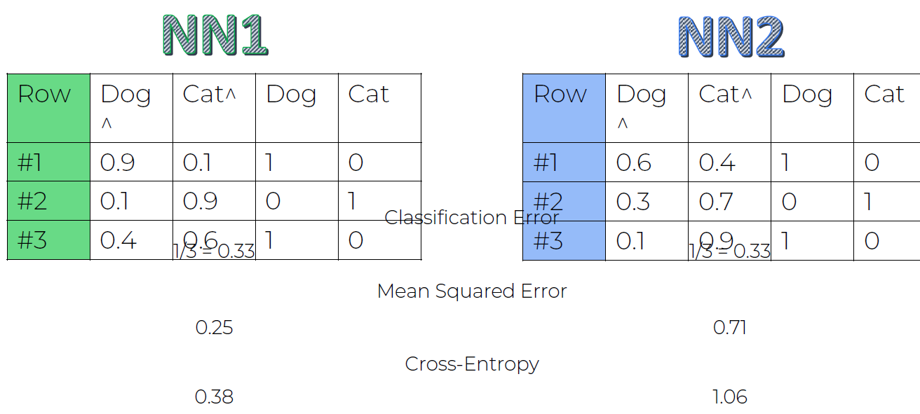

Why would you use Mean Squared Error over Cross-Entropy?

According to ChatGPT:

The choice between Mean Squared Error (MSE) and Cross-Entropy loss in Convolutional Neural Networks (CNNs) often depends on the nature of the problem you are trying to solve and the type of output your model produces.

Regression Tasks:

* Mean Squared Error (MSE): MSE is commonly used for regression tasks where the goal is to predict a continuous numerical value. If your CNN is designed to predict a numeric output, such as age, temperature, or a pixel intensity value, MSE is a suitable choice.

Classification Tasks:

* Cross-Entropy Loss (also called Logarithmic loss or Negative Log-Likelihood): Cross-entropy loss is typically used for classification problems. If your CNN is trained for tasks like image classification, object detection, or any other problem where the goal is to assign each input to one of several classes, then cross-entropy loss is a more appropriate choice.

Additional reading:

A **Friendly** Introduction to Cross-Entropy Loss  
By Rob DiPietro (2016)  
Link: <https://rdipietro.github.io/friendly-intro-to-cross-entropy-loss/>

How to implement a neural network Intermezzo 2  
By Peter Roelants (2016)  
Link: <http://peterroelants.github.io/posts/neural_network_implementation_intermezzo02/>

**356. CNN in Python - Step 2**

<https://keras.io/2.15/api/data_loading/>   
<https://keras.io/2.15/api/data_loading/image/>

**361. Deep Learning Additional Content #2**

Hi friends,

The Ultimate Guide to Convolutional Neural Networks is here!

CNNs are not easy to master, but our guide helps you understand their complexities and gain the clarity you need to apply this class of Deep Learning networks.

Here are the topics covered inside:

* Convolution operation: explore feature detectors, feature maps, Rectified Linear Unit (ReLU) layer and dive into linearity functions in the context of CNNs
* Pooling: explore various approaches to max pooling.
* Flattening: how we move from pooled to flattened layers in CNNs.
* Bonus tutorial covering Softmax and Cross-Entropy

<https://www.superdatascience.com/blogs/the-ultimate-guide-to-convolutional-neural-networks-cnn>

(At the basic level of a CNN, the image is seen as a 2D array for a Black and White image.)

## **Section 38: Part 9: Dimensionality Reduction**

Remember that in Part 3: Classification we worked with datasets composed of only 2 independent variables? We did it because of 2 reasons:

1. Because we needed 2 dimensions to visualize better how Machine Learning models worked (by plotting the prediction regions and the prediction boundary for each model).
2. Because whatever is the original number of our independent variables, **we can often end up with two independent variables by applying an appropriate Dimensionality Reduction** technique.

There are two types of Dimensionality Reduction techniques:

1. **Feature Selection**
2. **Feature Extraction**

**Feature Selection** techniques are: Backward Elimination, Forward Selection, Bidirectional Elimination, Score Comparison and more. We covered these techniques in Part 2 - Regression.

In this part we will cover the following **Feature Extraction** techniques:

1. **Principal Component Analysis (PCA)**
2. Linear Discriminant Analysis (LDA)
3. Kernel PCA

### **Section 39: Principal Component Analysis (PCA)**

Relevant videos: 363  
Interesting videos: -

**363. Principal Component Analysis (PCA) Intuition**

PCA is considered to be one of the most used **unsupervised** algorithms and can be seen as the most popular **dimensionality reduction** algorithm.

It is used for the following operations: noise filtering, visualization, feature extraction, stock market predictions, gene data analysis.

If you find a strong correlation between variables, then you can reduce the dimensionality, you can reduce the dimensions of a d-dimensional dataset by projecting it onto a (k)-dimensional subspace, where k<d.

Main functions of the PCA algorithm:

1. Standardize the data.
2. Obtain the eigenvectors and the eigenvalues from the covariance matrix or correlation matrix, or perform singular vector decomposition.
3. Sort the eigenvalues in descending order and choose the k eigenvectors that correspond to the k largest eigenvalues where k is the number of dimensions of the new feature subspace (k<=d).
4. Construct the projection matrix W from the selected k eigenvectors.
5. Transform the original dataset X via W to obtain a k-dimensional feature subspace Y.
6. More info: <https://plotly.com/python/pca-visualization/>
7. Cool visualization: <https://setosa.io/ev/principal-component-analysis/>

PCA is attempting to:

1. Learn about the relationships between X and Y values.
2. Quantified by: finding a list of principal axes.
3. Weakness: it is highly affected by outliers in the data.

### **Section 40: Linear Discriminant Analysis (LDA)**

Relevant videos: -  
Interesting videos: 369

**369. Linear Discriminant Analysis (LDA) Intuition**

LDA:

* **Used as a dimensionality reduction** technique.
* Used in the pre-processing step for **pattern classification**.
* Has the goal to **project a dataset onto a lower-dimensional space**.

This sounds similar to PCA but LDA differs because in addition to finding the component axes with LDA we are interested in the axes that maximize the separation between multiple classes.

Breaking it down further:

* The goal of LDA is to project a feature space (a dataset n-dimensional samples) onto a small   
  subspace k(where k<= n-1) while maintaining the class-discriminatory information.
* Both PCA and LDA are **linear** transformation techniques used for dimensional reduction. PCA is described as unsupervised but LDA is **supervised** because of the relation to the dependent variable.

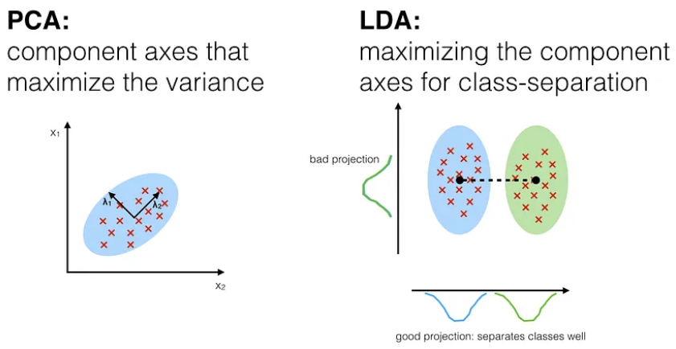

Steps for LDA:

1. Compute the d-dimensional mean vectors for the different classes from the dataset.
2. Compute the scatter matrices (in-between-class and within-class scatter matrix).
3. Compute the eigenvectors (e1, e2, ..., ed) and corresponding eigenvalues (lambda_1, lambda_2, ..., lambda_d) for the scatter matrices.
4. Sort the eigenvectors by decreasing eigenvalues and choose k eigenvectors with the largest eigenvalues to form a d x k dimensional matrix W (where every column represents an eigenvector).
5. Use this d x k eigenvector matrix to transform the samples onto the new subspace. This can be summarized by the matrix multiplication: Y = X x W (where X is a n x d-dimensional matrix representing the n samples, and y are the transformed n x k-dimensional samples in the new subspace).

Source: <https://sebastianraschka.com/Articles/2014_python_lda.html>

## **Section 41: Kernel PCA**

No theory, only practice.

## **Section 42: Part 10: Model Selection & Boosting**

Unanswered questions:

1. How to deal with the bias variance tradeoff when building a model and evaluating its performance?
2. How to choose the optimal values for the hyperparameters (the parameters that are not learned)?
3. How to find the most appropriate Machine Learning model for my business problem?

We will answer these questions thanks to Model Selection techniques:

1. k-Fold Cross Validation
2. Grid Search

Eventually we will see XGBoost, one of the most powerful ML model.

### **Section 43: Model Selection**

Relevant videos: -  
Interesting videos: -

**k-fold Cross Validation**: will allow you to measure the performance of each of your ML models.

**Grid search**: allows you to find the best version of a model by finding the optimal hyperparameters leading to the best score of performance. In classification you will find the optimal hyperparameters to get the best R squared and in regression you will find the optimal hyperparameters to get the best accuracy.

**375. k-Fold Cross Validation in Python**

### **Section 44: XGBoost**

Relevant videos: 363  
Interesting videos: -

This is the most powerful model.

### **Section 45: Annex: Logistic Regression (Long Explanation)**

Relevant videos: 382  
Interesting videos: -

**382. Logistic Regression Intuition**

No slides, only a presentation.

## **BONUS: Cloud Skills for ML & AI (COUPON)**

Dear student,

As a data scientist, there is something very important you should know:

**There is a convergence happening between AI and Cloud Computing, and that convergence is getting stronger and stronger with time.**

(Remember to check the P.S. for your Coupon Code 👇)



**Why? Two important reasons:**

1. Today the **data and processing power required** to train the Machine Learning / AI models are increasing at a fast pace, therefore we won’t have the choice but to use the Cloud to build and train these models.
2. Thanks to the economies of scale, the **cost of training these models using the Cloud is much lower** than on-premises. Therefore most of the companies today are using the Cloud for Data Science.

And that’s exactly why we are already seeing this crazy FACT: Between 30 to 43% of Data Science job posts mention Cloud skills as a requirement or a preference. That’s a lot! Because it means that without Cloud skills you will likely **miss out on 1 in every 3 job opportunities.** ❌

Therefore, we built this awesome community platform called [**CloudWolf**](https://www.cloudwolf.com/), which has 5-star Courses to train you to **get the AWS certifications you need** (so that you can prove to companies that you have the Cloud skills)...and also contains other courses and labs which train you to **leverage the Cloud for Machine Learning and AI.**

Here are five examples of what you will learn in this platform:

* 🤖 Build and train some super powerful Regression and Classification Fine-Tuned Ensemble models with **Amazon SageMaker**
* 💡 Build an Automated **Machine Learning Pipeline with AWS Lambda**
* 📈 Build a Time Series Analysis model with **Amazon Forecast**
* 🛒 Build some Recommender Systems for Netflix and E-Commerce with **Amazon Personalize**
* 🚀 Do some Generative AI for Text Generation, Code Generation and Image Generation with **Amazon Bedrock using the most powerful LLMs** (Claude by Anthropic, Llama 2 by Meta, Titan by Amazon, and Stable Diffusion by Stability AI)

Plus, this community is super vibrant so you will have fun along the way!

More and more Data Science, ML, AI jobs are moving to the cloud. Don't risk falling behind...

Get your **14 day free trial** and start your journey today: [**https://www.cloudwolf.com/**](https://www.cloudwolf.com/)

We can’t wait to see you inside,

Kirill and Hadelin

*PS:* 👉 *Use Coupon Code* ***UDEMYBONUS*** *at checkout to lock in 20% off. You will keep this discount for as long as you are a member!*